FIORI

# Authentication and Authorization

In security concept we have two concept one is Authentication and another is Authorization and Authentication comes first and Authorization comes then.

* **Authentication**

Giving access to enter into the system. Entry point to the system.

* **Authorization**

Once user enter inside the system, what tasks/activities they can perform

# FIORI Roles and Responsibilities

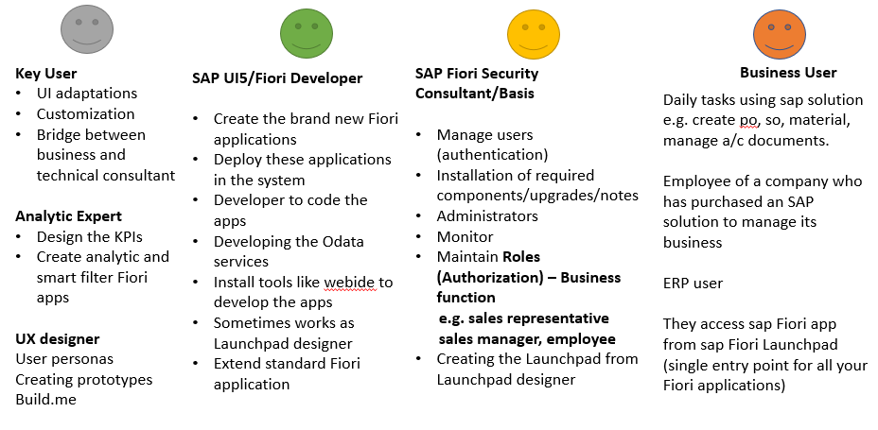

# FIORI App access

To access FIORI, we have some transaction codes. To access launchpad designer we will use these transaction codes **/n/UI2/FLPD_CONF, /n/UI2/FLPD_CUST**. To access launchpad we have **/n/UI2/FLP** transaction code.

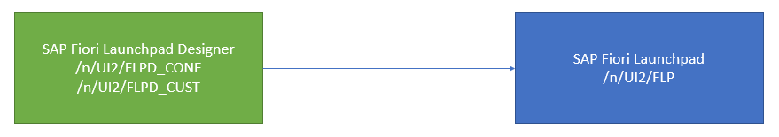

# Step by step FIORI access and user create

In these steps we will create a user first and then we will assign the respective roles to that user.

To create user, we use **SU01** transaction.

We will go to the SU01 transaction and the we will write the desired user name (**BUSER**) and click on **create** button. Then give the **Title, First Name, Last Name** and the go to **logon data tab** and give the **initial password** so, our user is been created.

Now this user cannot access anything because it doesn’t have any role. But using the Username and password we can access the sap log on.

This process of creating user is called **Authentication.**

Now if we log on with that user in FIORI launchpad, after login we can see an error called “**Failure – Unable to load groups**” this means we are not having any authorization.

To access FIORI launchpad we need authorization to 2 important service **/UI2/INTEROP, /UI/PAGE_BUILDER_PERS.** These can be done from /N/IWFND/MAINT_SERVICE transaction by activating these services, because FIORI can only understand OData.

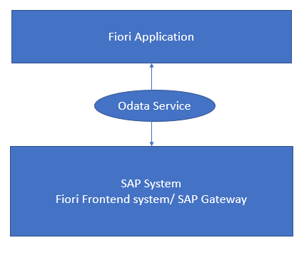

Now we will go to **iwfnd/maint_service** transaction and activate these services.

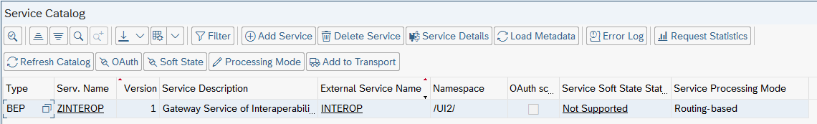

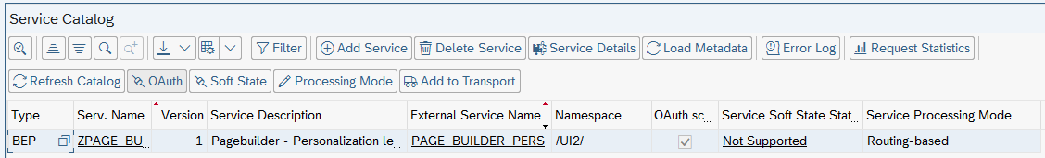

These two services are given by SAP and for the first time in the system we need to activate these services.

Our activation is done now we need to create role to give to the user so that the user can access the FIORI launchpad. Role can be created from **PFCG** transaction.

We will open the transaction PFCG and give the new role name and press single role.

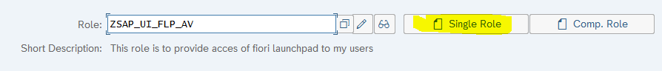

Then we will provide the role description and click on the menu tab and in that we will start adding the roles.

To add the access, we need to add two services one is service metadata authorization which comes from the gateway system IWSG and one comes from service backend system IWSV. Now we will click on **transaction** button and click on **Authorization Default** then we will click TADIR service, first choose IWSV.

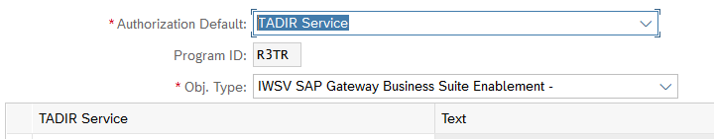

Now search for *INTEROP* and *BUILDER_PRS* add it.

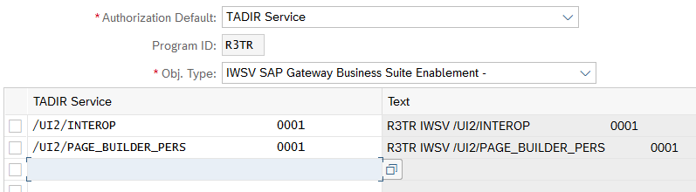

Then same way we will add for IWSG.

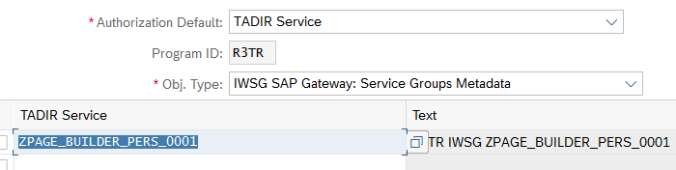

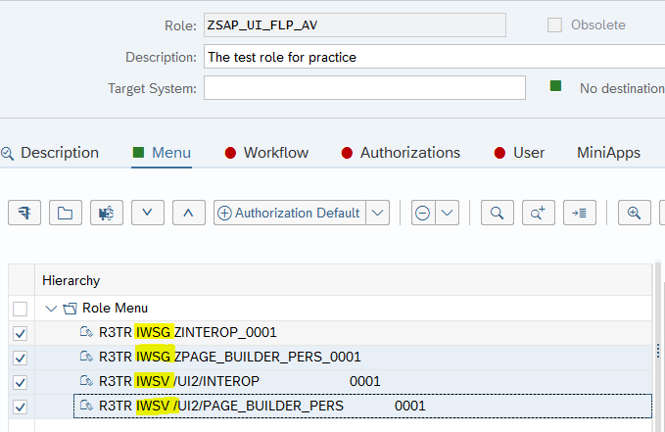

After adding we will save and go to Authorization tab and we will create a profile here. We will click on **Change Authorization Data**

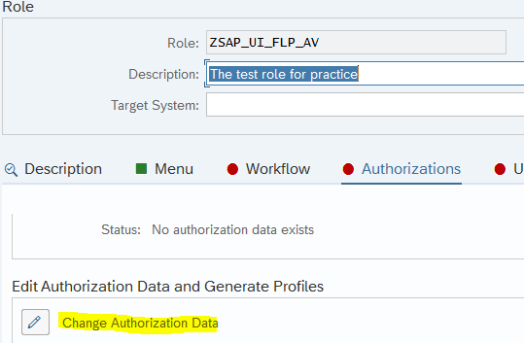

After clicking on that we can see that **S_SERVICE** authorization object is already been created and added.

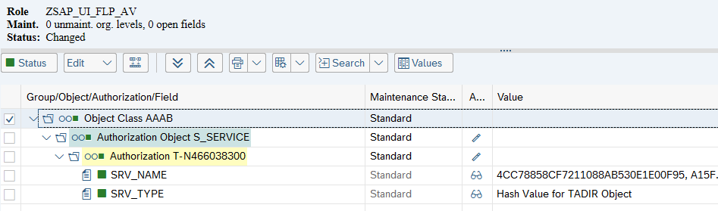

The we will click **generate.**

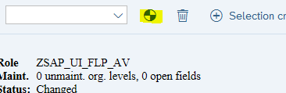

Then it will come like below.

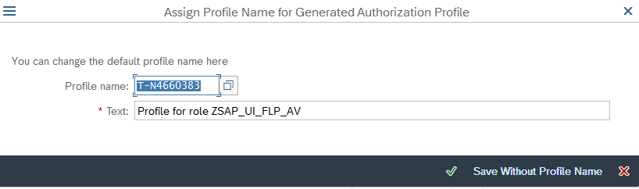

Now if we go back, we can see the profile generated.

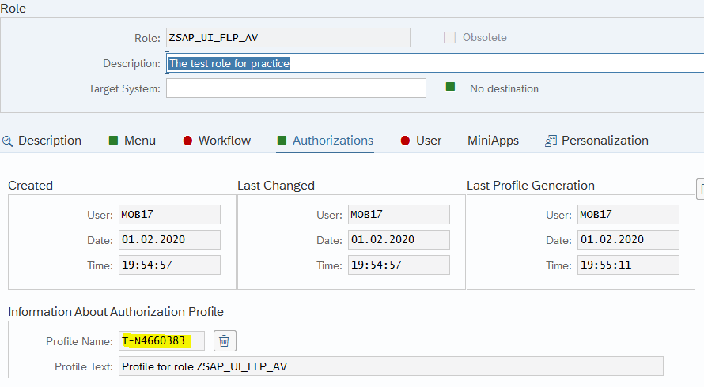

Now to assign the role to user we will go to **User** tab and add those users.

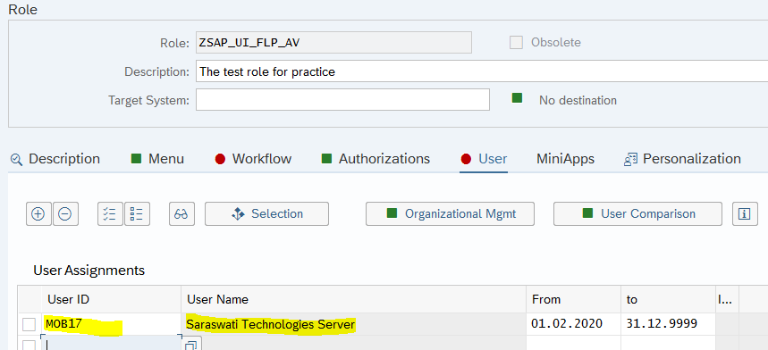

Now if we go back to the launchpad and reload we can see the page.

Now if we want to give the access to the SAP standard app access then we need to check our system and go to the SAP FIORI app library and then we need to find out the profile for this app like below.

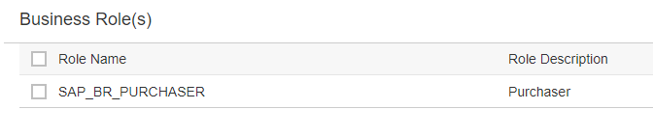

We will go to the user profile and add this role.

Now we need to add the authorization object for tiles. To do so we need to go to the role and authorization object tab and click on manually tab

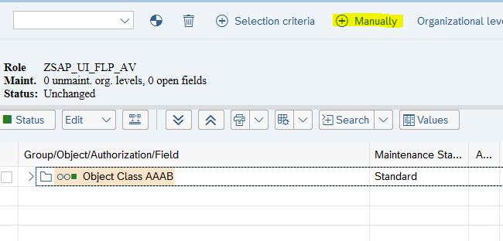

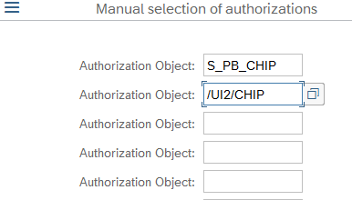

Then we need to add the authorization access like below.

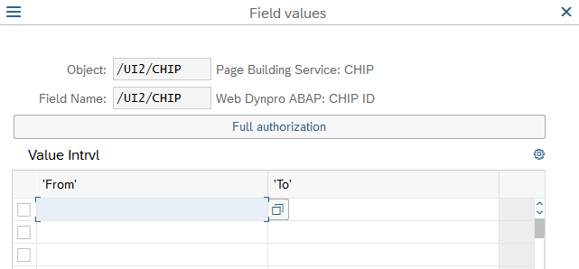

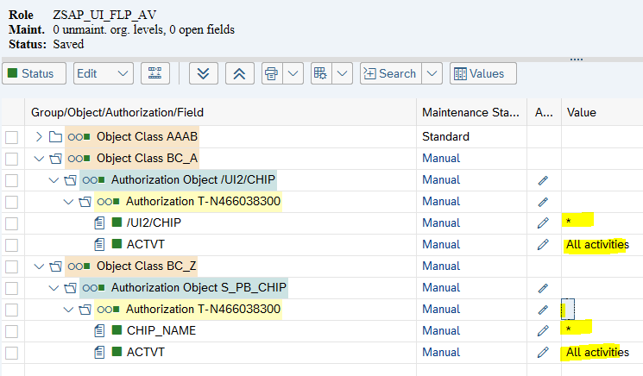

# Role Profile concept

One Authorization object can have multiple roles and one role can have only one profile and one user can have multiple roles.

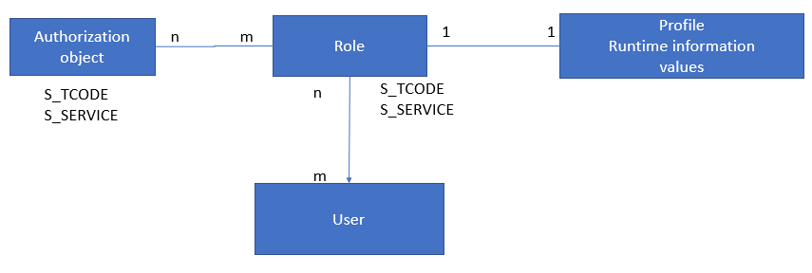

# Launchpad URL

<http://sts4c.st.com:8001/sap/bc/ui2/flp?sap-client=800&sap-language=EN&sap-accessibility=X#Shell-home>

# Standard FIORI app Library

<https://fioriappslibrary.hana.ondemand.com/sap/fix/externalViewer/>

# SAP UI5 Recall

SAP UI5 is the framework which allows us to develop responsive web application (app which adapts itself according the device), this framework is based on open standards like HTML5, CSS, JS and JQuery.

To develop the UI5 apps, we use MVC (Model View Controller) Architecture.

Models – JSON, XML, Resource, OData

Views – XML, JS, JSON, HTML

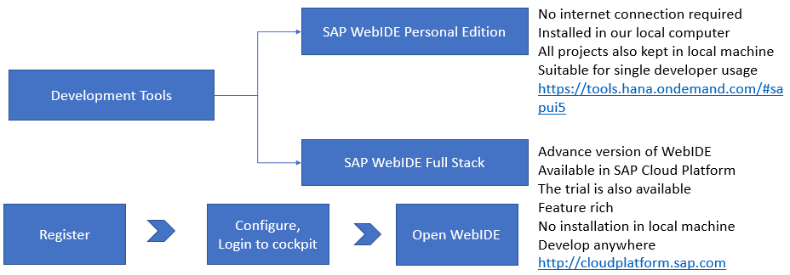

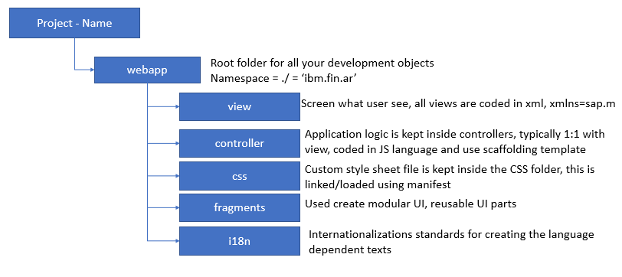

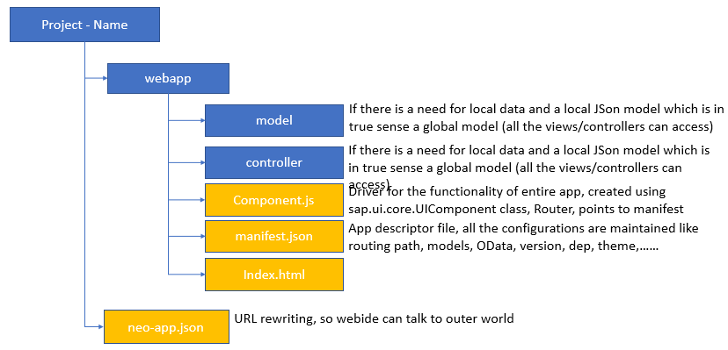

**neo-app.json** file is the interface for WEBIDE to the external world. In this we specify the URL rewriting.

# OData Recall

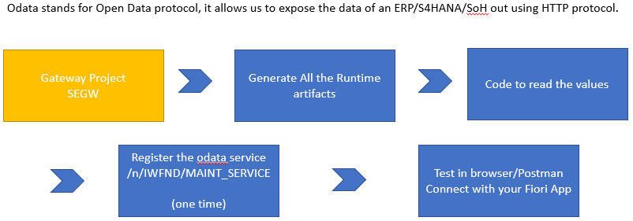

# Central hub Deployment Architecture

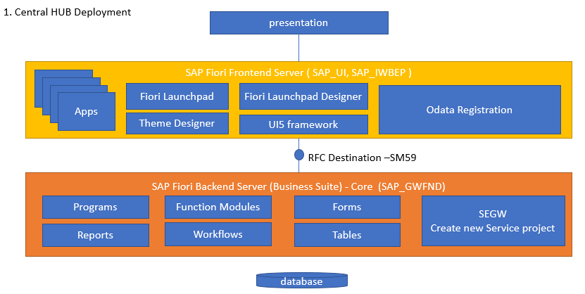

**Pros and Cons for central hub deployment:**

Pros:

1. If you have multiple SAP Solutions in your co. CRM, SRM, HCM, ECC, the data comes from different systems.
2. At runtime your OData can connect to any system to fetch data.
3. Implementation risks are minimized.

Cons:

1. Cost goes up.
2. Leads to confusion for developers/architects/testers/basis where to do what?
3. Maintenance is also high, because these server needs to be also in sync.

# Embedded Deployment Architecture

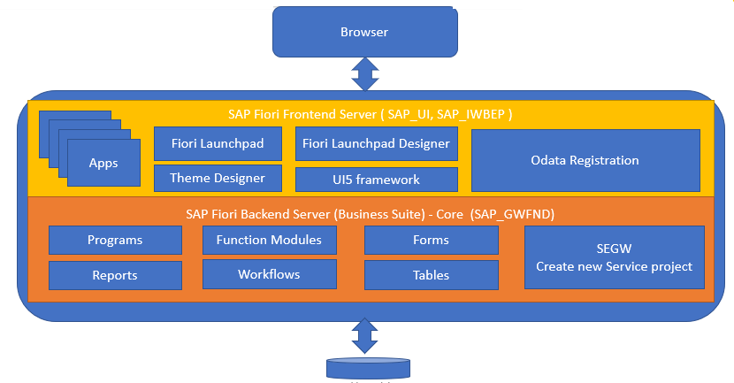

In the system and go to status we can see all the components, which means our system is embedded.

# Tools Required

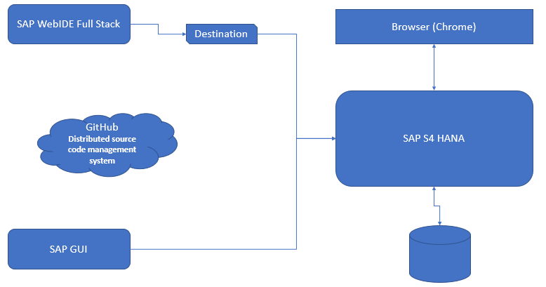

# Git Configuration

Git is a repository which is storing our project state accordingly and we have rollback options also available in git. This rollback is called reset in git.

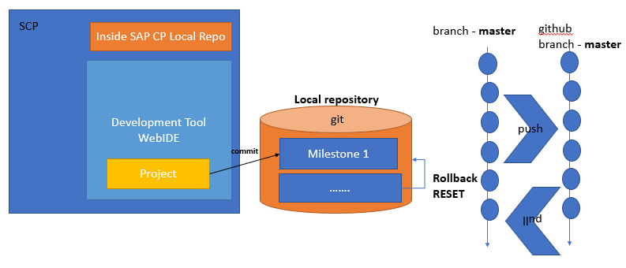

We need to first open Git account in **github.com.**

After creating the github account we need to go to the webide and right click on git and click on **Initialize Local Repository** like below.

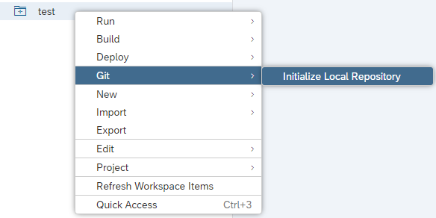

Then we need to specify git email and username like below.

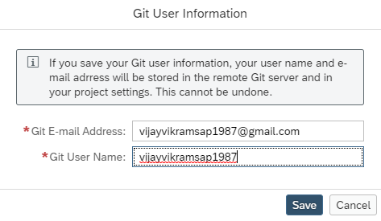

Then all the project items will look like ** like below. Which means we have a change but it is not yet been committed.

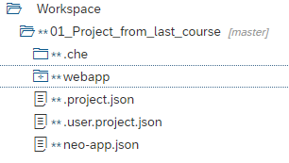

Now we will go to git pane and we can all the files with double * are listed there.

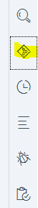

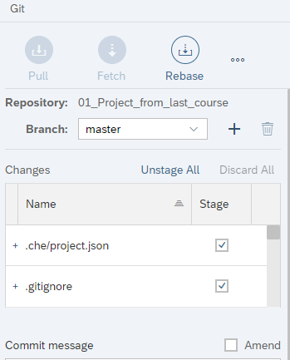

Then we will add the messages like below.

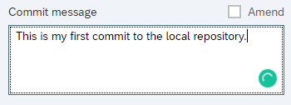

Then will press Commit like below. This is a commit to local repository not the global.

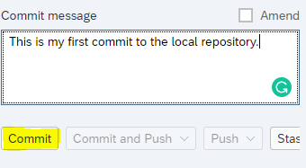

After commit all start became bubble icon like below

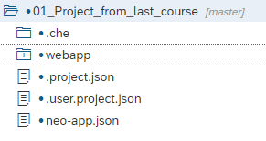

Now we can see the changes in history button like below.

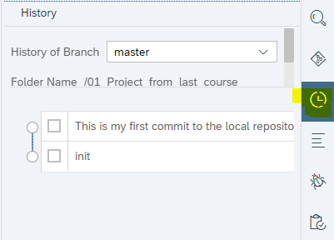

If we check the check box respectively, we can see the developer and commit details, like below.

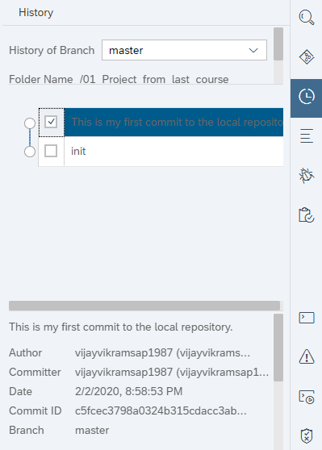

Now if we make any change in any file it will become * again, let’s say we have changed the manifest json.

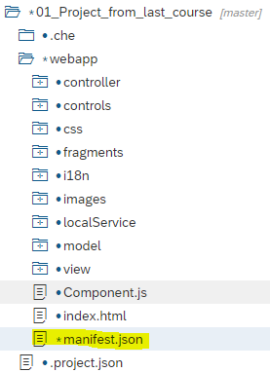

Now this change made my project not working so I want to rollback the changes. Rollback has two options

* Revert

Revert can be done like below. To do that we will go to the git history and click on the latest version or any version and go below and click revert.

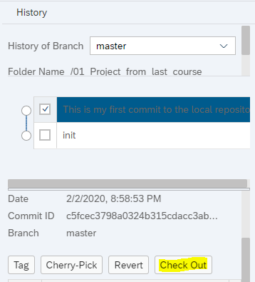

* Discard

Go to the Git Pane and right click on the respective change and click discard.

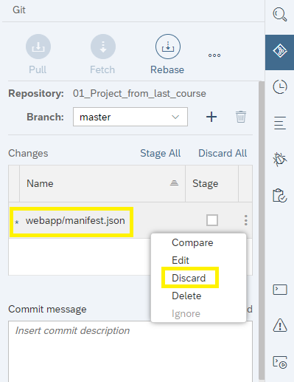

After that it became double bubble and start will be removed.

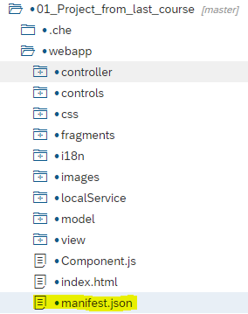

Now let’s say we have done lot of changes with lot of commits and now I want to share them with my architect or developer.

Like we don’t have anything in the git global like below.

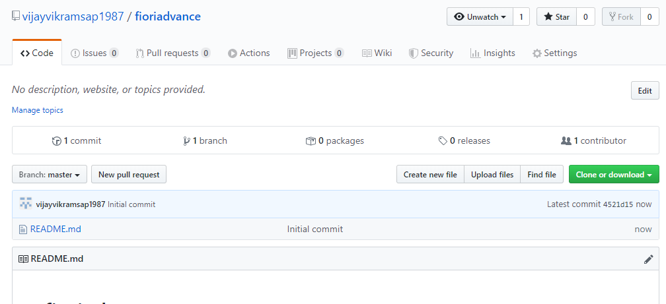

Now for that we will right click on the project and click git and then **Set Remote**

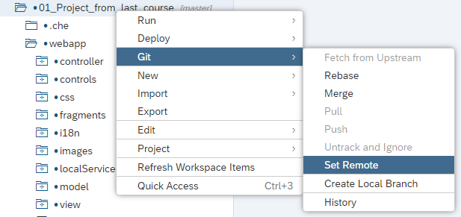

After click on Set Remote we will get options like below.

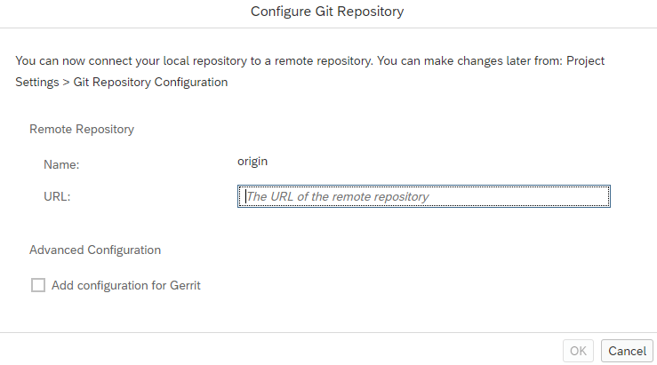

Now for that we need the git url like below.

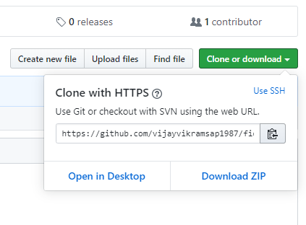

Then we need to put this URL here and then click OK.

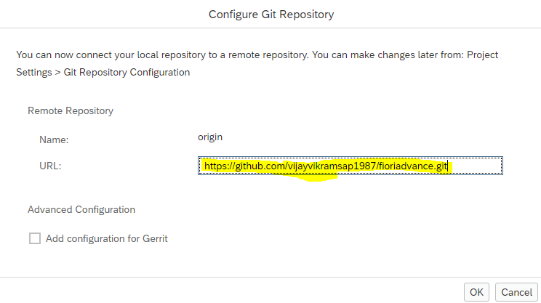

Commit is for local repository and Commit and Push for global repository.

Then we will push the code like below.

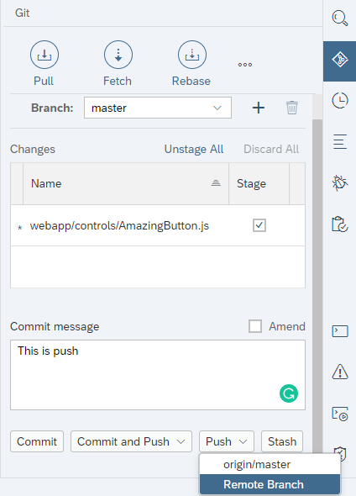

Once push is done will get message like below.

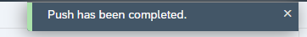

So, after the push changes can be seen in Git.

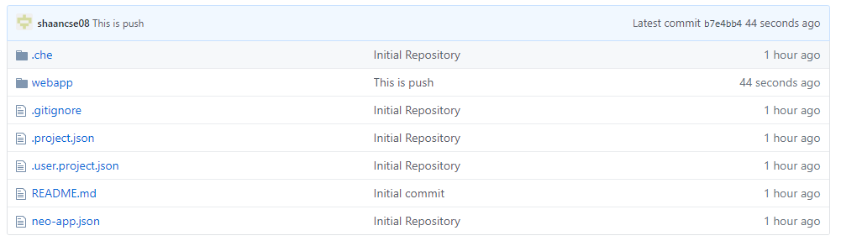

Now if another developer wants to work then he or she has to clone it like below.

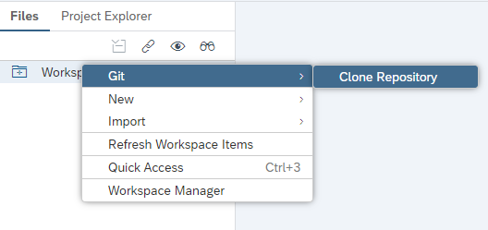

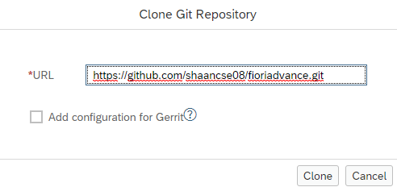

After the clone clicked it will come to our workspace like below.

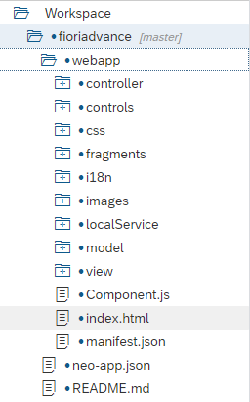

# Git Issue Fix

1. During push if we get SSH issue, please maintain project settings 🡪 git settings with the url of your repository

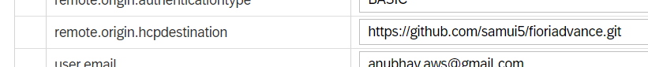

1. Keep committing the stable states of the project
2. Once we have a feature ready in local (includes multiple local commits), Push your change
3. If we get **NON_FASTFORWARD** issue, which means your local change is not in sync with remote repository, so we need to pull the changes.
4. A pull will naturally work, if the changes in remote and local can be synchronized – auto merge
5. But in case the remote branch has a change with same line same file as local branch, we need to manually adjust the code and then push the changes
6. Always keep pulling the changes and keep pushing the features.

# What is Amend

Let’s say we have done some changes and for that I don’t want to create new commit for that and we want to amend my changes to the last commit, in that case I will select amend and soon I check the Amend it will automatically bring the last commit name.

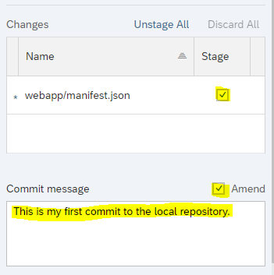

# SAP WEBIDE Advantage

SAP WebIDE Full stack is the main development environment tool for supporting SAP’s strategy of wide verity of development.

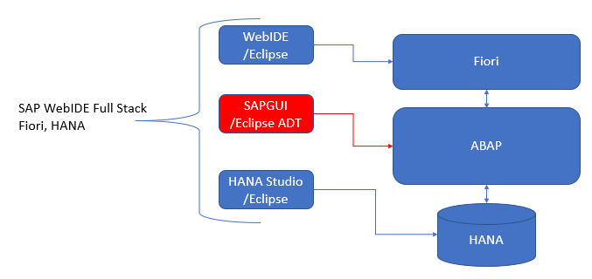

To have single unified development environment tool to support all kinds of development HANA Native (XS, XSJS, HANA CDS, HDI, HANA artifacts), Node JS, Java Dev, SAP Fiori, Leonardo, IoT, ABAP (soon….). It has capability to connect to Cloud systems and OP systems by using destination feature of SAP Cloud Platform.

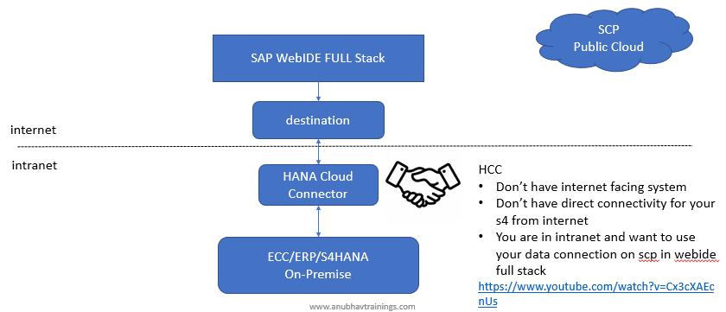

# New in SAP WEBIDE

The classical WebIDE was based on ORION server approach, now the WebIDE full stack is based on Eclipse Che Server concept. That is why it is possible to run the webide full stack supporting different technologies like node js, java etc.

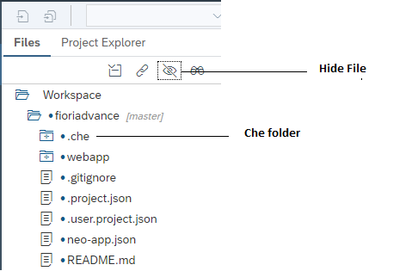

**Full stack features**

1. New Theming experience
2. New Storyboard feature for interactive application development – code-free development
3. Problems, run console and resource manager
4. Search, show/hide hidden files
5. Assign OData to a model and synchronize metadata
6. New types of templates – IoT, MTA, Leonardo….
7. Visual Extensibility and customization
8. Visual Editor
9. Multi-workspace feature
10. Code completion / JS Code snippet
11. Drag and drop capabilities = Layout editor
12. Frequent updates
13. Grunt JS based best practice build
14. Node js development also using webide full stack

# Application component Hierarchy

In the FIORI standard app library, we will find all the apps which are delivered by SAP and there under support tab we will get the application component hierarchy like below.

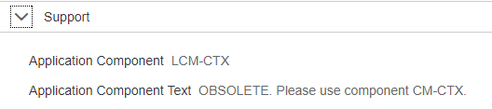

# FIORI ID

For every app which is delivered by SAP will have a unique app id which starts with F, below screen shot will show the same.

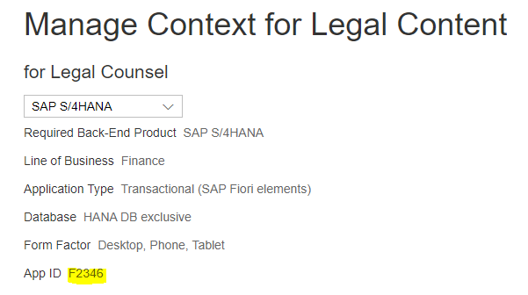

# OData addition components

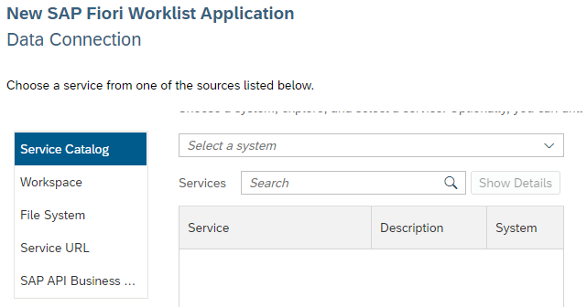

* **Service catalog:** we will use if we have system
* **Workspace:** If we have OData metadata with us from another project workspace then will go with this.
* **File System:** We can browse the metadata from our local computer.
* **Service URL:** majorly use in S4HANA cloud system.
* **Business API:** Central API hub where will find all the white listed APIs.

# Catalog Services

CATALOGSERVICE?v=2 – is a standard SAP service, which is used by external tools like eclipse ADT, WebIDE to load the list of Odata services available in our system (Suite, S4 HANA).

When we select the Service Catalog then a call goes to backend system to list out all the OData services.

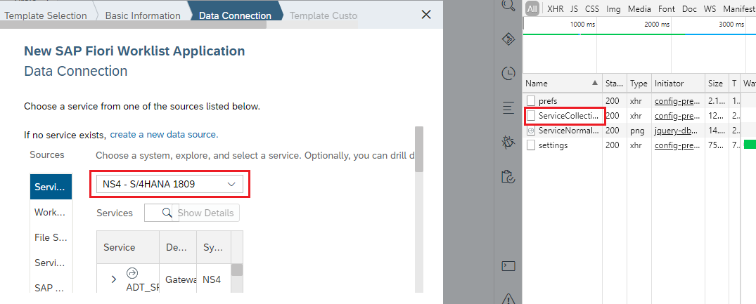

The URL will be like /NS4/sap/opu/odata/IWFND/**CATALOGSERVICE;v=2**/ServiceCollection?$format=json

So CATALOGSERVICE;v=2 is basically a service in OData, which is responsible to list all the services present in that system.

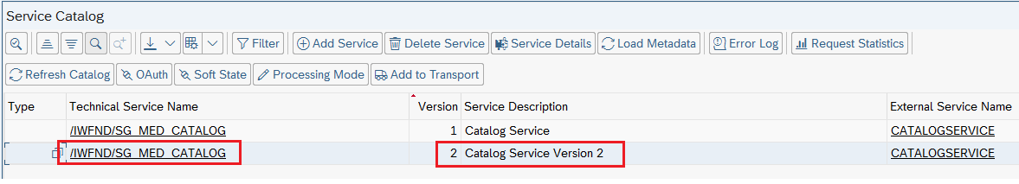

# Link Editor

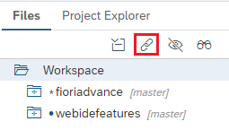

Let’s say we have opened n number of files and we don’t know from which project these files belong to, by clicking on the link it will open the respective project left side. It is same link editor in ADT/Hana Studio.

# Git Ignore

Let’s say we have some files which are not to be deployed to git hub and it is only local purpose so in that case that file name will be on Git ignore. Once it is in Git ignore file then after changes also it will not be pushed to git hub.

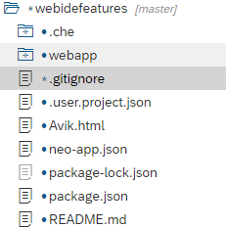

Like we have one file called Avik.html.

Once I click on ignore like below.

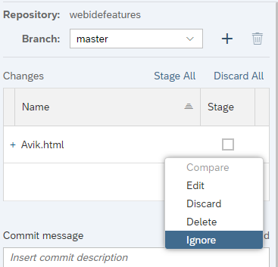

It will automatically be listed in git ignore file.

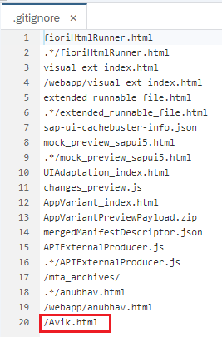

# .project.json File

if I don’t want to send the file to my SAP system when I am deploying my App (e.g. index.html)

# Outline

Let’s say we have 100 methods in a controller and it is impossible to scroll and find out the respective method so for that web ide has outline option enabled. Once we click on that outline will find all the object method listed there, it is like ADT/HANA Studio outline.

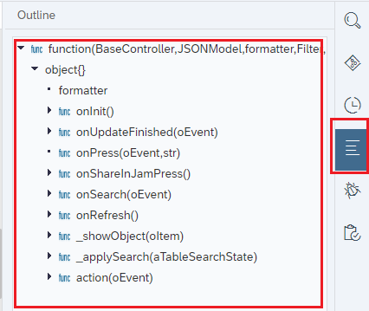

# Cherry-Pick

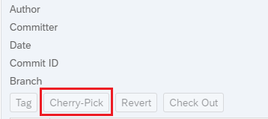

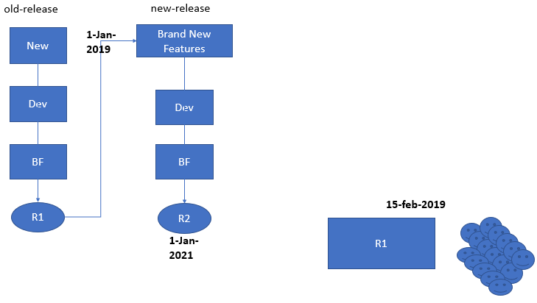

So now at times we have developed one app and delivered to client as R1 and now we have started development for another release like R2 and we are doing that in another branch. Now on 15th Of Feb we got one bug and we fixed it to R1 and same way we cannot copy all the code to R2 for this reason we have Cherry-Pick. This cherry-pick will merge all the changes from R1 to R2.

# Step by Step Cherry Pick Execution

Let’s say we have a project and that is finished and a new branch will be created for new features. We will create a new branch first called **NewFeature** in our WEBIDE.

**TestGit** is our project and that is finished and moved to git and the branch name is Master

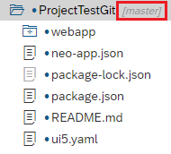

Now we will create another branch called NewFeature to do that we will right click on the **Project** 🡪 **Git** 🡪 **Create Local Branch** and will name that **NewFeature**.

Then it will look like below.

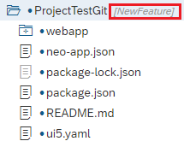

Now we have some bug and we will switch to Master branch and will fix the issue. To switch the project, we will go to Git Pane and switch the project like below.

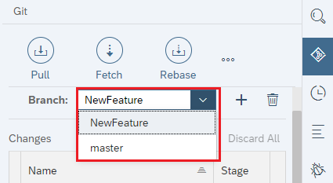

Once we switched to master it will show like below.



Now to fix the Bug we have create new file in the **webapp** called **BugFix.js** file.

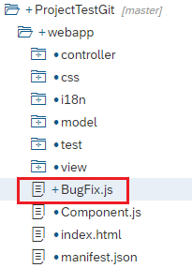

We can create a Git branch from WEBIDE and right click on the **Project** 🡪 **Git** 🡪**Create Remote Branch**

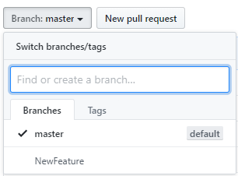

Now we have deployed our changes to Master branch and we can see the file is visible in **Master** not in **NewFeature** Branch

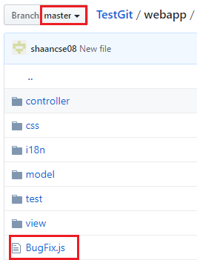

Now if we switch to the new branch **NewFeature** this file will not be visible.

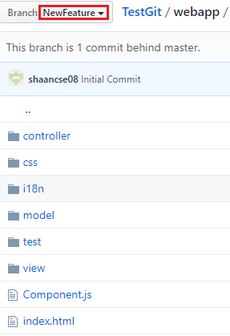

Same will happen in the WEBIDE also.

Now we will do cherry pick so that the changes should be visible to **NewFeature** as well. To do the cherry pick we will set our branch as **NewFeature** in Git Pane.

We will go to Git History and set the Tab where the new file is available which means **Local Main** then click on the CherryPick Options.

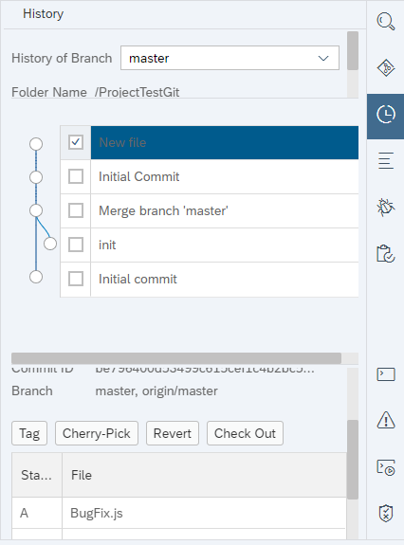

Now we can see the file in **NewFeature** branch and now we will do a Push for the new Branch.

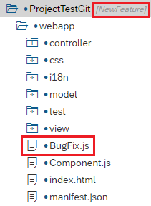

We will do the push in NewFeature branch.

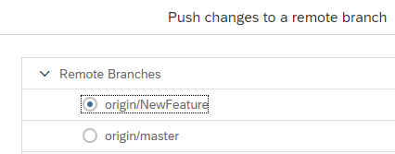

Now we can see all the files in new branch.

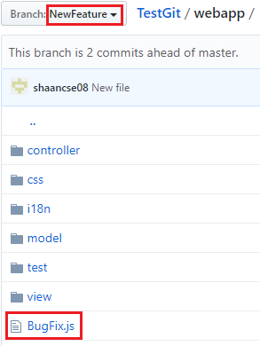

# Reset

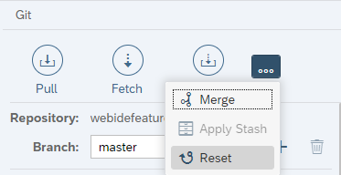

Let’s say we have messed up our code and We don’t know in which file and where we have done the changes and now, we want to go back to the last stable stage, for that we use Reset button. It will reset to the last stable state.

# Code Completion

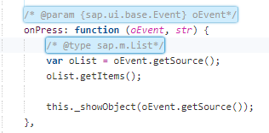

If the code completion is not working fine then we need to give the annotation to make the code completion happen.

* **/* @param {sap.ui.base.Event} oEvent*/**
* **/* @type sap.m.List*/**

# Story Board

The storyboard in Web IDE full stack provides representation of the Application, its views and their interconnections in form of graphical editor. All the binding of views, with the respective entity sets will also be depicted.

The idea is to develop/enhance sap Fiori apps using code free technique, graphical development.

Here we can create and add new view or delete view as well like below.

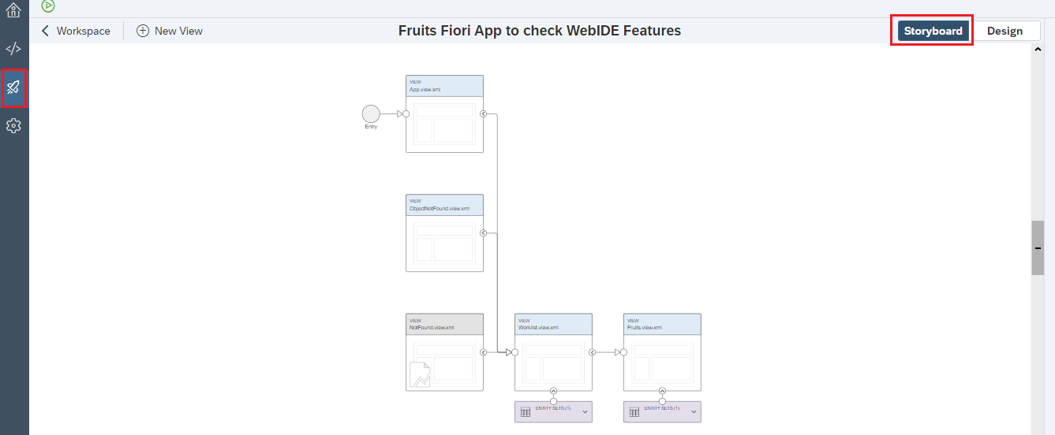

# Component.js file

Component.js is the main driver for the functionality of entire application, an app is called Fiori like app only and only when that contains a Component.js file.

It is mandatory to have a component.js file in the root directory of the application to add a tile of our app to Fiori Launchpad.

# FIORI Launchpad

SAP Fiori Launchpad is the central the page/web page/starting point for all the Fiori Applications which are deployed in your company system.

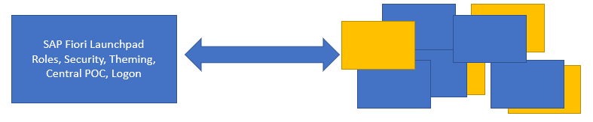

# What is App type while creating list application in UI5?

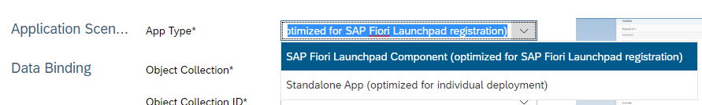

* **SAP Fiori Launchpad Component (optimized for SAP Fiori Launchpad registration)**: If we select this one then App will start from component.js file. It will create app which is suitable for FIORI launchpad.
* **Standalone App (optimized for individual deployment):** If we select this, which means we want a standalone app not FIORI launchpad app, maybe in this project will have index.html file. It is not advisable option.

# What is line count in i18n?

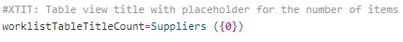

The **({0})** is basically a $Count which gets count from OData.

In the controller the code will look like.

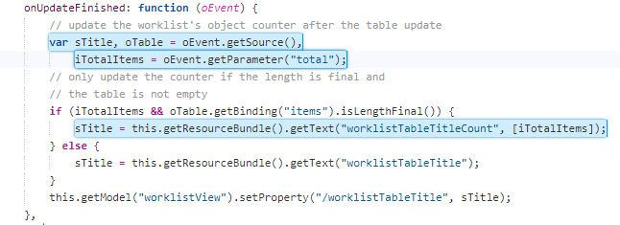

# SAP Cloud Platform

SAP Cloud platform is a platform as a service, which allows us to design, develop, deploy, manage the end to end lifecycle of an application in public cloud.

If we don’t want the application which we develop to deploy in an SAP system rather, wants to give access of this Fiori app in public cloud to all my end users, we can use **SAP Cloud Platform portal service.**

**SAP CP portal service** allows us to develop a Launchpad in sap cloud platform, and deploy our apps to this Fiori Launchpad in cloud, all the users can access then these application on internet directly.

# FIORI Launchpad

Launchpad is collection of Catalog each Catalog contains collection of tiles. So, which means one launchpad can have multiple Catalog and one Catalog can have multiple tiles. One Catalog can have multiple associated groups. So, all the tiles which are added in the Catalog from there they are moved to the groups. So, from one Catalog tile can be moved to one group or multiple group, multiple group can contain Tiles from different groups also. Each tile is exactly a FIORI app. One Role can contain multiple Catalogs inside. One Role can contain multiple Groups. One Role can be assigned to multiple User. Role is basically, to add the access to the user, how user can access our App. Group and Catalog together assigned a Role

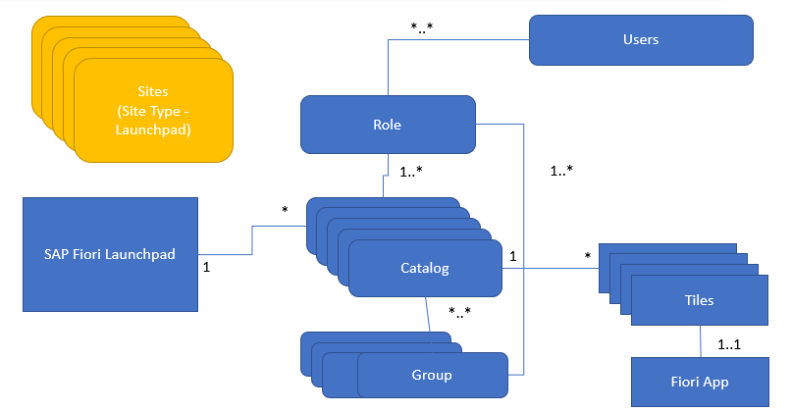

Before work on launchpad we need to enable the portal service for that we will go to the SAP Cloud Connector like below.

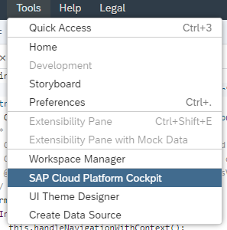

Then will click on Services

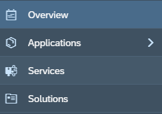

Then here we will search **Portal** and enable it.

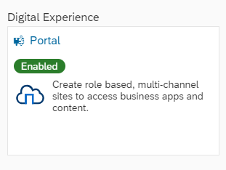

Then will go to the service inside and lick on Go to Service

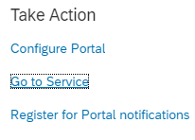

Then will click on **Create New Site.**

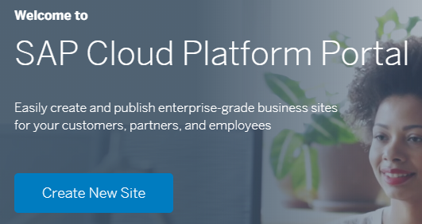

Then put the User name as **P1942213603**.

Then will give the Site Name and select Fiori Launchpad.

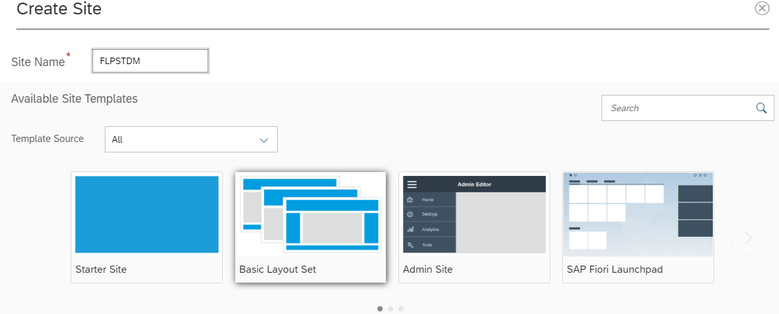

Now from the Content Management Site we can add or edit the Catalogs Groups Tiles.

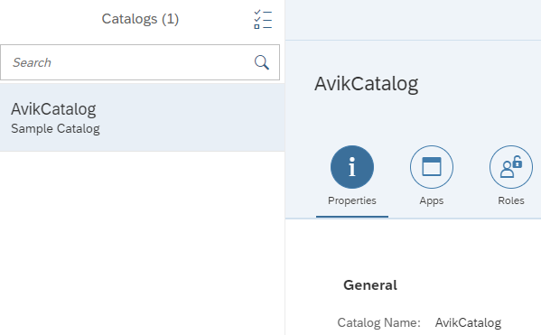

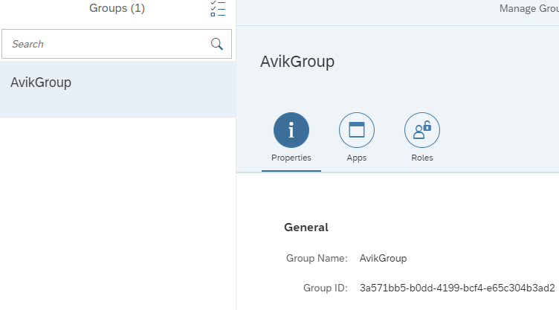

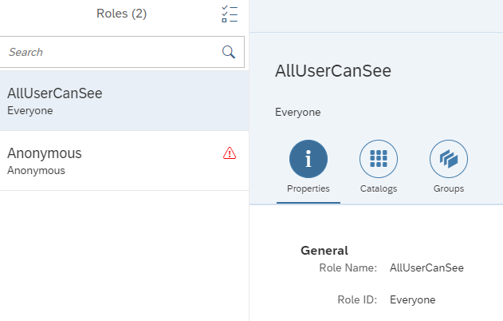

Then we will deploy our App to Cloud Platform.

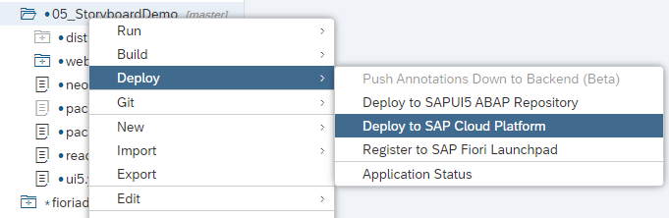

Then click on deploy.

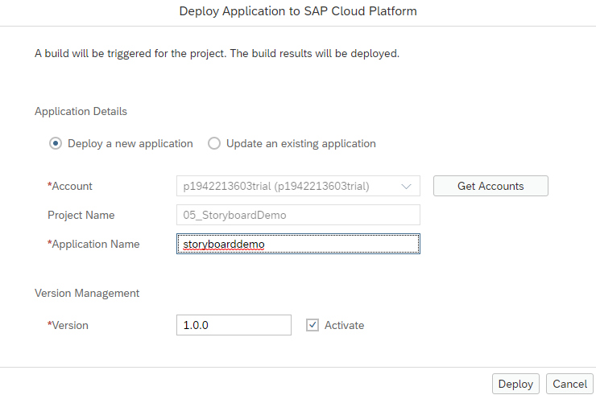

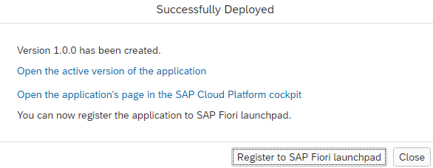

Now we will add an App from this menu

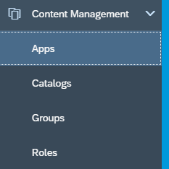

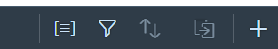

Then we will browse our deployed apps.

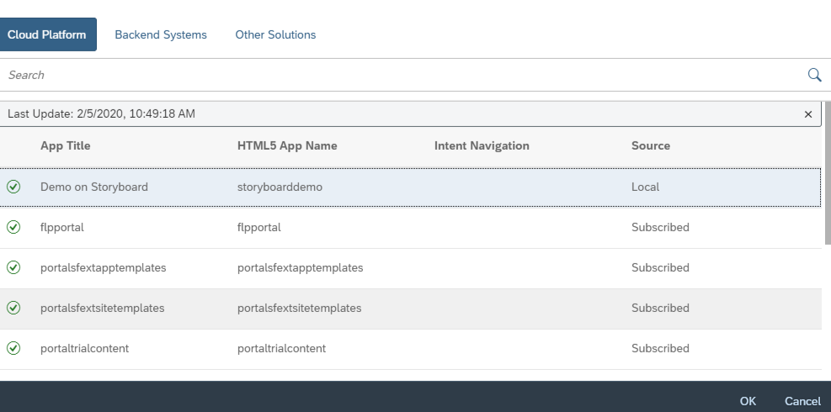

Then we need to provide some mandatory fields.

Intent Navigation means purpose of the app. So basically, this app is Fruit app and is to display the Fruit from different suppliers. So that’s why we put the name of the app is SupplierFruit and Action is display. Semantic Object is meaning your Business Object name and Action is purpose of this app.

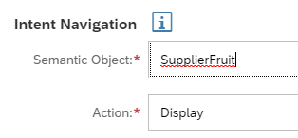

We can give a Fiori app id as well like below.

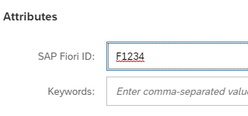

Then save and System is actually making a tile here. So now this tile is not visible to the user.

* First Tile has to be added into a Catalog

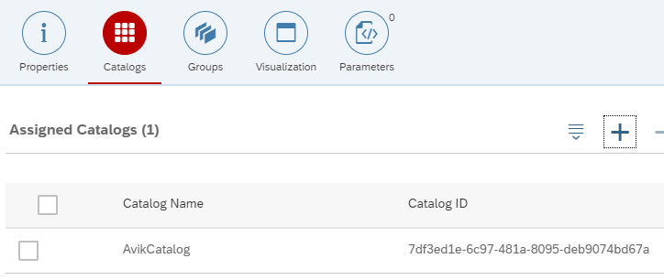

Next is group and we need to add a group. Group is very important without that user can not search the app and Catalog is not visible in Launchpad. Catalog we have created for role assignment.

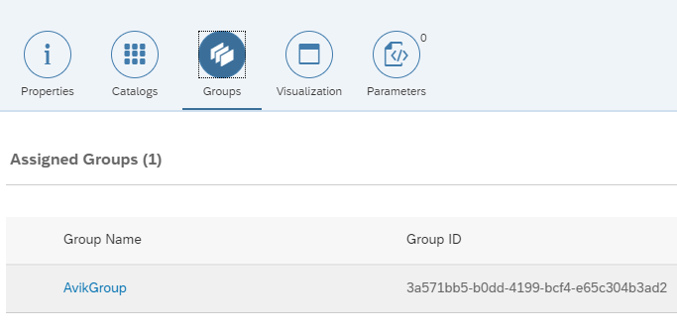

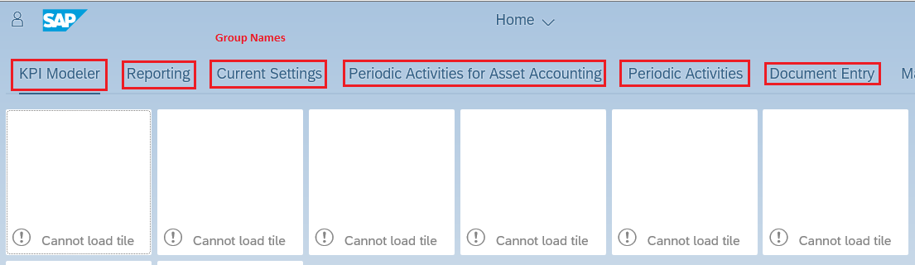

* Now we will be got to the **Roles** tab and add these groups and Catalog in that like below. And once this role is assigned to user, it can be accessed by the respective user.

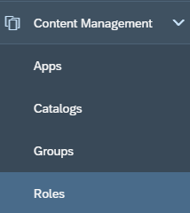

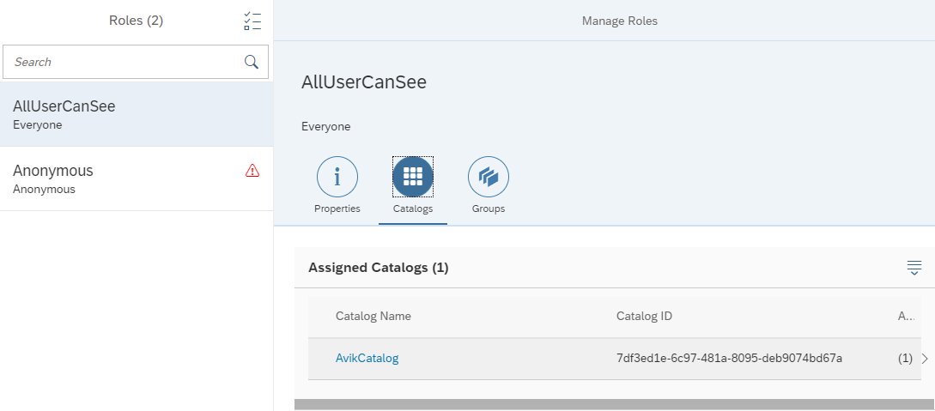

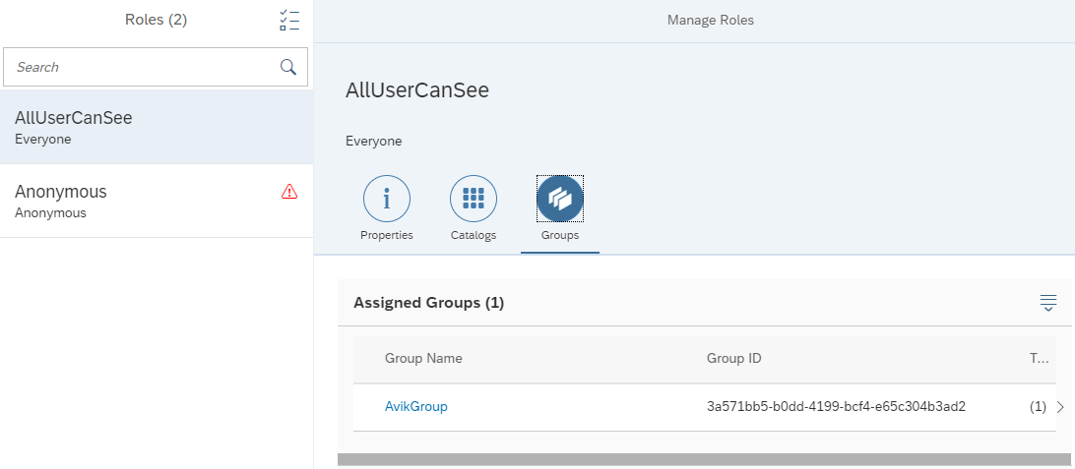

* Now we need to publish the app without publish the app we can not see them for that we will go to the previous page and in Site Directory Tab.

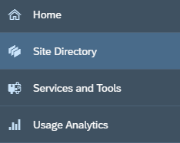

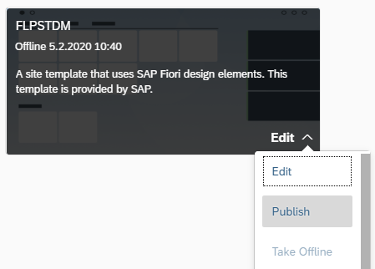

* Now after publish we can see the url to open this app

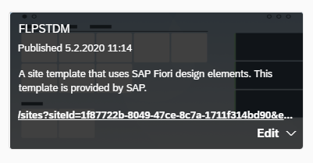

* After opening the link, we can see like below

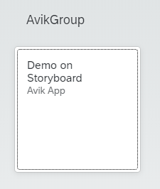

# Power of Group with respect Catalog

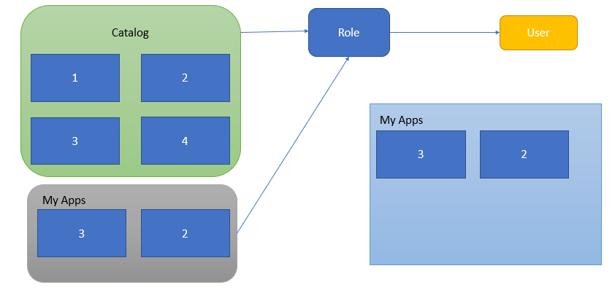

Here user is having access to all 4 apps but though two apps are in My Apps group so when user open the launchpad he or she can see only two apps by default app but for all the other apps (1 and 4) we need to go to app finder and add them.

# Business Process Management

In big organizations the large number of employees can only be managed when we have pre-defined, standardized processes. Processes in each area like leave request/approval, SRM purchasing, Order-to-cash, order approval, maintenance contract preparation, procure-to-pay, hiring.

Business process is the heart of an ERP system and a software which manages such business processes is called BPM.

It is in the best benefit of a company to comply to business process is to automate the same.

# Workflow

Classical SAP world (On-premised) we have SAP Workflow to automate a business process.

To create a workflow, we use T-CODE as **SWDD**.

* **Workflow –** Represents the steps of activities, these are called steps
* **Step –** one activity in the flow, there are different step types
* **Step Type –** indicates the type of activity e.g. send mail, user decision, tasks are created from the step type
* **Workflow instance** – when we execute a workflow, a workflow instance is created (runtime of a workflow)
* **Context** – Whenever we run a workflow at times, we need data which float inside workflow, this data is held inside context, It’s the memory of workflow instance
* **Agent –** person/user/entity to which a workflow task is assigned to. User needs to take an action so that workflow can continue.

At runtime, when a step type of task gets executed a ***work item*** gets created. This work item is sent to user’s inbox.

# Workflow Creation Steps

* First, we will go to the transaction SWDD and click on create button.

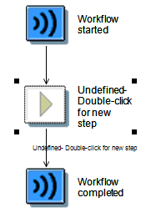

* Then we will click on the middle button to create step. We will select the decision maker and give the text like below.

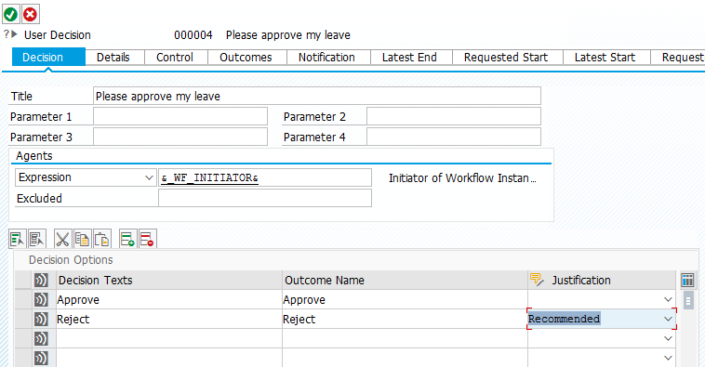

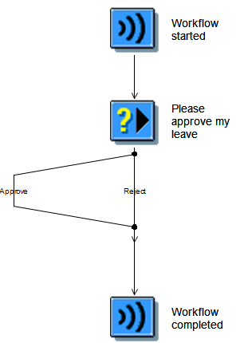

* Now we will configure the main we will right click on Approve and Reject and create mail.

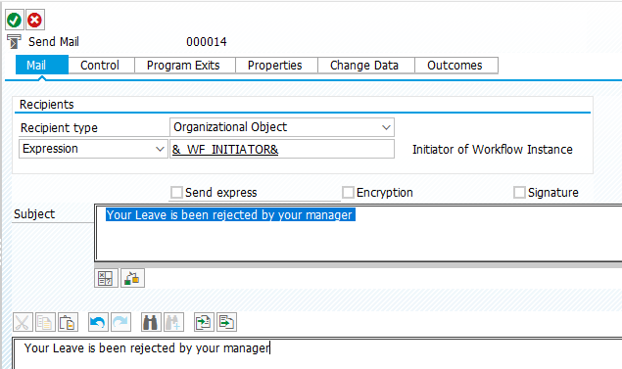

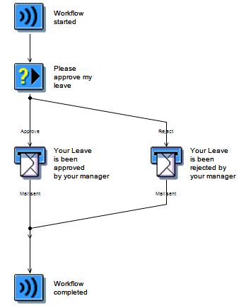

* Now activated the workflow. Once we execute this we will get an workflow item in our inbox.



# What will happen once we activate workflow service in SCP

When we activate the workflow service in SCP, a ***bpmworkflowruntime*** destination gets created automatically inside the sap cloud platform destination section. The purpose of this destination is to read and write in the sap workflow management system in sap cloud platform. reading/changing work items, reading agents, count, auto approve tasks, perform actions using code.

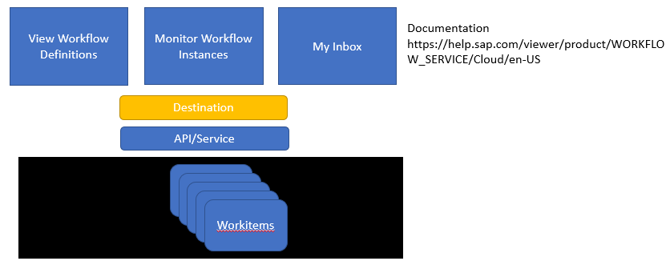

# Destination for North wind

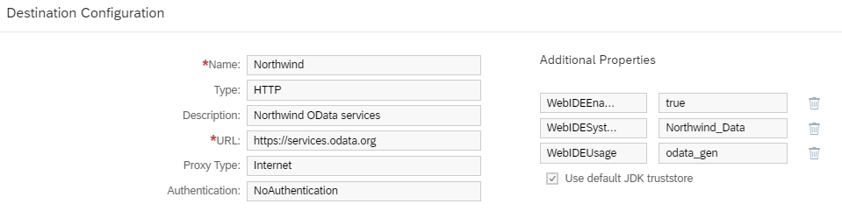

# Pre-requisite to create workflow

1. If our workflow needs to read data from OData service in public cloud (s/4hana, fg, sf, Ariba, Northwind), first we need to create a destination
2. Make sure that the sap web ide full stack has the workflow Extension/feature enabled. For this go to settings in the left panel.

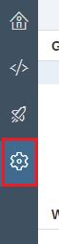

Now go to extensions like below.

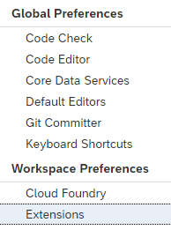

Search for **work flow** extensions.

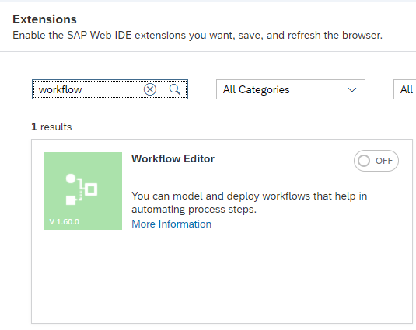

Make it on like below screen shot. And then click on **Save**

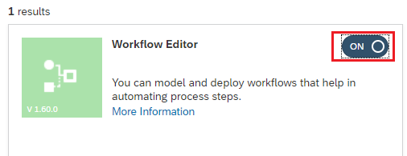

# Task Types in SAP Cloud Workflow

Task types in SAP CWF

* **User Task –** where a manual decision is required by agent like approval or rejection of leave request
* **Service Task –** just want to invoke the communication to a system via service call
* **Script task –** we can write code to manipulate the workflow context, call the work flow API at runtime (JS code)
* **Mail task –** configure, design and send an email

# SAP API Business Hub

**SAP API Business Hub:** It’s a central place where you find all the list of SAP API's offered today in cloud.

For API HUB intro

<https://www.youtube.com/watch?v=DHkxa4JqBzI>

# Workflow Status

Status of a workflow

1. **Running:** user task is assigned to an end user
2. **Completed:** When everything is done properly.
3. **Erroneous:** When there is something wrong tin the code.
4. **Suspended:** can be resumed again.
5. **Cancelled:** When we terminate as a Workflow administrator/ boundary event, it can never be resumed.

# How to configure services Workflow API

Go to workflow Service in services section in cloud platform. Then click on **GO TO APIS** then click on **Workflow API For Neo App.**

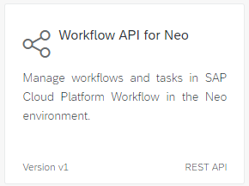

Then click on **Configure Environments.**

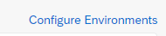

Then we need to configure that. To configure we need to take the data from **bpmworkflowruntime** destinations.

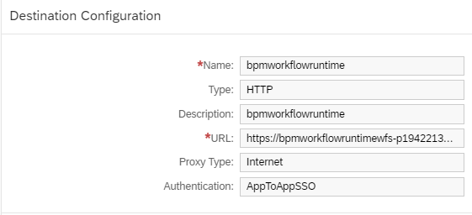

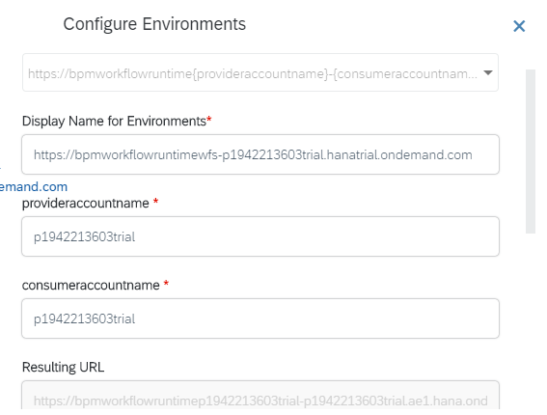

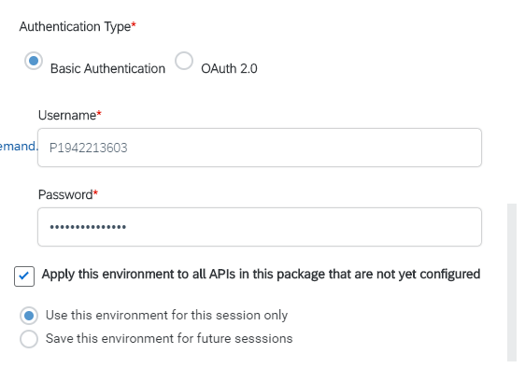

Then execute and we will get the data.

# Exclusive & Parallel Gateway

**Parallel:** you requested for an iPhone in a company and the request went 3 managers and, in this case, we need Parallel Gateway.

**Exclusive:** And in Exclusive Gateway only one request will work at a time.

# Pre-requisite to use mail task

The pre-requisite is to use mail task is that we have to configure ***bpmworkflowruntime_mail*** destination which contains the details of your SMTP server.

**SMTP *=*** Send Mail Transmission Protocol

**Host, user, pass,…..**

# What is Deadline Monitoring

**Deadline Monitoring:**When we have a workflow, which contains a user task, and if the user has not taken a decision for a long time, we want to complete that item automatically.

For example, let’s say I have requested for a mouse in my company and the request goes to my manager and if manager doesn’t approve that request for next 1 day then the request automatically get approved.

# Workflow Destination for Mail

Type=MAIL

Name=bpmworkflowruntime_mail

mail.user=

mail.password=

mail.smtp.host=mail.example.com

mail.smtp.port=587

mail.transport.protocol=smtp

mail.smtp.starttls.required=true

mail.smtp.starttls.enable=true

mail.smtp.auth=true

mail.smtp.from=cpworkflow@example.com

mail.smtp.ssl.checkserveridentity=true

mail.bpm.send.disabled=false

# Claim in Workflow

**Claim Button:** Claim button is actually if there is a work flow item which you see, you can claim that work item and then it gets locked, then other users cannot take a decision on that work item. Suppose you are running a work flow and there is a user decision task which was sent to 5 users and now I will say go back and I will first seen it and I will claim it, when I claim it it will become my own property and other cannot see that and for others this approve and reject button will disappear. They can see the task in their inbox but they cannot do anything with this task to take decision.

# Workflow procedures till Mail

<https://github.com/shaancse08/WorkflowTillMail.git>

# AJAX in UI5

AJAX means Asynchronous JavaScript and XML; it is used to call the API. OData can be called using OData model in UI5 and other than OData if we want to call any API then we have to use AJAX. Even we can use AJAX to call OData. Basically, it is a hardcoded process to get 0data from server.

# AJAX Get

Below code we use to do ajax call for getting data from OData.

Syntax **$.get(“URL to get data from OData”, call back function(data){})**

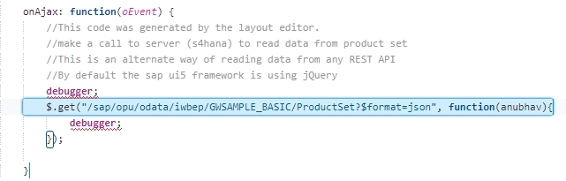

# What is the difference between $.get, $.post, $.ajax

$.get() and $.post() contain features that are subsets of $.ajax().

So $.ajax() is the method that provides the most flexibility of the three. You’ll see that the biggest difference from an implementation standpoint is that you pass an object to $.ajax(), which contains the necessary parameters. And as for $.get() and $.post(), here you pass in arguments. So you might say that $.get() and $.post() are both shorthand for $.ajax().

**$AJAX Call:**

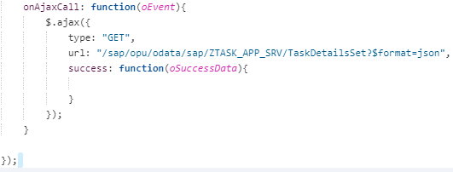

**$.get Call:**

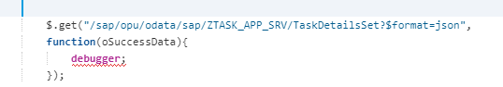

Basically, both are the same.

# How to get CSRF token in Ajax

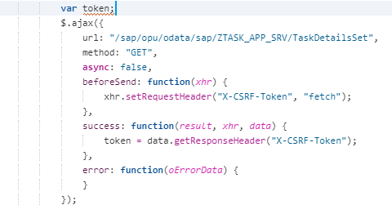

Or we can directly write get call.

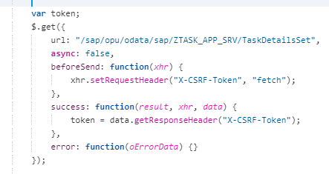

# Ajax Post Call in UI5

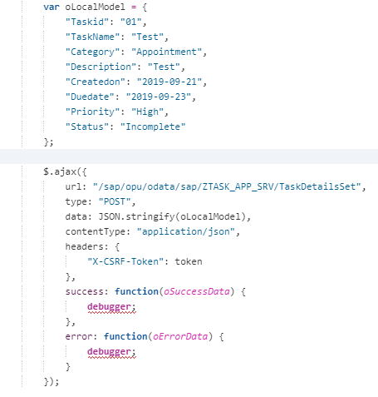

Or we can use directly use the Post call like below.

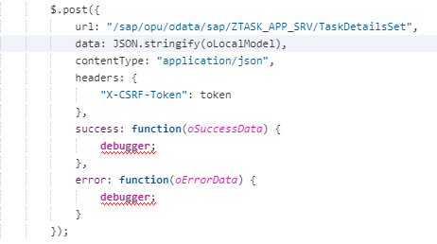

# Advantage and Disadvantage of Ajax

Let’s say we don’t have OData Model registered in **manifest.json** file but we want to call OData service that can be done by using ajax call.

This is the advantage of ajax call over OData model call.

But Ajax will be hard coded means we need to pass everything in ajax call like

**"/sap/opu/odata/sap/ZTASK_APP_SRV/TaskDetailsSet"** but in OData model we don’t need to pass everything system takes care of all like top, skip, filter, and the address (/sap/opu/odata/sap/ZTASK_APP_SRV).

# What is Node.js

Node JS is server-side JS language to implement the logic on server side. It can do what ABAP can do and it is asynchronous programming language. The below operations can be done through Node.js

* DB looking
* Send Email
* Generate Files
* Validate data
* Manipulation
* Another system comm.
* Call REST Services
* Schedule Jobs
* Generate Excel/files
* Read files from server

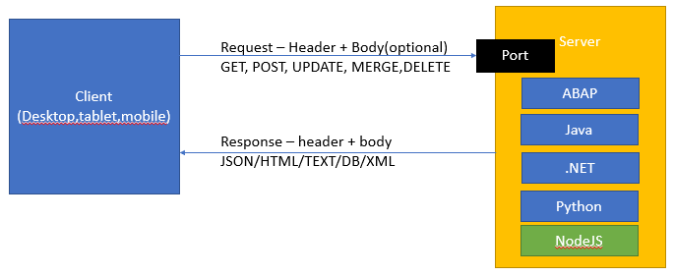

# Advantage of Node.js

1. No additional new programming knowledge required, whatever we have learnt (Java Script) in UI5 that is sufficient.
2. Consistent architecture
3. Open Source
4. BIG Eco system
5. Event Driven Non-Blocking IO, asynchronous processing
6. The deployment of node.js is cheaper in terms of cost

# Steps to Install Node js

Steps to build programs on node js

1. Install node js

<https://nodejs.org/en/download/>

1. Just install the node js and after that run command **node –v**
2. **If node command not working close the command prompt and add system variable with address where installed node js in Path variable**

C:\Program Files\nodejs

Develop Node js program – [ATOM.IO](https://atom.io/)

# Execute Node js program

To create node js program we need to first create a folder in our computer and then we will give this folder in atom tool after that we will go to cmd to execute the node js program.

All the files has to be .js extension.

To execute we will use the below command.

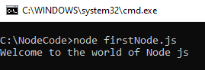

Here **C:\NodeCode** is the folder where our node js code resides.

# How to come out of infinite loop in Node.js

We will press ctrl+C to come out of infinite loop.

# How to install express

Express is a powerful webserver module, we can create a server using the express module.

When we want to get a reusable module from npm (Node Package Manager), we have 2 options

1. Download module for current project only
   1. npm install express
2. Download module globally, @ system level so all the projects can reuse it.
   1. npm install express -g

# How to import and export a file in Node.js

module.export is the syntax to export it so that it can be imported again in other file.

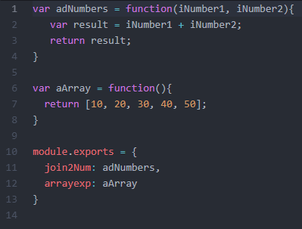

Here we have exported two method one is **adNumbers** and another is **aArray.**

**require** is the keyword to import any file in Node.js like we used sap.ui.define in UI5.

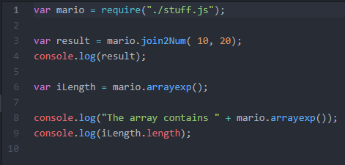

# How to configure server in Node

For server we have already installed express locally or globally. Now we will require the express so that we can create our own server.

Then we will use the variable and call the method **Get** and in that there is a function which will take request as a parameter and process the response parameter. And response.send() will be used to send the data hard coded or any text. Response.sendFile() will be used to send the file to the browser.

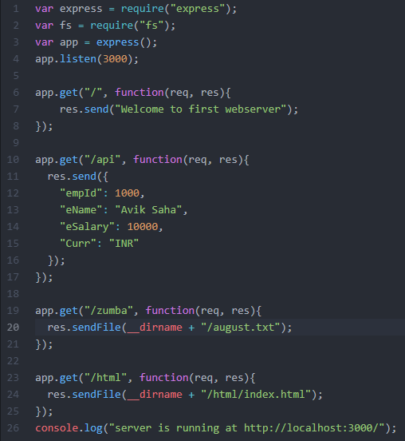

# __dirname in Node.js

__dirname will take the root folder here in node js, and we will use this variable and use letter folder and file name to make it use in **sendFile** function.

# Install Init

Let’s say we have developed a project and give it to another developer and we have installed 30 packages in that project. So, then that developer has to write **npm install <package_name>** and this is a big problem and for that we have a concept of **npm init.** Now while developing the project then we will give the **npm init** in the command prompt. It will create package json file automatically.

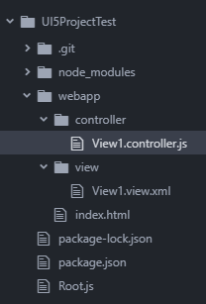

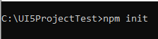

Then whenever we install any package we will use the syntax like **npm install <package_name> --save.**

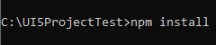

And this package will be registered in that **package.json** file, and next developer will get the project and he will give **npm install** and automatically it will install all the packages which are there in that **package.json** file.

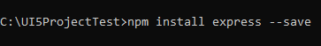

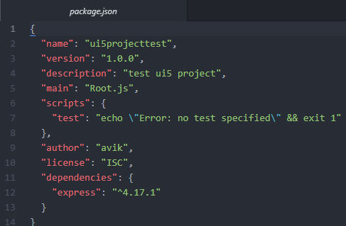

After that we don’t need to give **node filename.js** to execute the project. We will give only **node .** it will automatically execute the main file which is mentioned in the **package.json** file.

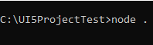

# Best Practice to create Node Project

When we need dependency in node application, we were adding them one by one. Now if we want to give the same project to another developer in my team, the developer needs to install dependencies also.

When we deliver a project, we want to know what is the name, purpose, version, author, year of the project. Metadata of the project is also needed for maintenance purpose in future.

We need to create a **package.json** file which contains all the dependencies of the entire project and the metadata of the project.

Download dependencies with save option to the **package.json**

**npm install** depName **–save**

***npm init*** will create a package.json file.

# Challenges in SAP UI5 app in terms of performance

In our UI5 project we have various amount of files like **manifest.json**, **controllers**, **views**, **formatters, fragments, component.js, models, i18n** etc.

1. In a typical UI5/Fiori App we have so many verities of files inside our project, when we start our app. All these files are downloaded from server to the browser. When browser downloads these files individually, it takes a while since they are pulled one by one. So total booting time of your app is equals to total time taken by all the files together. (our project took about 3,683 ms time -🡪 163 ms ). Sap says don’t load that many files instead of that create one file and load that and that one file is called **Component-preload.js** file. This is very powerful file it optimizes the performance.

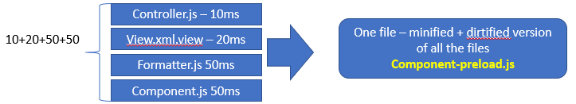

2. Anubhav when I run my project in sap Fiori Launchpad in my lpd, in console I get an error called **component-preload.js** is not available. Because sap ui5 framework is searching a for this file which has all the coda inside…

3. Each of the file has spaces, tabs, carriage returns which takes even more time to load files.

4. This component-preload.js file generally will be switched off in the URL at the time of development and it can be seen in the URL like **&sap-ui-xx-componentPreload=off.** Now if we remove this option from the URL then we can see the error called **component-preload.js** file not found.

 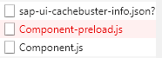

This file does the below things

1. Minify the content of our file.
2. Club all the files which you have together to build a single file.

# Task Runner App

A task runner is used to

* perform the repetitive tasks
* Capable of automating the manual steps for e.g. minify a file
* Create the build (packing your product) folder every time before de deploy
* Minification of resources (jquery.js 🡺 jquery-min.js)

# What are the types of task runner?

There are two ways to do minify and dirtify.

* Grunt
* Gulp

SAP uses the Grunt to do the minification.

Generally grunt can be done like below.

1. To be able to use the grunt, we have to use the grunt command line interface. GCLI allows us to run the grunt command.
2. Also add grunt to the local modules to use the grunt itself in your project as dev dependency

npm install grunt --save-dev

1. When the grunt command is executed the grunt is looking for a file name Gruntfile.js
2. A grunt file contains 3 things
   * Configuration
   * Plugin and task details
   * Registration of tasks

# Creation of Component-preload.js file

To generate Component-preload.js we have to create the **package.json** in the project folder.

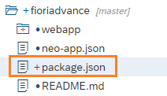

The code inside the **package.json** file will be like below.

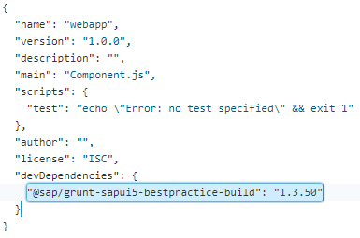

"@sap/grunt-sapui5-bestpractice-build": "1.3.50" is the actual npm package from SAP.

Then we need to create a **Gruntfile.js** file

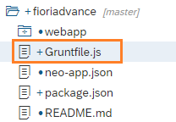

The code inside the **Gruntfile.js** will be like below.

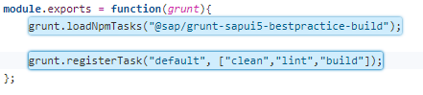

The **lint** one is for best practices and if we don’t follow the best practice then build will not be created, and it will throw error.

So, in those cases we will remove the **lint** from that.

The error will be like below.

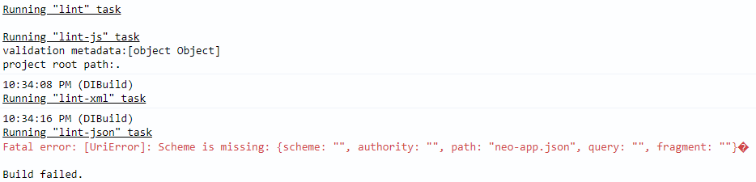

Then we will right click on the project folder and click on **Build** and click **Build Project.**

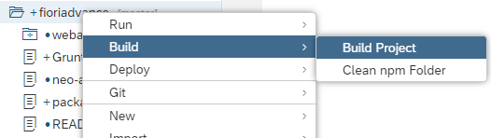

Now once build is completed successfully, we will have a new folder generated **dist.**

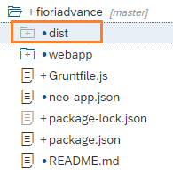

And we can see the **component-preload.js** file inside the dist folder.

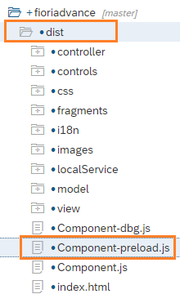

Now if we deploy the app and create the fiori launch pad and if we execute, we will not all the files loaded. But we can see the **Component-preload.js** file is been loaded.

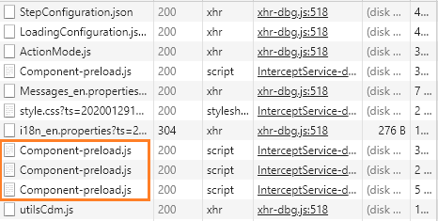

If we don’t create the **Gruntfile.js** then the **Build** option will not be visible in WEBIDE full stack.

# How to create a UI5 Project in from Node js in Atom

We need to create Root.js file (it can be any name) and then the below code has to be implemented in that.

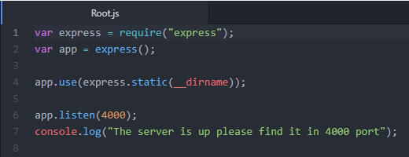

The project structure will look like below.

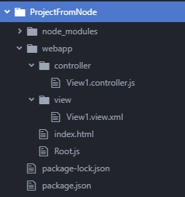

# What is UX (User Experience) and why do we need it

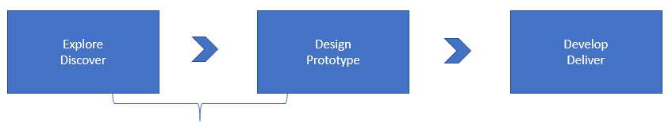

User experience is related to user’s mind-set and behaviours; however, the UI is about development/coding/frameworks in the development process.

**Why do we need it?**

The software should be usable without/minimal training.

UX Consultants are the candidates who understands the design principles of the UX, they know the colour combinations, themes, design patterns for UIs, frameworks, guidelines etc. Their main job responsibilities are

1. Understand/write user stories
2. Map the requirements to the solution
3. Create prototypes
4. Take feedback from business
5. Create a bridge between end users and development teams
6. Validate the development with the prototype
7. Apply UX principles/ design principles in the development to achieve best user experience.

# Terminologies in UX

User Story?

Consists of 4R – Role, Requirement, Reason, ROI

* Short and simple description of feature
* Describe the feature by keeping the role in centre
* Tells as a potential and/or existing user of a product/service – persona
* All the development action item (product backlog) in agile development
* The product backlog is a collection of user stories.

e.g. **I want to explore a holiday destination for adventurous sport**

Role – Persona – Traveller

The Requirement/Feature – User should be able to search holiday destinations based on category – spirituality, adventure, nature beauty, beach, jungle, safari…..

Reason – So that we can make good business, and user can find a destination out of millions of destinations offered

ROI – High

**What is an Epic?**

Epic is a big user story. A product backlog is a collection of epics (which can have sub items as small user stories).

**Acceptance Criteria**

When the user story is developed, the acceptance/rejection of a proposal of the solution is with product owner. Is also can be considered as a checklist for acceptance of development item.

Once you start working on a user story in the prototype phase, we need to depict the flow of screens to show case interactions between screens in order to fulfil the acceptance criteria.

## JIRA

JIRA tool is typically used in software world for planning and development. Here is where all the Epics/User Stories are kept.

There will be product/Release backlogs and from there the individual tasks will be assigned to the developers.

# Prototype

**Wireframe –** Screen and it is connected to another screen

**Prototype –** sample application with sample data to realize the user story with user journey. A prototype is created as a collection of the wireframes. Directly associated with the design of a solution with mock data. This helps us to get the early feedback from our business and fulfil the gaps.

[**Build.me**](https://www.build.me/) is the standard tool for creating SAP Fiori prototypes easy.

Example: Design a prototype for purchasing of toys.

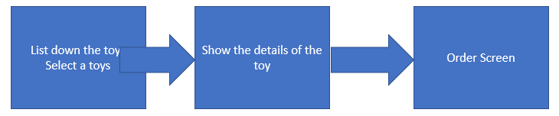

A person who doesn’t have knowledge on Fiori he can click image and create his own prototype.

# FIORI 3 3 1 Formula

FIORI runs on 3 3 1 rule means

* 3 screens.
* 3 user steps.
* 1 application.

# How to import project from Build to WEBIDE?

Now there is an option, that we can directly import the project from Build tool. To do that we need 4 destinations please find them below.

* BUILD_Production
* Web_IDE_PLUGIN
* sapui5-private-build
* sapui5-private

If we go to the services section, we will find one service called **SAP Build,** once it’s enabled the first two destinations will be enabled and the other two will be added manually.

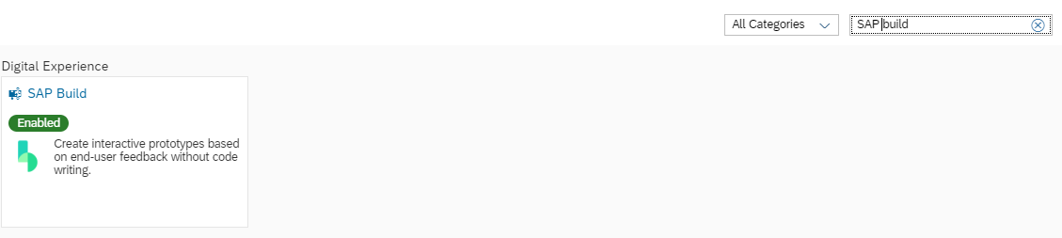

Please find the other two find them below.

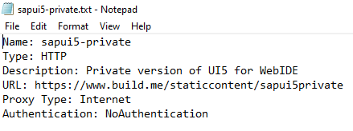

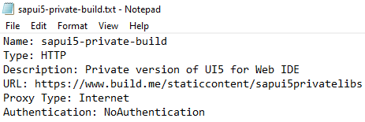

And then after that we need to go to the preference section and add some extension.

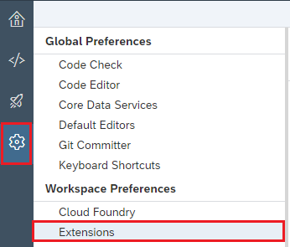

Then there is an extension called **Import Prototype from Build,** that needs to be enabled.

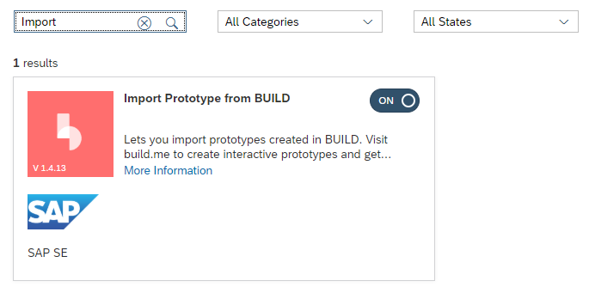

This is it all about configuration and now we can create the project. New template will be added in the template section.

# What is FIORI Launchpad

SAP Fiori Launchpad is the single-entry point for all our Fiori apps. All the apps are displayed as a tile in Fiori app.

Advantages:

1. Launchpad provides a logon page
2. Coherent experience
3. Consistent theming experience
4. Role based – Fiori Security (Groups, Catalog, Roles)
5. Fiori Features 2.0 – Personalization, Context Search, Co-piolet
6. Personalization – theme, app finder, date/time formats, default values
7. Fiori 3 – conversational UI, fiori_3

***Fiori-like app –*** Is an app which has Component.js

Launchpad technically is a **shell control** and this shell control contains a **component container** and Component container is the holder for **Component.js** file. So, every application which wants to be in FIORI launchpad they have to have mandatorily Component.js file. Basically, when we clicked on the tile in FIORI launchpad it looks for the Component.js file for that namespace and once it finds that it will load that component.js file in the Component container, and when we will press the back button it will unload the component.js file from component container. The library which is used to create the shell control is **ushell** library.

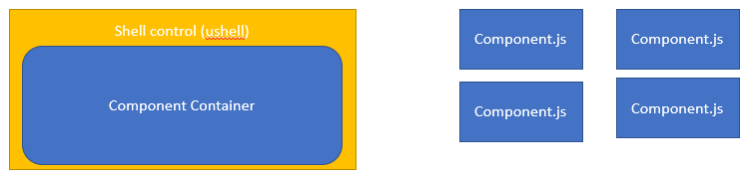

# SAP Fiori Launchpad SANDBOX

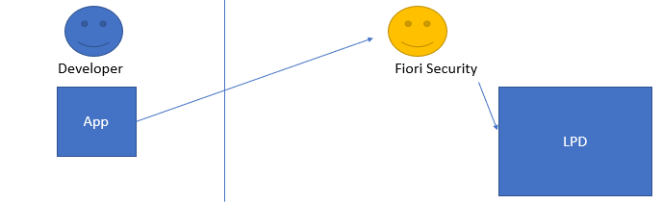

As a UI Developer, the company wants us to deliver the application faster. However, our application is dependent on other factors like SAP UI5 version, configuration, dependencies, loading of right components, app coding, security config….

1. These dependencies and availability of the GW system. The design of our application is not a Fiori-like app it is obvious that our app is not going to work with Launchpad. Even sometimes, we had put component js we cannot be sure that it will work after deployment with Launchpad.
2. Let’s say it didn’t work, now it is difficult to gaze where is the issue.
3. We want to make sure, before even we ship the app, that our app is robust enough to fit with Launchpad.
4. We want to give same look and feel as like standard Fiori apps before even delivery.

For this reason, we have SAP FIORI launchpad sandbox which is given by SAP.

# Configure SAP launchpad SANDBOX

1. Bootstrap sap test-resource to load Launchpad sandbox API
2. We need to set a global configuration which will be read by the sandbox API to launch the launchpad in local system and add our app to the same
3. Instead of launching the app directly, we need to now load the sandbox (so called renderer) inside the body of dom.

Fiori Launchpad always use intent base navigation. An intent is made up to 2 things

1. Semantic object
2. Action

For example, if we wish to load an app related to sales order the same object will be SalesOrder

And action will be the purpose of the app like create, read, manage, lookup etc…

#SalesOrder-manage

#Purchasing-lookup

**Intent = SemanticObject + “-” + actionName**

To execute our app in launchpad sandbox we need to do some configuration.

1. We will copy our **index.html** file in to a **testFLPService.html** that in test folder.

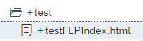

1. Then in that we need to add one by one configuration. Bootstrap sap test-resource to load Launchpad sandbox API.

**<script src="/test-resources/sap/ushell/bootstrap/sandbox.js"></script>**

1. Now we will write a global configuration in the script

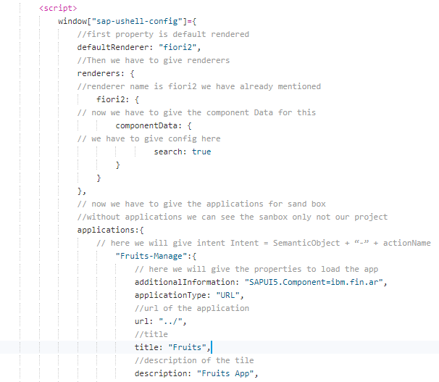

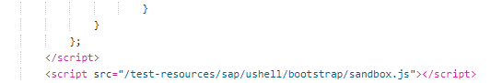

1. Then we need to add the sandbox object to my div.

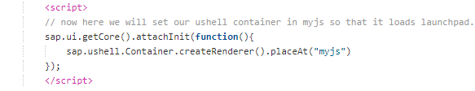

# Mock Server

**Challenges with OData:**

1. Our real time apps are coupled with OData services, at times when the service is down, the whole app is down, since we are the front-end developer, everyone will question us.
2. At times we are out of office and because of n/w/system issue, the app doesn’t work and that is also pointed on UI.
3. At times the OData itself is not ready (under development), so we cannot start working with the Fiori app development.
4. I am as a freelancer consultant in SAP Fiori, w/o having the backend access, I need to create Fiori app.

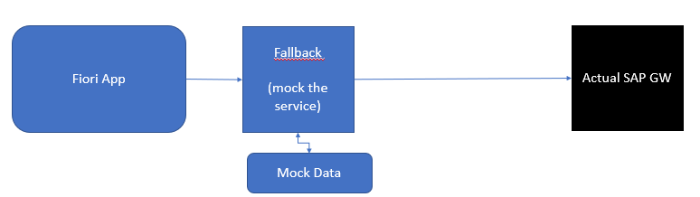

This **fall-back** mechanism is called **mock server.** The only pre-requisite to implement the mock server is to use the metadata.xml of the service. This can be created manually, by a sandbox, can be downloaded from [API hub](https://api.sap.com/).

# Steps to create Mock Server

First, we will create a folder called **localService** (though it will be created automatically). And in side that folder we will create two files

1. Metadata.xml
2. mockServer.js file.

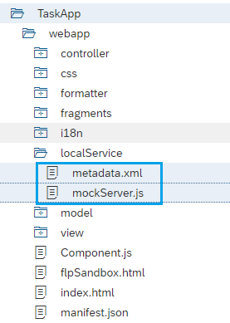

The we will generate the **mockdata** to do so we will right click on the metadata.xml file and select **Edit Mock Data** option.

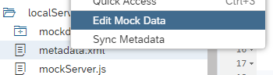

And there we will select **Generate Random Data** button to generate data and once we click on that it will generate some mock data like below and we can edit the mas well.

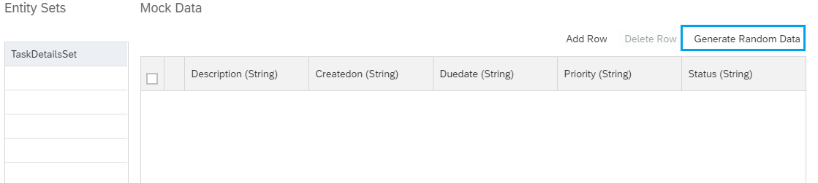

After generate:

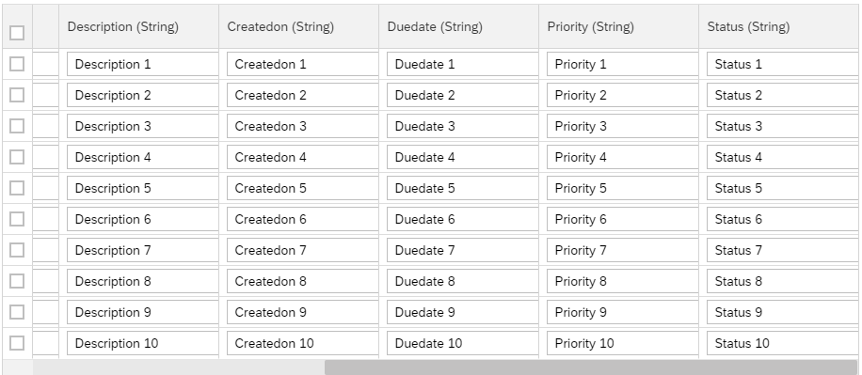

Now if we press on then there will be one folder created in the name of **mockdata** and inside that there will be a json file with these mock data.

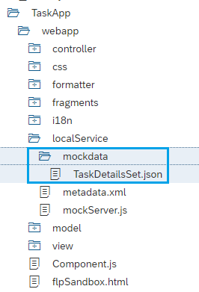

Now we will start coding for these mock servers in **mockServer.js** file and coding will have below steps.

* Create initialize (init) method.

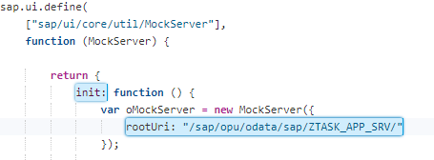

* Give the configuration in **MockServer.config** method

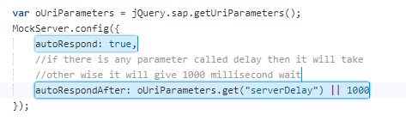

* We need to specify what is the type of data and where mock data is kept using **simulate** method.

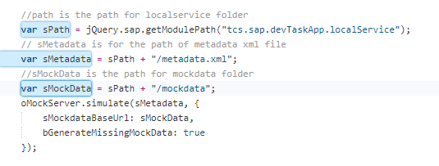

* Then we need to start the mock server using **start** method.



* Then we will call this **init** method from any of the HTML file like index.html or flpLaunchpad.html file using scaffolding template so that we can see the mock data on the screen.

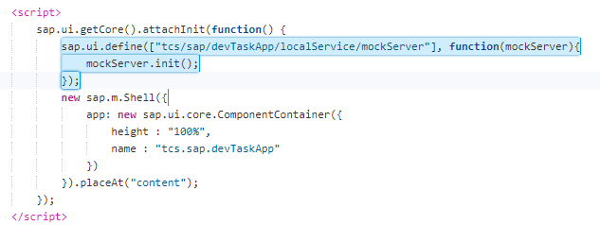

* Below is the entire code for mockserver.js file.

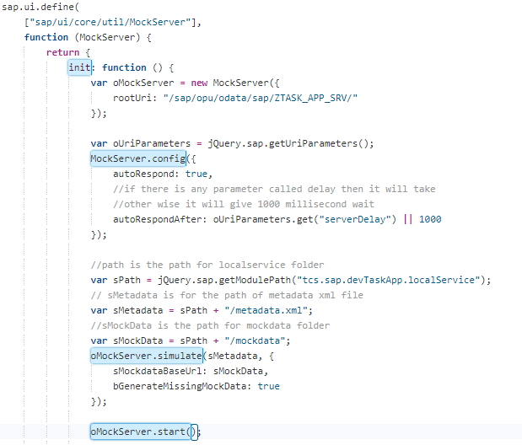

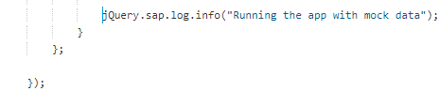

# Steps To create Mock Server

* First Create a folder called **localService** (though that will be created automatically).

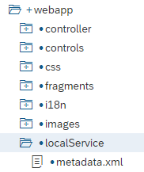

* Then create **metadata.xml** inside that folder.

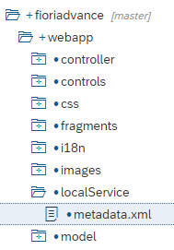

* Create a new file **mockserver.js** in that folder, we have to follow below steps in the js file.

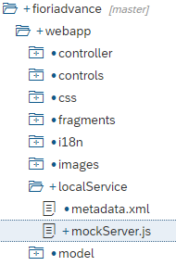

* + Create initialize (init) method.

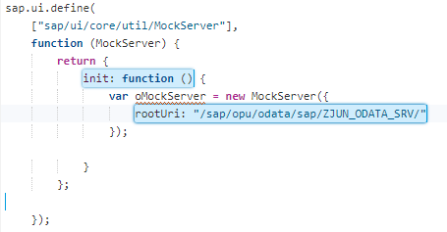

* + Give the configuration in **MockServer.config** method

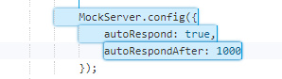

* + We need to specify what is the type of data and where mock data is kept using **simulate** method.

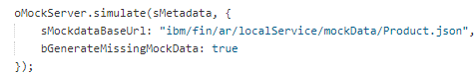

* + Then we need to start the mock server using **start** method.



* + Then in the sandbox html file we need to call this file and start this.

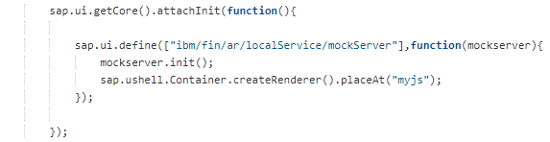

The final code for mock server is

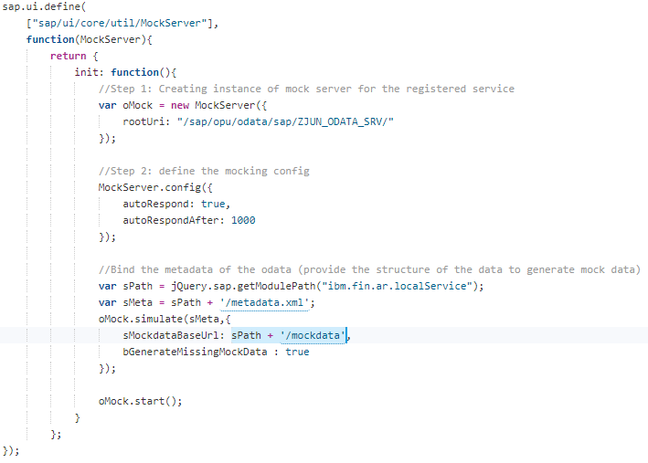

# Test Pyramid

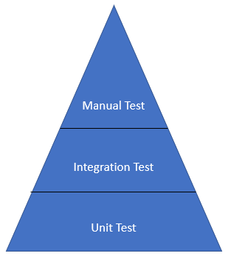

# Quality of FIORI Apps

**Regression defect:** something which was working yesterday (last release, last patch) has to work in the current release/current version, if it is not it is called regression defect.

In software industry, we have test pyramid to cater highest quality software. Defect leakage is reduced by implementing the tests at different levels.

**Test Strategy**

The entire application is built with multiple modules which is broken down into pieces (methods), joining all these modules becomes your software/main functionality. As a developer, we believe in robust programming, that means whenever we make a code change, we want to make sure that it does not disrupt our/other functionality.

This approach of keeping the use cases in mind and implement the tests even before the development is called **Test Driven Development.** There are 2 types of tests which are owned by Developers.

**Unit Test –** targets one smallest piece of software (methods of a module) e.g. formatter.js -- **Qunit**

**Integration Test-** Used to test cross-module integration. In SAP UI5 contexts are more journey oriented which spans across multiple modules (formatter, controller, view etc) – **OPA5 (One Page Acceptance Test)**

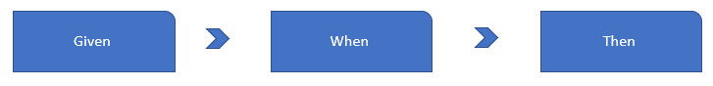

# QUnit Steps

To do QUnit test we have to generate a folder called **test** and inside that we will have 3 files

* AllTests.js: Basically, this will call all the test files.
* unitTests.qunit.js: This will call the **Alltests.js** file
* unitTests.qunit.html: This HTML file will have all the boot strap of QUnit and will call the **unitTests.qunit.js** file

Inside the **test** all the files and folders as it is in **webapp** folder. Like Controller, View etc.

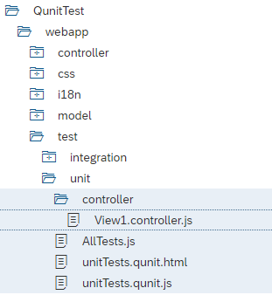

**AllTests.js:**

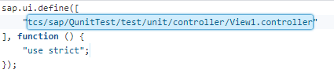

**unitTests.qunit.js:**

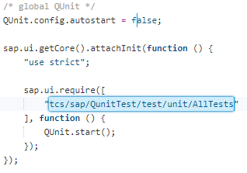

**unitTests.qunit.html:**

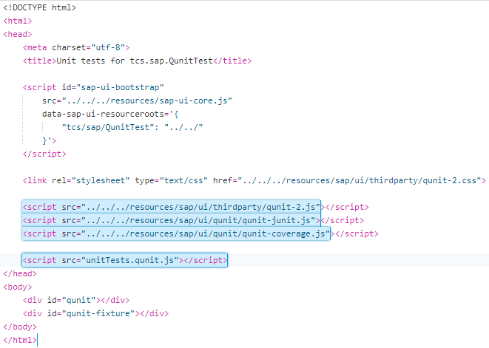

This bootstrap can be found in UI5 SDK also. So, now we will create all the files which we need to test inside the **test** like as the folder structure and create the respective file. And start writing the tests.

Once bootstrap is done system will return a gloab lobject called **QUnit** and it can be used everywhere in the project.

* **QUnit.module(“Something”):** Will create the module in the UI let’s say we have 50 files and we don’t want to test all the files at a time and we need to execute only one file at this moment using the module we can filter them and execute.
* **QUnit.test(“Test_Name”, function(assert){}):** We will use the test method to test our files. Once we call test method of QUnit object it will return a **assert** object and we use that object for further testing.
* **Assert.ok():** if assert.ok is true then it will show positive result in the screen and if it is false then it will show negative result on the screen.

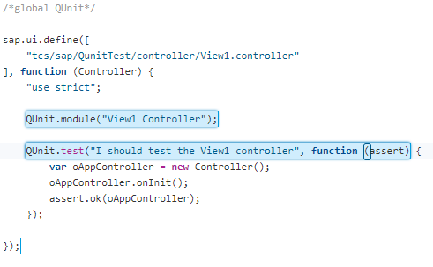

Module can be seen on the screen like below:

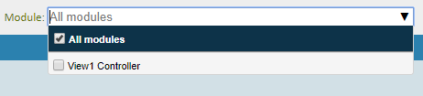

**QUnit Fundamentals:**

1. Qunit must be started after all your modules are loaded
2. Resolve the path of webapp directory properly
3. Modularize your files as per the files under test
4. There has to be proper orchestration between the files

All the documentation for [QUnit](http://qunitjs.com/) can be found in <http://qunitjs.com/>

We have created some test for our formatter file, please find them below.

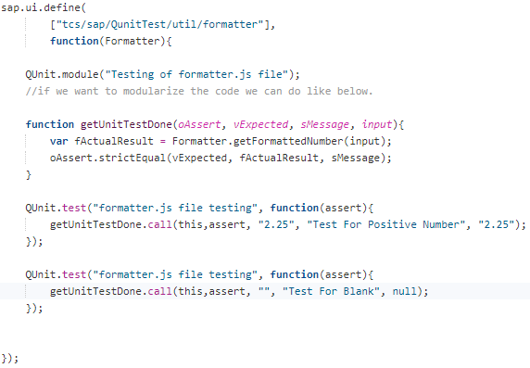

After result we can click on the **Enable Coverage** check box option to see the overall test coverages and it will be called golden project if we have coverage of 80%.

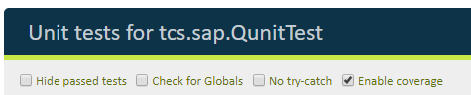

The **Blanket.js** file the behind file who creates the coverage.

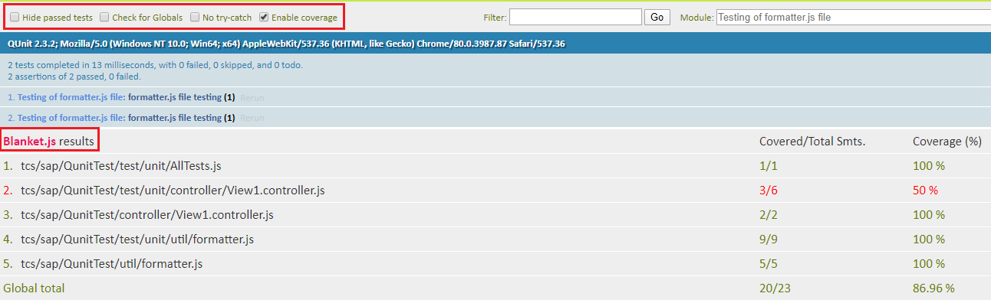

# OPA5 Test

OPA5 stands for One Page Acceptance Test

We use OPA 5 in a UI5 project to perform integration test, The main purpose of integration test is to check the inter-module integrations are working fine. In relation to UX Concept, the integration tests are used to test ***user journey.***

Given 🡪 When 🡪 Then

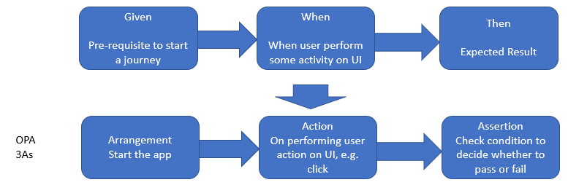

**Mandatory Fundamentals of OPA5:**

* It is mandatory to assign ID to your element/views to conduct an OPA5 test on an application.
* When we move more above in test pyramid towards the E2E tests, we use frameworks like selenium to perform the automated tests. For a stable test automation of an application it is recommended to have ids assigned to our controls.

# Class and Methods for OPA5

The important class for OPA5 is **sap.ui.test.Opa5.**

|  |  |
| --- | --- |
| **Class/Method** | **Descriptions** |
| **extendConfig** | Register all the arrangements, actions, assertions with opa5 framework |
| **waitFor** | Automatically wait for 15 seconds before it performs action or assertion  Yes, while giving the initial config we can increase this wait time |
| **iStartMyAppInAFrame** | Starts our app inside the opa5 page in an iframe |
| **sap.ui.test.matchers.PropertyStrictEquals** | Performing assertion to check if expected vs actual is matching. |

# Steps to Create OPA5 Tests

1. Make sure your app is working fine either with index.html or with Component.js
2. Create an OPA test html page with bootstrapping of SAP UI5+Qunit
3. Ask Qunit for not start immediately and start after the attachInit is triggered 🡪 Qunit.config.autostart=false
4. Create a JS File to write all the tests, in this file we add following
   1. Create Arrangements, Actions, Assertions
   2. Register the These 3As to the OPA Config Class
   3. Create and Run the testcases of OPA – Implementation of User Journey
5. Call the journey with opa test html page using scaffolding

# Simple Button example of Button click test

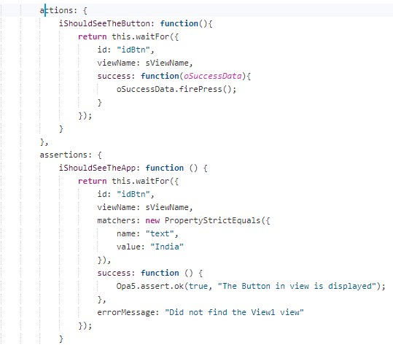

# OPA5 search options example

OPA Page:

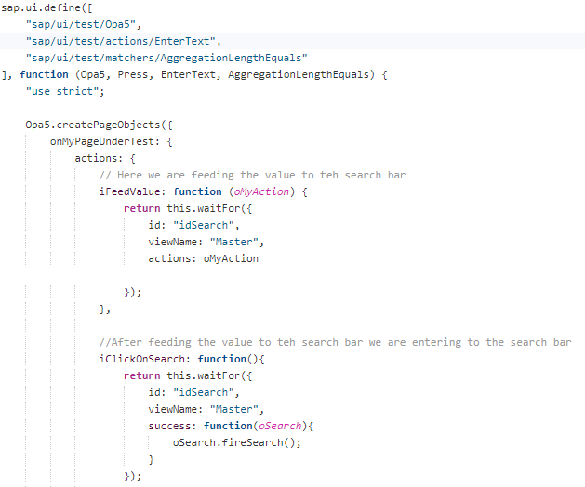

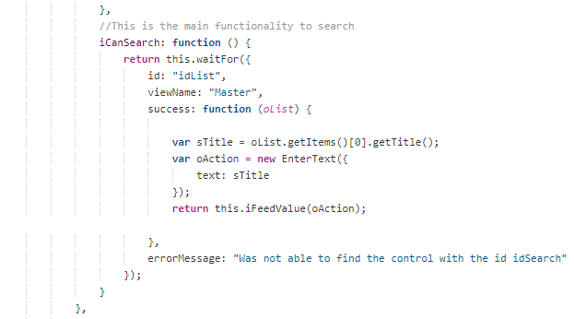

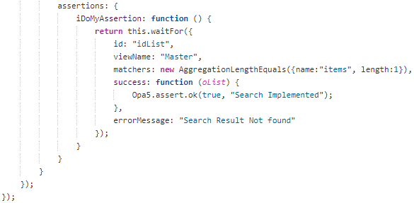

Navigation Page:

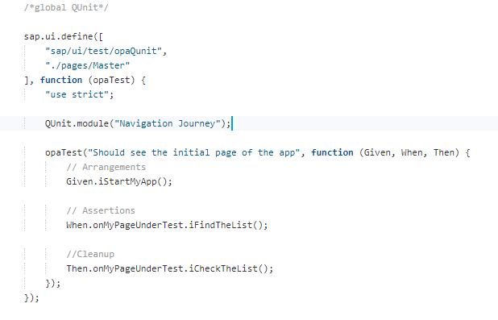

# CI/CD Continuous Integration/ Continuous Delivery – DevOps

Jenkins Server which is popular in industry to create a job. Automates something.

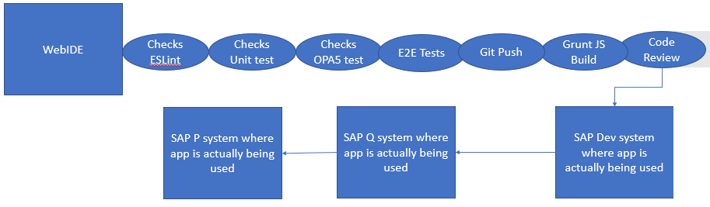

# Steps to Create OPA5 Test in SAP WEBIDE

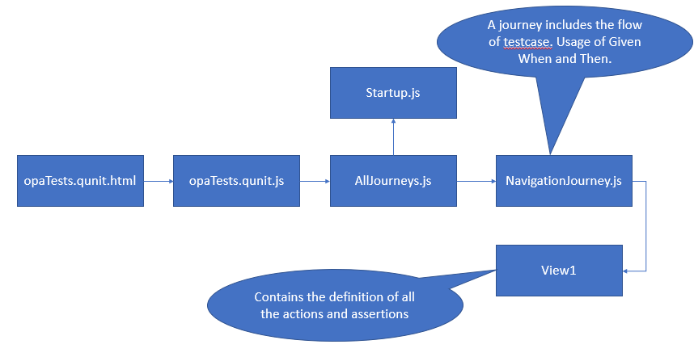

OPA Page will have only the assertion and actions, and the journey will have all the test cases and the start-up file will have the given means arrangements. OPA5 is not only checking the test cases which we are writing in the JS file but it will explicitly check the console errors as well.

# SAP Fiori Evolution

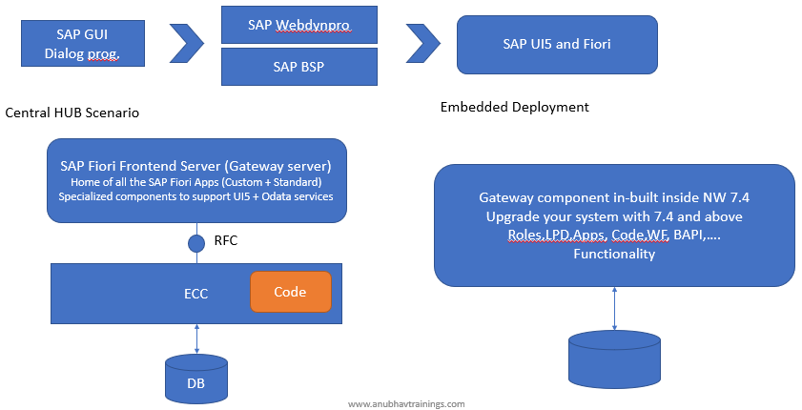

# Central HUB vs Embedded deployment.

**Central HUB Deployment**

**Pros:**

* Innovation w/o disruption
* Connect to multiple backend systems at same time – [Multi-Origin scenario](https://www.youtube.com/watch?v=wFH52FMJ1nI)
* Clear responsibility

FES – All the Fiori administration/Security will take place

ECC – Current on-going development

**Cons:**

* Some Fiori developers gets confused, where can they deploy, find, extend standard Fiori apps, where to develop service implementation and service registration
* Cost is high in terms of system budget, resource, user maintenance
* When it comes to OData services, the metadata will be duplicated

**Embedded Deployment**

**Pros:**

* Cost saving
* No need to create/maintain multiple RFC destinations
* No metadata redundancy
* No confusion for developers
* You can go for multi origin functionality

**Cons:**

* During the installation/upgrade if something goes wrong, it affects everyone
* System scalability will be a challenge as we need more memory and resources to manage the services/Fiori apps.

# Component to Check in System

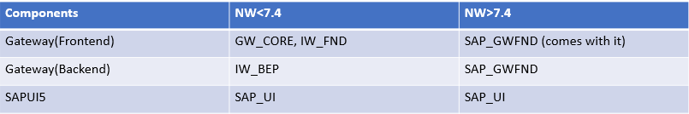

# How to check if the system is ready for OData Development

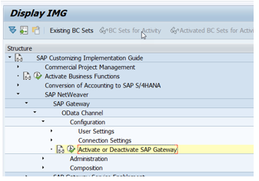

# Types of Fiori Apps

Three types of Fiori apps present, they are mentioned below

1. Transactional App
2. Analytical App
3. Smart Filter Apps/Factsheet Apps

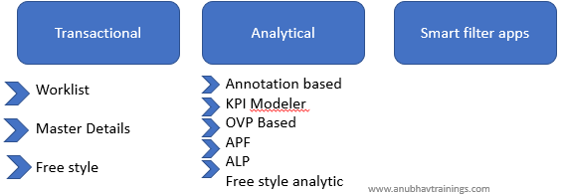

# Where will your Fiori app get deployed?

Front-end server.

# As what object type it created?

BSP Application, which means SAP Standard Apps are also shipped as BSP application.

# Basics on FIORI App library

The Fiori app library link is <https://fioriappslibrary.hana.ondemand.com/sap/fix/externalViewer/>.

There we can find all the apps which are developed and delivered by SAP with one Unique FIORI ID.

Once we filter the App, we can open the app in that library.

* In the below section it will show this app supported by only cloud or S4 HANA on premise as well.

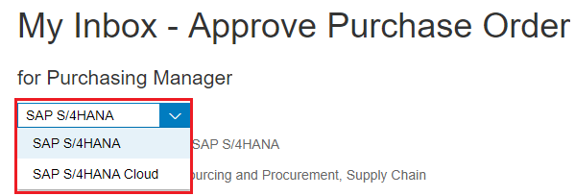

* Below section will show the details about the app and which version will support this app and what is the app id means FIORI id for this.

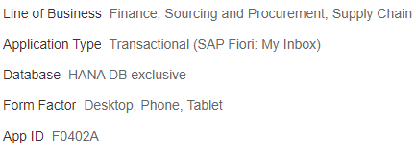

* Then if we go to the **Implementation Information** tab then we can find the Support packs what it supports.

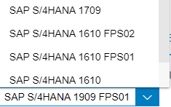

* Then in the front-end component section we can find the software component version is needed to install this app.

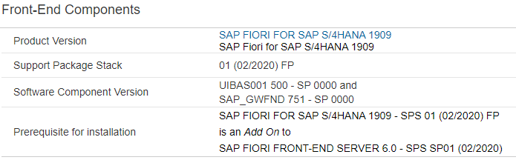

* Then in the back-end section we can find the SAP version to install the OData services.

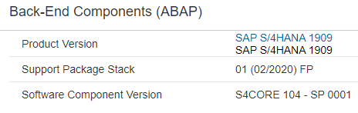

* Then in the Configuration section we will have all the necessary OData services name for this service, roles needed to access this app, Business catalogue information so on. The SAPUI5 Application name is the BSP application which can be found in se80 transaction code.

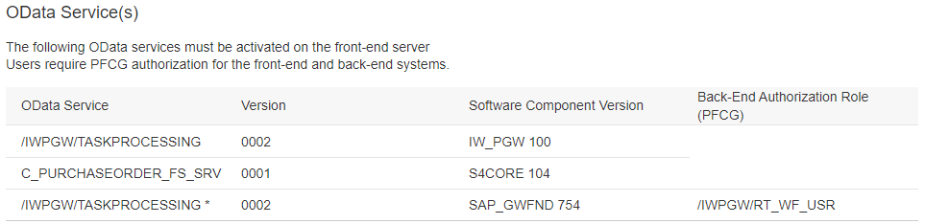

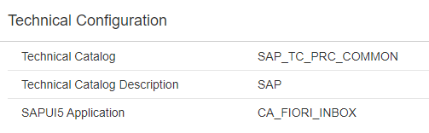

# Fiori App Installation Guide

* Fiori App reference library and find the apps which needs to be installed, check and aggregate them
* Cross-check the aggregated result and required setup options
* Use SAP Fiori Maintenance planner tool to be launched from App ref. library to install/upgrade the system

**Pre-requisite: You must have a valid P user or S User id**.

SOLMAN has retired on 9th Jan 2017, the successor of in the cloud is SAP Fiori Maintenance Planner tool, which is used for

* Consolidated Planning – It provides us a file called **stack.xml** which contains the list of components and their dependencies to install Fiori apps.
* All the necessary files are automatically pushed to download basket and will be downloaded from service market place
* You will also get multiple deployment options

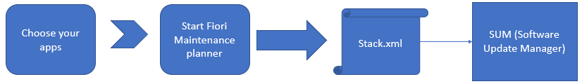

Will see the steps to install the Fiori app.

[Click here](https://www.youtube.com/watch?v=I2azTzV5P70&feature=youtu.be)

Link to maintenance planner: <https://apps.support.sap.com/sap(bD1lbiZjPTAwMQ==)/support/mp/index.html>

Use your S user to login

The view looks like below

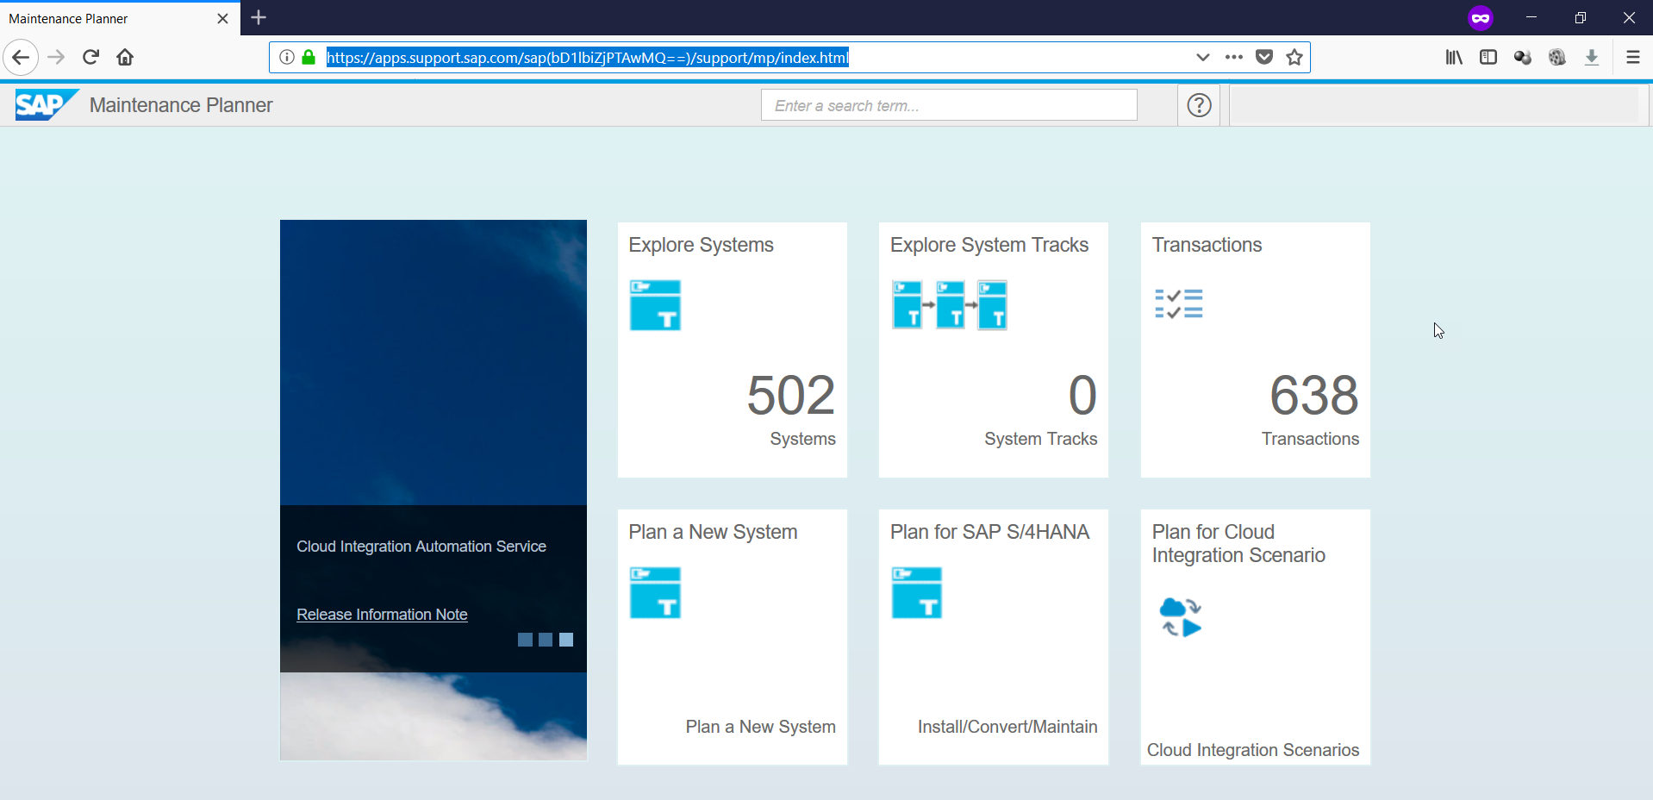

* Go to Fiori App Reference library and select the app (Check the selected apps). Aggregate Apps based on need

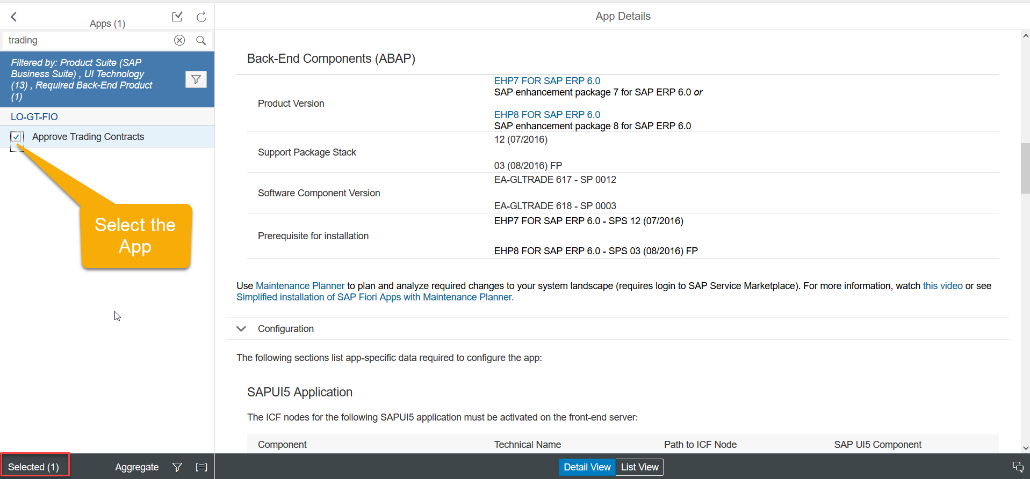

* Aggregated view of all selected apps, and click on Prepare apps for planning with MP button

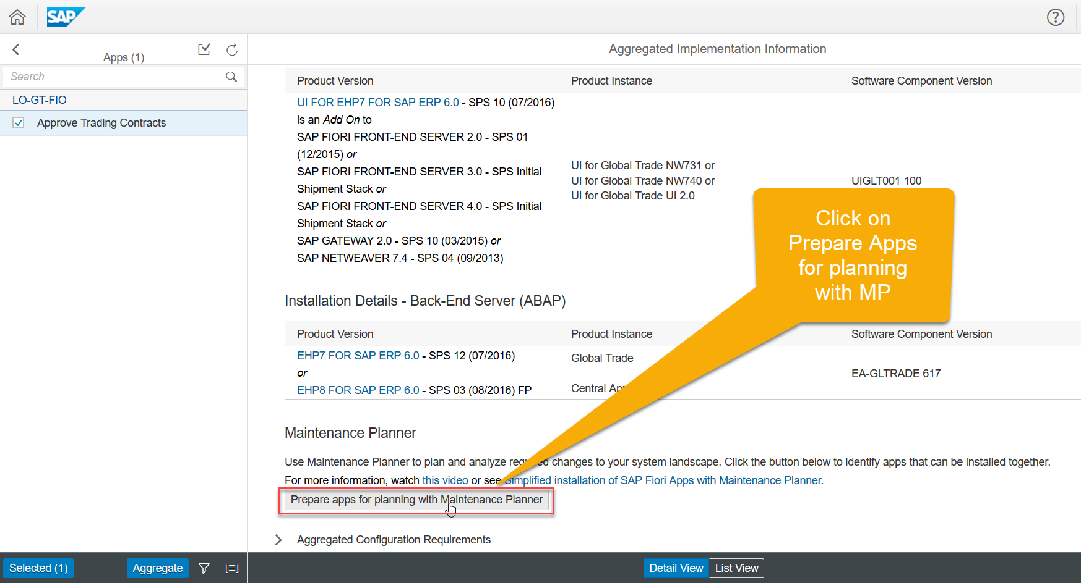

* Click on Plan with Maintenance planner, System will launch maintenance planner in Another tab

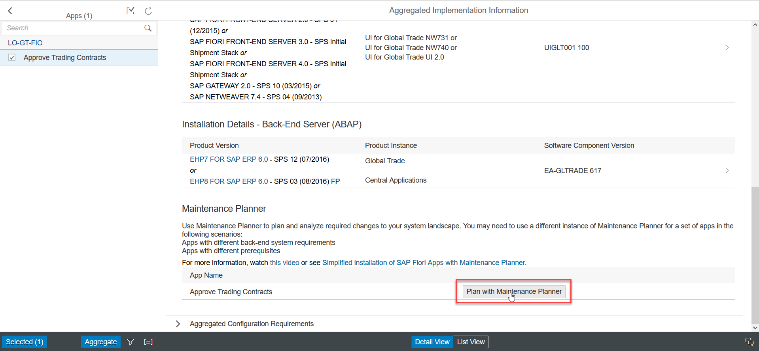

* This is an overview of the server to be installed of backed and frontend system. More like pre-requisite for installing the Fiori app(s). Click on **Next**

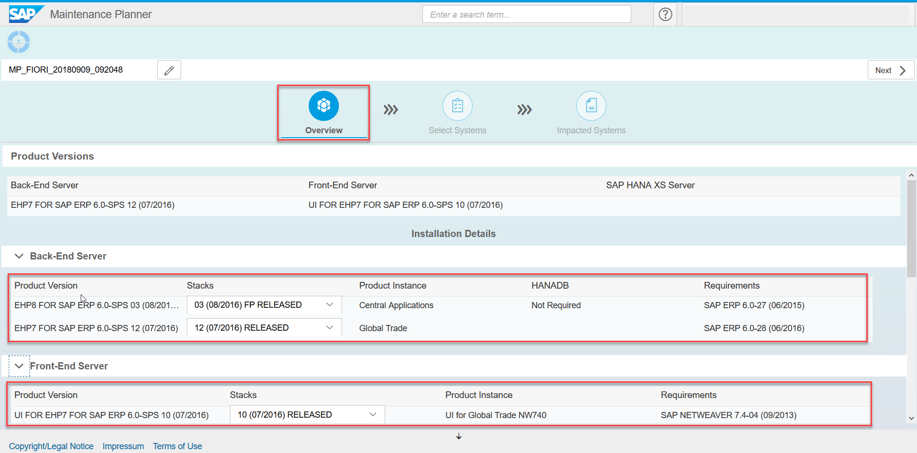

* Select System for Installation. Choose your backend and frontend system where installation should take place. You can decide also if it is a fresh installation. Choose **Next.**

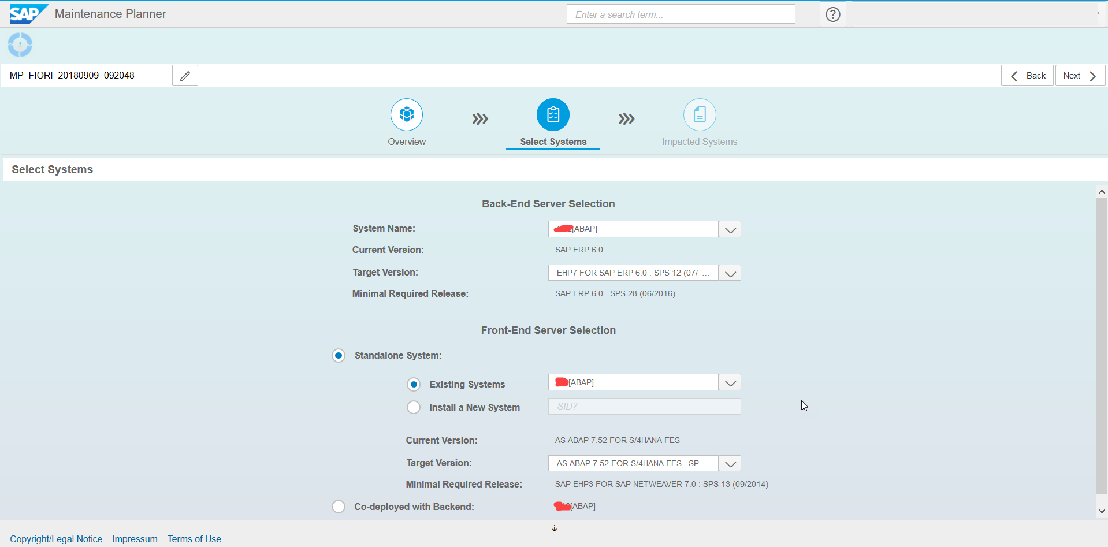

* Impact of installation. It will inform us; which software's will be installed and which one will be upgraded. Choose **Next.**

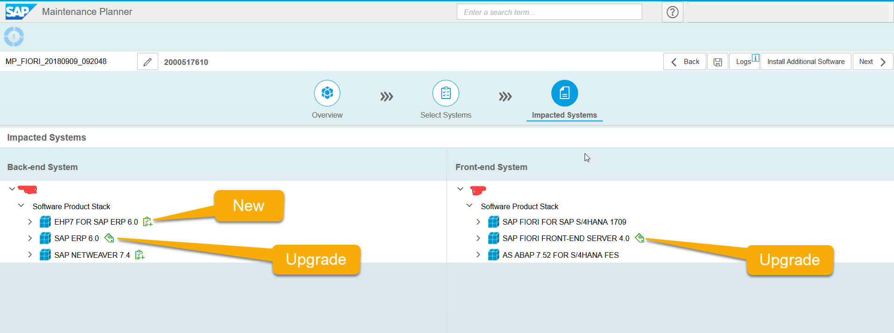

* Selection for files to be downloaded. System provides an overview for files which needs to be downloaded for both frontend and backend. Choose **Confirm Selection.**

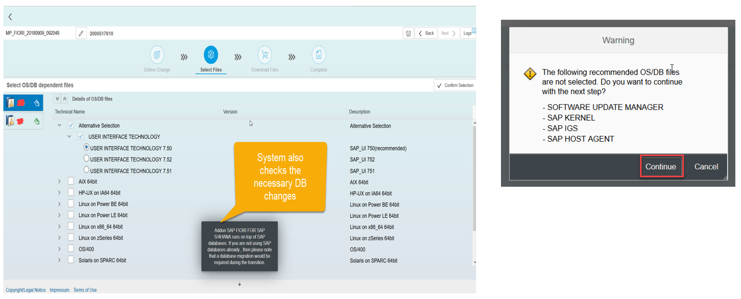

* Review the selected Software components to be downloaded. Below example some important components highlighted. Choose **Next.**

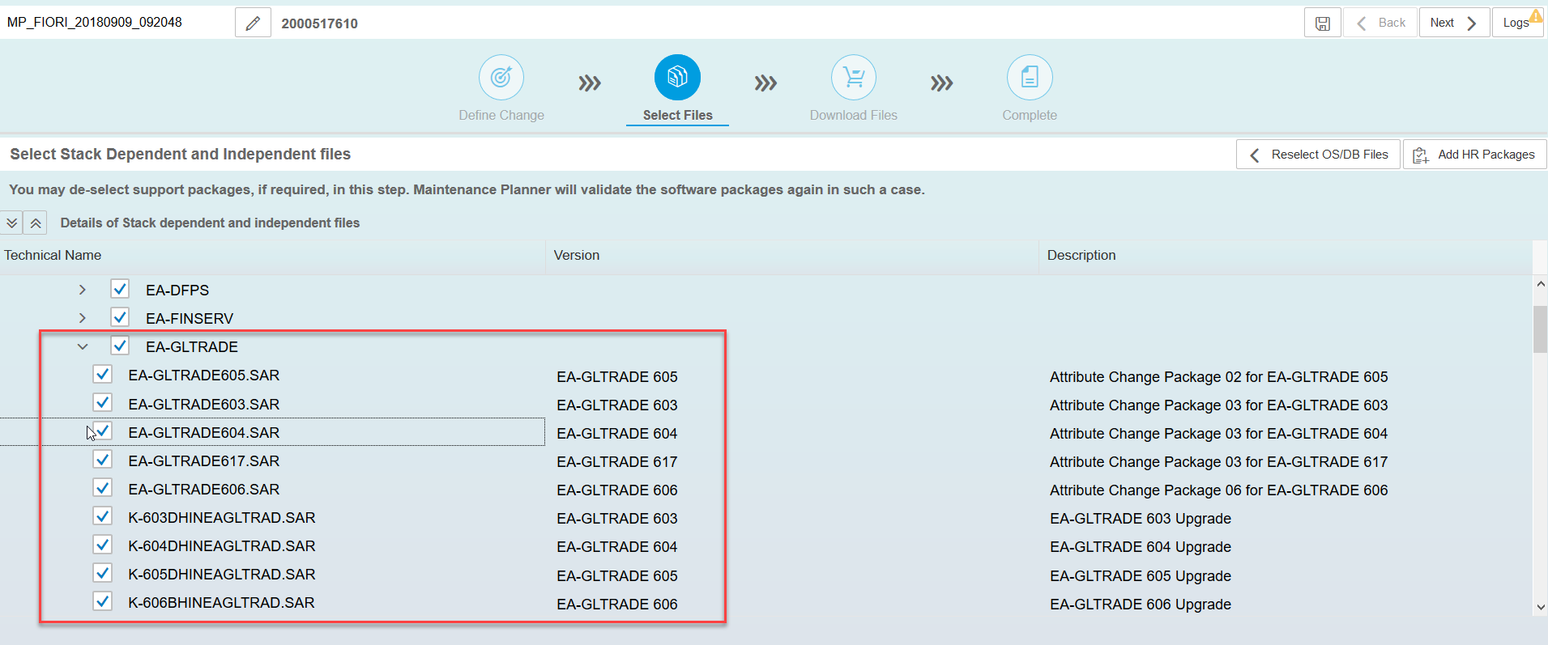

* Download Stack.xml file for final installation or click on next to download other things in system. Choose **Next.**

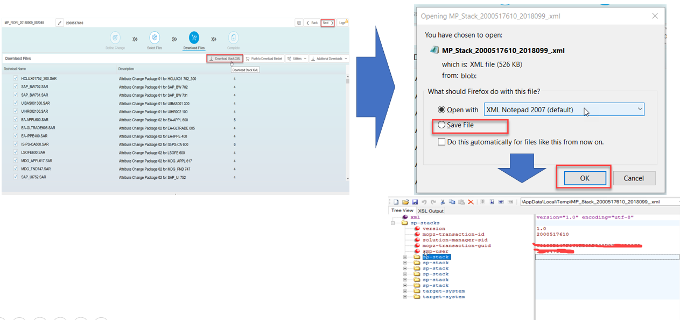

* Maintenance planner shows report of new backend system and frontend system package as below.

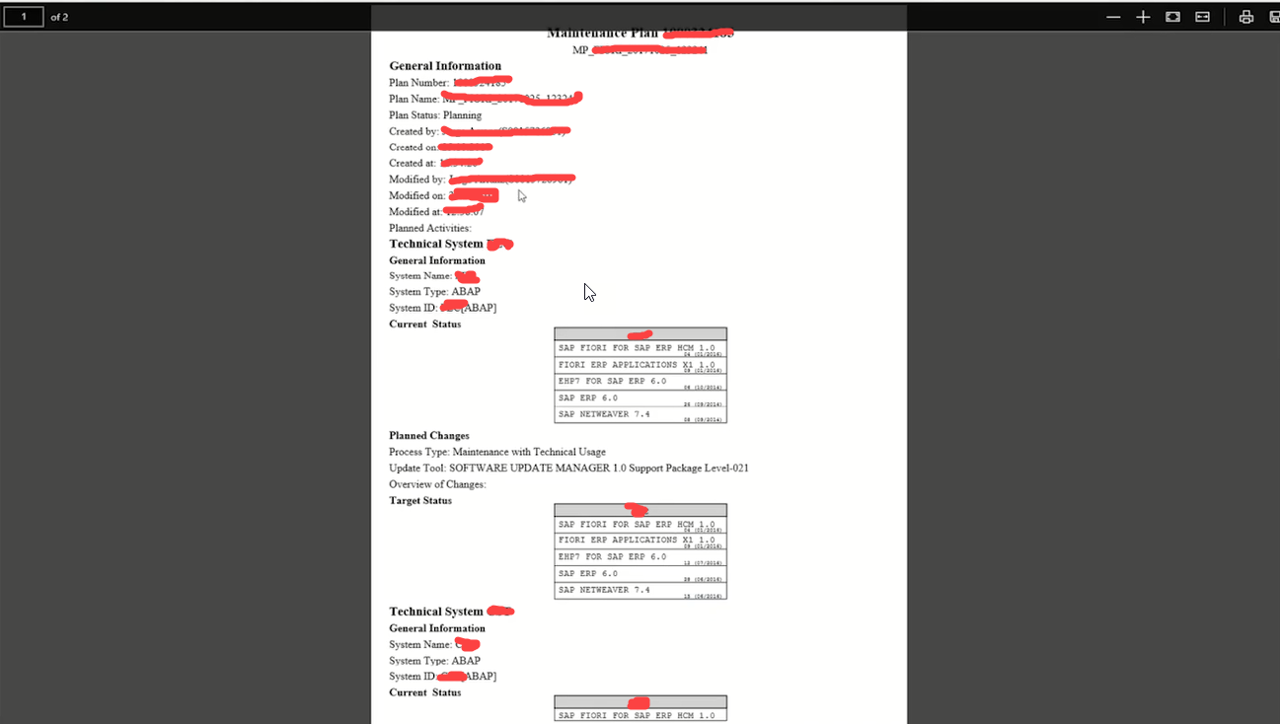

* Then we use SUM tool to upload the stack.xml file and install the same. Below link will demonstrate the same.

<https://blogs.sap.com/2012/03/16/sap-software-update-manager-tool-sps-update-demo-part-i/>

<https://blogs.sap.com/2015/07/15/support-pack-stack-upgrade-using-sum-solution-update-manager/>

# SAP Release

S4 version always denoted by YYMM so version 1909 means 2019 Sept.

# What is FIORI Launchpad

SAP Fiori Launchpad is a single-entry point for all the Fiori Applications (Standard + Custom). Real-time, context enabled, role based, and personalized aggregation point for business application.

Launchpad takes care of Authentication as well (with all SAP system users).

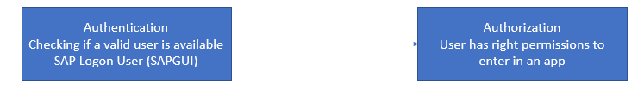

* Users will not even see the apps which are not in their context
* Simple to user
* Responsive
* Role Based (EVEN TO ACCESS LPD ITSELF we need role)
* Fully supports Fiori, Visually harmonized Webdynpro + HTMLGUI
* Branding = Theme Designer

Direct Link Transaction Code for Fiori Launchpad: (/n/UI2/FLP)

**NW 7.5 =** https://<host>:<port>/sap/bc/ui2/flp/FioriLaunchpad.html

**NW 7.4 =** https://<host>:<port>/sap/bc/ui5_ui5/ui2/ushell/shells/abap/FioriLaunchpad.html

# What is Cache Buster?

Every time we open the launchpad, browser has to load all the files from the server. And every browser has some small amount of memory and in that they store all the information about the details so that every time if we open the launchpad it doesn’t need to go to server again. This memory is called Cache/Cookie.

Now if there is any change on the role then browser has to know about that otherwise it will load the old data which is stored in the cache memory. For that before opening the launchpad every time browser is asking server is there any change and if there is any change then server is sending one token back to the browser and this token is called **Cache-Buster,** we don’t need to do any implementation for this just we need to use the right URL which has this feature. And on 7.5 onwards SAP has already the Cache Buster feature in it.

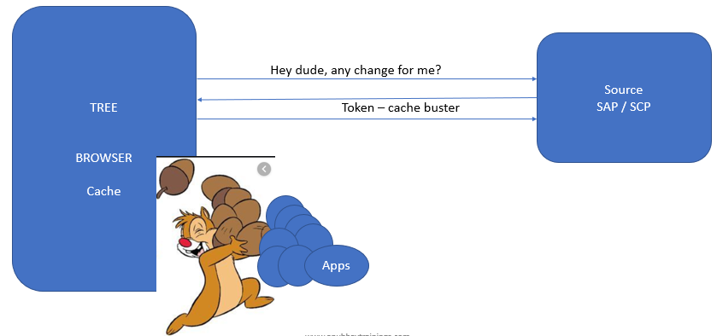

# How to get started with Launchpad – End user/Business User

1. Create a new user
2. When we login with the SAP User, User can’t access anything, the reason is that the does not have the right authorization to access SAP Fiori Launchpad. Error: **Failure - Unable to load groups**
3. **As an administrator, create a role which provides access to INTEROP service, the INTEROP service is used by launchpad for navigation. Service name is /UI2/INTEROP**
4. For the end user access to SAP Fiori Launchpad, we need following services to be activated and then a role needs to be assigned to the user who wish to use LPD.

* **PAGE_BUILDER_PERS – Fiori Launchpad to load Catalog (Catalog is collection of apps)**
* **/UI2/LAUNCHPAD – To load the launchpad page itself**
* **Add manual Authority objects /UI2/CHIP and S_BP_CHIP** to manage tiles

As a security consultant, we need to create a role (TCode PFCG). And then assign the necessary service rights to the role and Role to the user.

1. Make a copy of template role **SAP_UI2_USER_700** to **ZOFT_UI2_USER_700,** as this is a template role which is been prepared by SAP and given to you.
2. In menu tab, add Authorization Default and, Select **TADIR** service, Select **IWSG** and find 2 services (**INTEROP, BUILDER_PERS**)
3. Assign them and generate profile in Authorization Tab (Q and Production system)
4. Assign role to user and compare user button
5. Transport Role to Q and P

To transport the role, we will use the Truck symbol and then click on execute button.

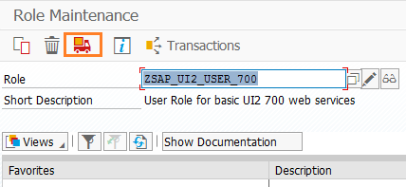

# What is Launchpad Designer

Tiles are not created in launchpad rather they will be created in launchpad designer.

LPD Designer is for BASIS, Fiori Security Consultants, Fiori Administrators to create Tiles, Groups, Catalogs and transport them to Q System.

As an Administrator, if you want to assign access of Standard Fiori Apps with your own view/perception in your co. or you want to add tile for custom apps, LPD designer is the central place.

**/n/UI2/FLPD_CONF –** Launchpad designer for system wide changes – Configuration

/sap/bc/ui5_ui5/sap/arsrvc_upb_admn/main.html ?scope=CONF

**/n/UI2/FLPD_CUST -** Launchpad Designer for client specific – Customizing

/sap/bc/ui5_ui5/sap/arsrvc_upb_admn/main.html ?scope=CUST

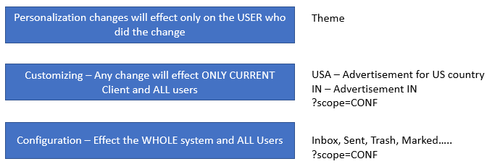

When we open Gmail, we all see trash, inbox, updates folder for all this is configuration and if we open Gmail in USA, there US advertisement will come and in India it will show IN advertisement this is Customization. And if we change the them then it will be visible to me only and this is called personalization.

# How to Run LPD Designer – Fiori Administrator

As an administrator, the Fiori Admin would need following service authorizations

* **/UI2/PAGE_BUILDER_CONF –** Used by LPD Designer to load Catalogs/Pages/ and gadget services for configuration
* **/UI2/PAGE_BUILDER_CUST -** Used by LPD Designer to load Catalogs/Pages/ and gadget services for customizing
* **/UI2/TRANSPORT –** The launchpad designer is used to create Tiles, which needs to transported to Q and P locking entry in TR. So, the service is used by LPD designer to Read Transport requests.

Sample Templates for roles

* Template: SAP_UI2_ADMIN_700
* Reference Role: ZOFT_UI2_ADMIN_700

Naming Conventions:

* **Catalogs**: COMPANYNAME_BC_AREA (for e.g. ZOFT_BC_FIN)
* **Group**: COMPANY_BCG_AREA (for e.g. ZOFT_BCG_SEP_APP)
* **Roles**: COMPANY_BCR_AREA (for e.g. ZOFT_BCR_FIN)

BC: Business Catalog

BCG: Business Catalog Group

BCR: Business Catalog Role

# How to create App in Launchpad

Find the below steps to create

1. First, we need to create the Catalog.

Go to **+** sign in the bottom.



Then give the title and ID like below. The naming for Catalog is **CompanyName_BC (Business Catalog)_AREA** Like here **ZTASK_BC_APP**

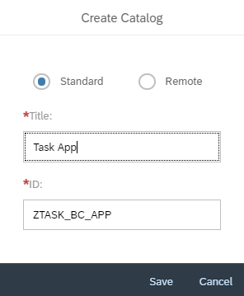

Then we will provide Semantic Object because Semantic Object is the purpose of Navigation.

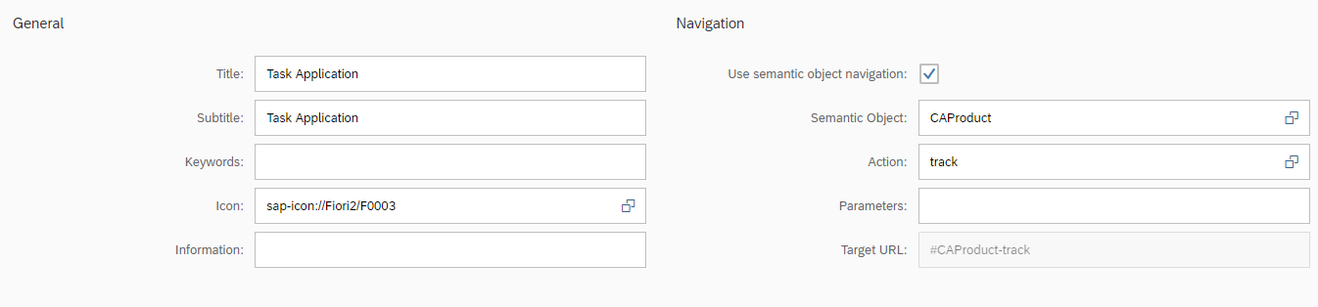

1. After Catalog we need to create the Target Mapping.

For Target Mapping we will click on the below button.

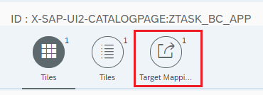

Then in the bottom we have a button called **Create Target Mapping** to create the target mapping.



Then we will provide the below details like title, id, url, intent.

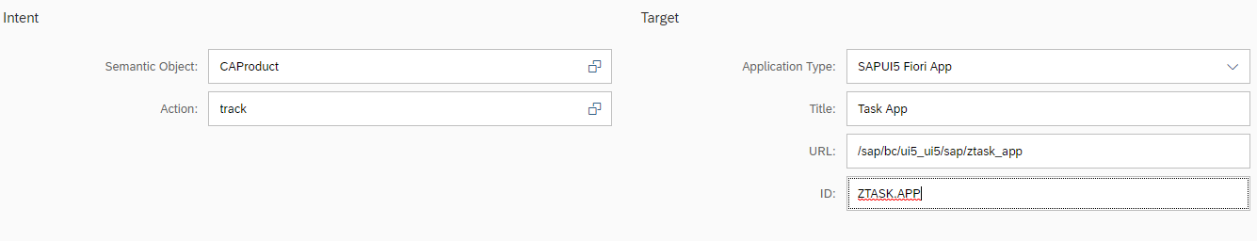

After deploy the app we will have a section created in manifest.json file, the section will look like below.

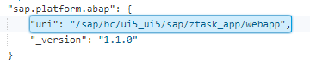

There is one section already present in manifest.json file in sap.app section.

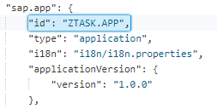

The uri will be the URL for Category mapping and the id will be the ID in Category section.

1. Then we will create the Group and add the tile in it.

To create Groups, we will switch to Group tab like below.

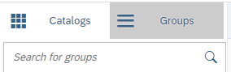

Then we will click on the create button in the bottom.



Then we will provide the details like below.

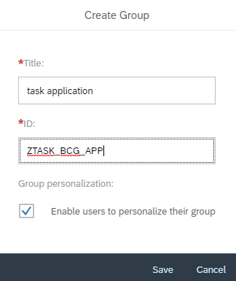

Then we will add the tiles in that group.

1. Then we will create the Role and add these Catalog and group in that role.

To create role, we will go to **PFCG** transaction and we will create a role there. We will go to the Menu tab and click on the Transaction section and add the created Catalog and Group in it like below.

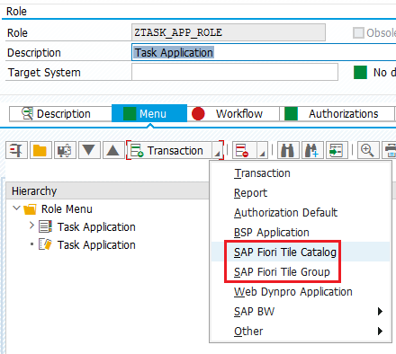

Then we will go to the **Authorizations** tab and click on the **Change Authorization Data** and generate it.

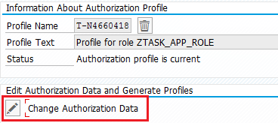

Then we will click on the User tab and add the desire user who will have a access of this app.

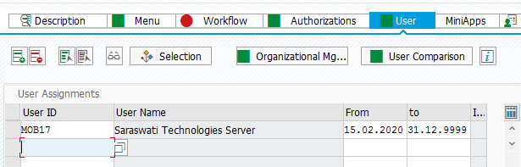

Then we will click on the User **Comparison Button** and complete that.

1. Add the desired user in this role so that user can access the App.

Then we will open the Sandbox and check the app.

Note: **If there is not OData model present means if the app is only on Json model the it is impossible to create the role for that app in PFCG**

# Full Form of POWL

POWL: Personal Object Worklist Framework

# What is the difference between /UI2/FLPD_CONF and /UI2/FLPD_CUST?

If the tile is only for any specific client then we will use /UI2/FLPD_CUST and if the tiles for all the client visible then we will use /UI2/FLPD_CONF to create the tiles.

**/UI2/FLPD_CUST:**

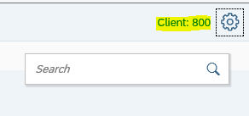

**/UI2/FLPD_CONF:**

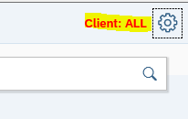

# What is Fiori Launchpad Content?

SAP Provides standard Catalogs, groups and roles which makes it easy for administrator to assign access of Fiori apps according to the business function of a user in the company. This will help save lots of time to avoid creating target mapping, tiles, etc.

All of this as per the business. This is known as Fiori Launchpad Content.

# What are all the contents provided by SAP in standard apps?

* **Technical Catalog (SAP_TC_) –** A technical Catalog contains ALL the business application tiles related to the whole area. E.g. there is one technical Catalog which contains tiles for ALL the SALES area.

**Do we give access of apps via role which includes technical Catalog?**

No.

* **Business Catalog (SAP_BC_) –** A Business Catalog contains the Apps relevant for the role/business function of a user in the company. What SAP does; they copy a reference from technical Catalog to create business Catalog. Which means an app is defined only once in technical Catalog e.g. create leave request, from there, whom so ever (business users) it is relevant for, a reference is created to BC. We only give access of Business Catalog to the users via Role.
* **Business Catalog Group (SAP_BCG) –** It is used to group apps, pertaining to a business function, helps user to organize the work related to the business function they are responsible for. Rather dumping all the apps on Launchpad, a proper grouping helps users to find apps easily.
* **Business Role (SAP_BCR or SAP_BR) –** The business role contains business Catalog and groups inside, along with the access of OData services needed to access the Fiori apps relevant for the business user. The roles are typically named as actual role in the company for a person.

SAP provides technical Catalog **SAP_TC_CEC_SD_COMMON** which has 160 Apps and in that we have one App which is called Sales order and in that technical Catalog is same and Business Catalog is **SAP_SFIN_BC_CM_CASH_OPS** and in that we have only 93 Apps present. So, we will use the Business Catalog instead of technical Catalog. If we use the technical Catalog the user will have all the apps.

Basically, after creating the Technical Catalog they don’t create the Business Catalog they just use the **reference** of the Technical Catalog to create Business Catalog.

Same way sap has given lot of business roles also to give the App access.

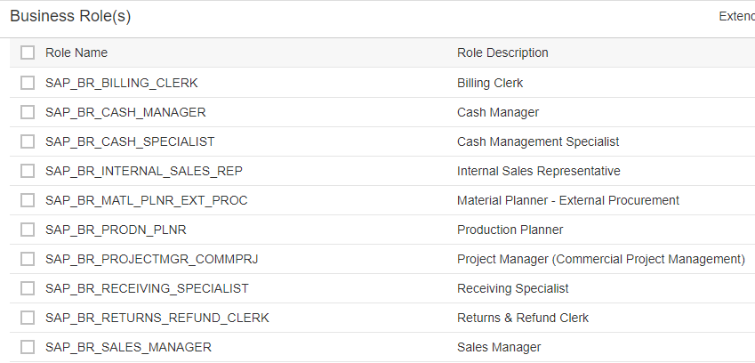

# What is Intent Based Navigation

An intent is used to perform navigation in SAP Fiori launchpad from #Shell-home.

Every Fiori app has to have a unique intent to navigate. Semantic object is a business object.

Most Recommended way is creating your own semantic object if it is custom Fiori app.

**Intent = <SemanticObject>-<Action>**

Like <http://sts4c.st.com:8001/sap/bc/ui2/flp#Shell-home> is the launchpad home app. And soon we click on the App and the URL will be like. <http://sts4c.st.com:8001/sap/bc/ui2/flp#CAProduct-track> So here intent is **CAProduct-track** and **CAProduct** is Semantic object and **track** is Action.

An intent is created using 2 parts

1. Semantic Object – It indicates what is the need of the user. E.g. Sales Order, Purchase Order, Product….
2. Action – Indicates the purpose, the action/activity which needs to be performed on the semantic object e.g. create, maintain, lookup, display etc…

SAP Delivers pre-defined Semantic objects which can be found in **/N/UI2/SEMOBJ_SAP** TCode.

Custom semantic objects are maintained in TCode **/N/UI2/SEMOBJ.**

SAP Fiori Launchpad Checks to find out issues related to Target mapping not configured for intent

* **/n/UI2/FLC** (FLC means Fiori Launchpad Checks)
* **/n/UI2/FLIA** (FLIA Fiori launchpad intent Analysis)

# How to create Dynamic Tile

To create dynamic Tile, we will create a Catalog and in Add Catalog Section We will select Dynamic Tile.

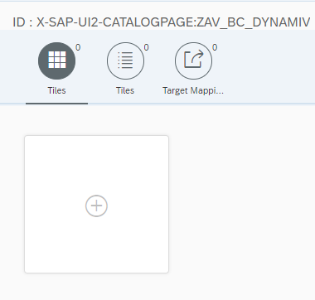

Then we will select Dynamic Tile from template section.

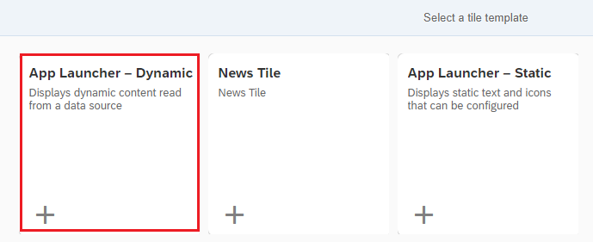

Then we will fill all the details like Semantic Object, Action. And in the **Dynamic Data** section we need to put the URL for what count we need to show the data in the tile. Like here we used **/sap/opu/odata/sap/ZTASK_APP_SRV/TaskDetailsSet/$count** means we want to show the count of the task set in the tile. And the Refresh interval second will decide in which interval the count should refresh, here it is 30 seconds.

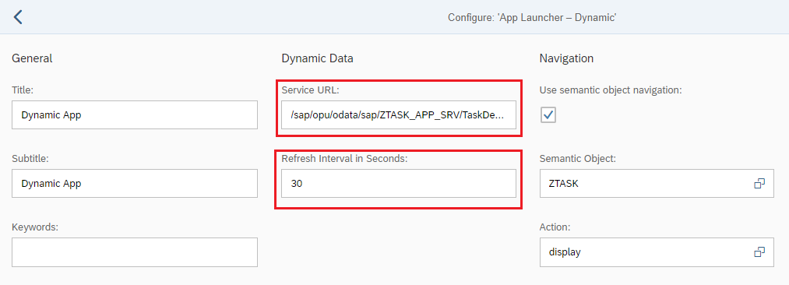

Finally, after all the Catalog, group and Role the tile will look like below.

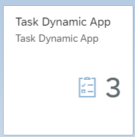

Which means here we have 3 count in the taskset entity set.

# How to create HTML GUI enabled Tiles

We will create the Catalog and in that while selecting the tile we will select **App Launcher Static**.

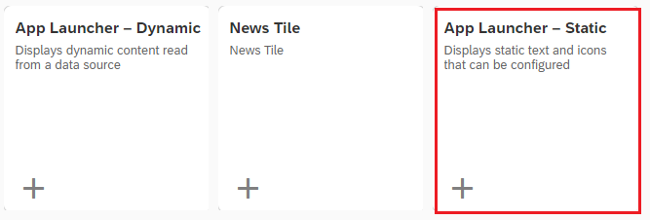

After that in the next screen we will fill all the details like below.

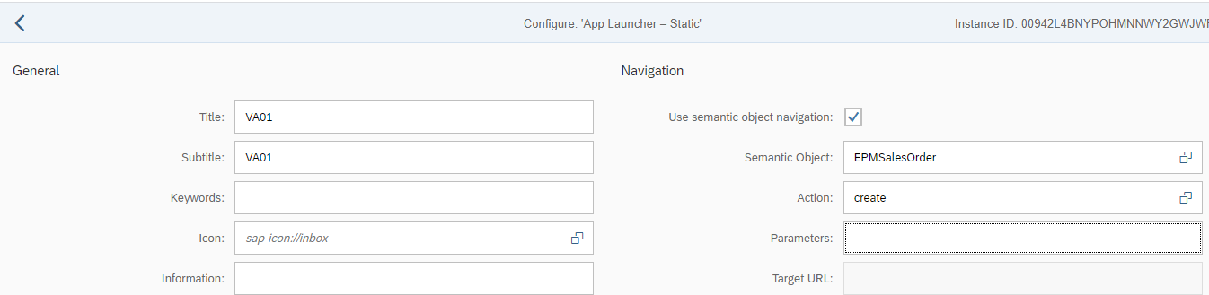

Then we will create the target mapping and while creating that we will select the **Application Type** as **Transaction** like below and in the Transaction section we will give the **Transaction Code**

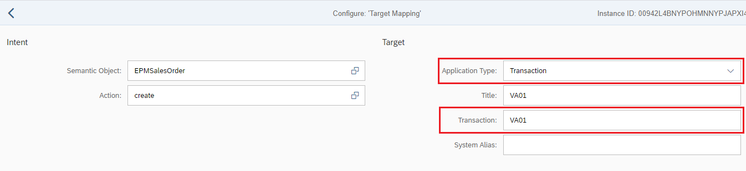

# How to create a URL Based Tile

We will create the Catalog and in that while selecting the tile we will select **App Launcher Static**.



After that in the next screen we will fill all the details like below.



Then we will create the target mapping and while creating that we will select the **Application Type** as URL and in URL section we need to put the desired URL.

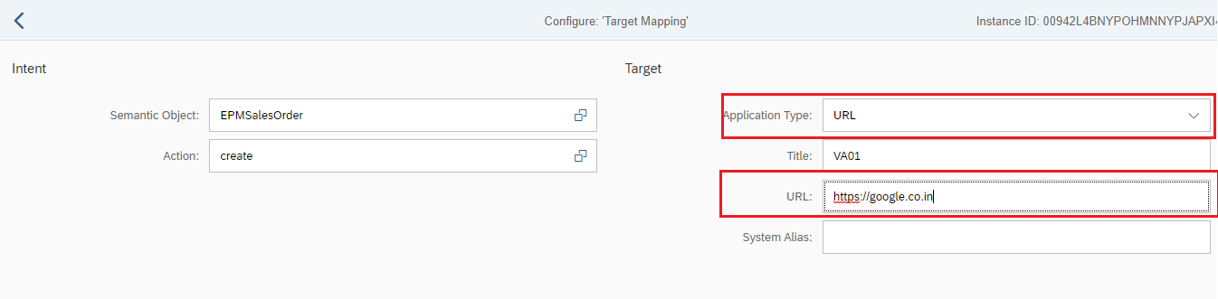

# Is it possible to reuse target mapping?

Yes, it is possible. If we create the same Semantic Object and Action in the new tile then it will reuse the old target mapping app. But it is no use.

# How create App reference

Let’s say we have tiles and target mapping created in Catalog and now to create the App reference we will just drag the tile and will get a Create reference option, like below.

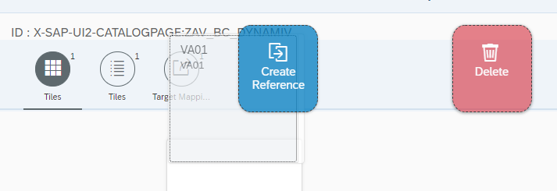

If we create reference for tile then we must need to create the reference for target mapping otherwise the app will not work because the target mapping is having the details of the app.

To do that we will go to the target mapping section and select the target mapping and click on the create reference option at the bottom.

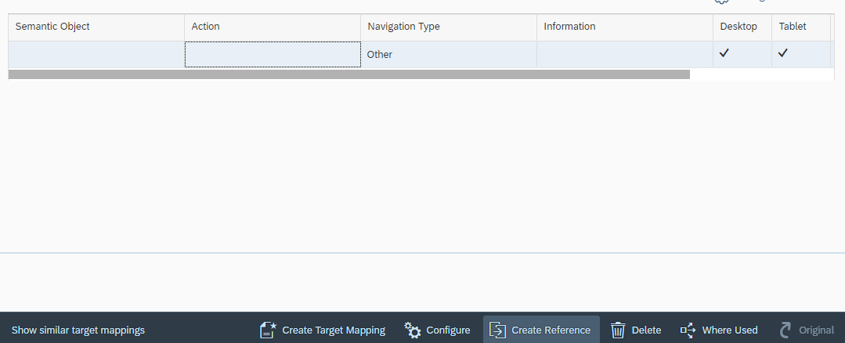

# Steps and files load while launchpad loads

1st File to load: **login.js –** this file is the login file which brings the logon page on launchpad

2nd File to load: **Flp/Launchpad.html** **–** Our main launchpad page

Then LPD calls now an entity set called – **PageSet**

**Start_up** call, the call will load all target mappings on launchpad

Activating App

1. Check if the service is active
2. Check the $batch call made for that service and inside that there is no error, **/n/IWFND/ERROR_LOG**
3. Check if service is registered with right system alias
4. Check the NW calls to see if there is any authorization, add OData service auth to the Role
5. Additionally, app specific changes, we need to maintain the customizing entries, implement BADIs

# SAP Workflow and My inbox App

SAP Workflow is used to automate the business process. When you request leave, a notification will be sent to your manager, on approve/reject, a notification will be sent to employee. WF in SAP world is there since years.

When a notification is created, it will be sent to Inbox application inside SAP system (SBWP)

Now the inbox is moved to SAP Fiori. SAP have designed an My Inbox app.

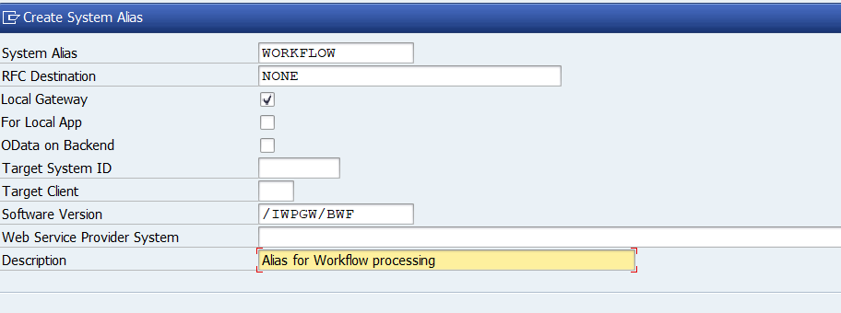

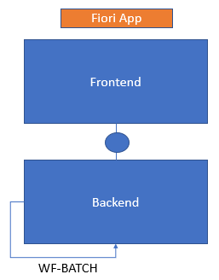

WF-BATCH is a user which can be found in su01d Transaction and it is added by basis team.

All the workflow related apps will have one OData service common which is **/IWPGW/TASKPROCESSING.** And for these kinds of apps we need to add our service with special system alias called Workflow.

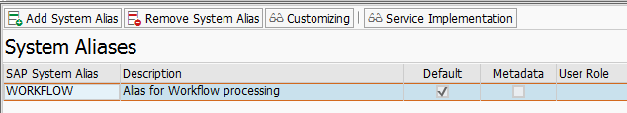

And these Workflow alias will be created by us in SPRO transaction in the below path.

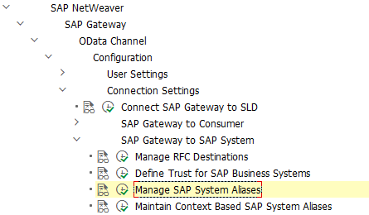

And in that we have added one like below.



Then in the OData service section in **/iwfnd/maint_service** we will add the system alias is this one.

Then the Workflow app should start work and if the Alias is LOCAL then it will not work.

**SWDD** is the Transaction Code for Workflow builder.

# Workflow Customization from BADI

The workflow can be customized by using BADI there are BADIs which used to customize the Inbox app title and description as well. Find the BADI description below.

BADI Name: **/IWPGW/ES_TGW_TASK_DATA**

  method /IWPGW/IF_TGW_TASK_DATA~MODIFY_TASK_DESCRIPTION.  
    IF IS_TASK_HEADER-TASK_DEF_ID CS 'WS90100017'.  
      cv_description = 'This was one of my best session'.  
      CV_DESCRIPTION_HTML = '<img src="https://static.wixstatic.com/media/a27d24_169a9792408440658927397f184c582c~mv2.png/v1/fill/w_925,h_655,al_c,q_90,usm_0.66_1.00_0.01/a27d24_169a9792408440658927397f184c582c~mv2.webp" />'.  
    ENDIF.  
  endmethod.

  method /IWPGW/IF_TGW_TASK_DATA~MODIFY_TASK_TITLE.  
    IF IS_TASK_HEADER-TASK_DEF_ID CS 'WS90100017'.  
      CV_TASK_TITLE = 'Anubhav did magic at runtime'.  
    ENDIF.  
  endmethod.

# How to create Simple workflow in SAP

We can build our workflow in SAP using **SWDD** transaction. Once we open the Workflow then we need to click on create button like below.

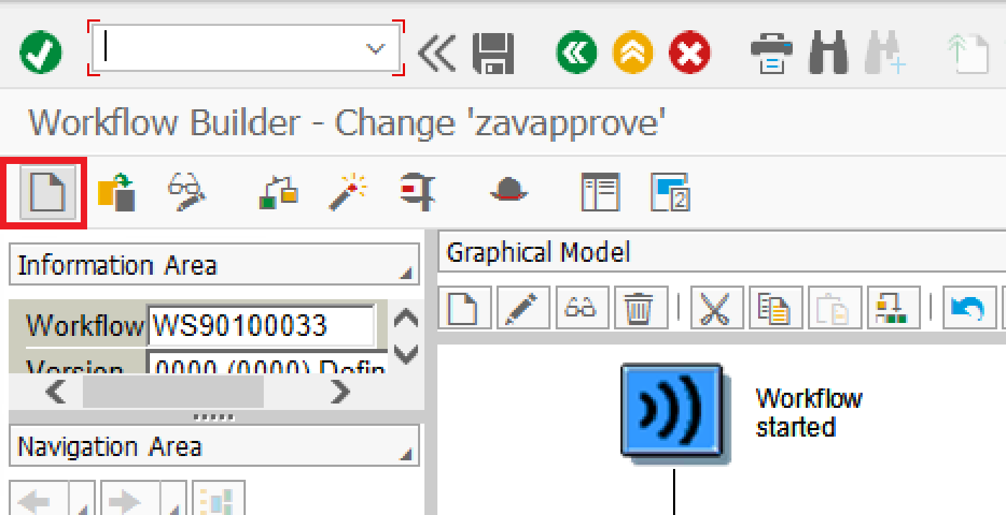

Then it will come like below.

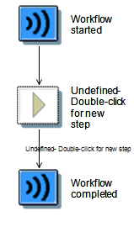

Then in the middle section **Undefined Double-click for new step** and select our **user decision** then in that we provide the title, give the agent as user with user name and then provide the decision objects like below.

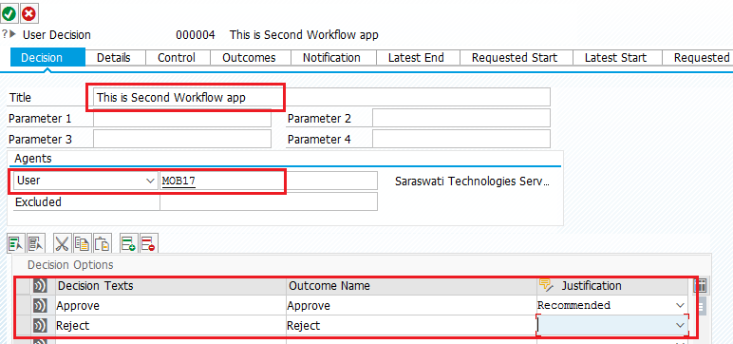

Then the in the workflow we will get Approve and Reject Button and there we will right click on Approve and Reject and will select **Create** and in the new screen we will select **send Mail** like below**.**

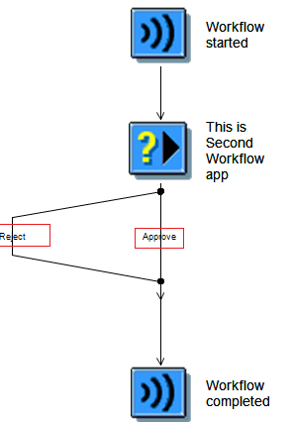

Once we configure the mail it will look like below.

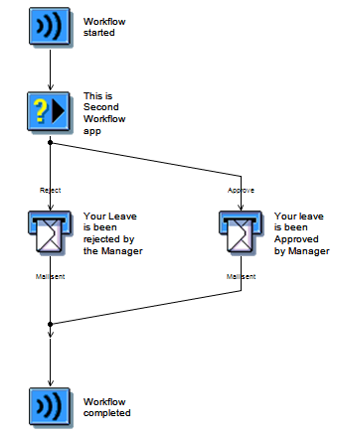

That’s it we will execute this and will see the request in SAP Fiori Launch Pad my inbox app. After execution:

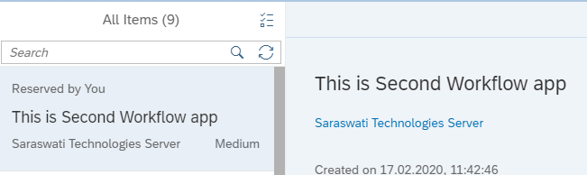

# How to change Standard Template

To change the standard template then we will go to the user decision section and then move to **Control** tab and click on the comp button.

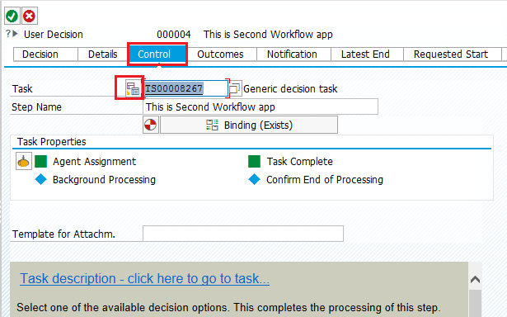

Then give the new abbreviation and then click on ok.

Then we will go to the description section of the newly generated template and then click on the edit description section like below.

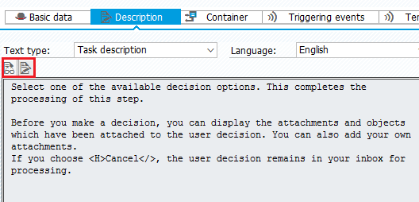

Then go to the **Control** tab and click on the below button to assign the agent.

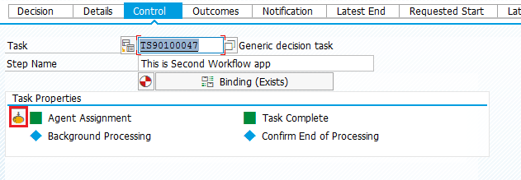

Then do the below step and select the generic task

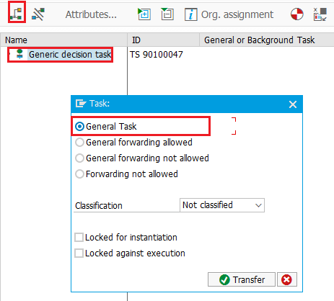

That’s it is done.

# How to customize Open task button in workflow

To do that we have a Transaction code called **SWFVISU** there we will give the task no and then intent where it should open or any other thing.

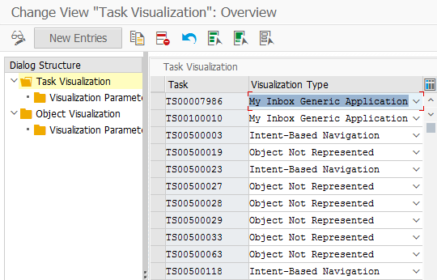

# Configure Parameter in Fiori

**Configuration Parameters**

SAP Fiori Launchpad comes with large no. of configuration and customizing parameters, these parameters influences the loading of sap Fiori launchpad features.

<https://help.sap.com/viewer/product/SAP_FIORI_LAUNCHPAD/EXTERNAL/en-US>

<https://help.sap.com/viewer/a7b390faab1140c087b8926571e942b7/201809.002/en-US>

Tcode for Configuration Parameter: /UI2/FLP_SYS_CONF

<https://blogs.sap.com/2018/06/21/fiori-for-s4hana-top-5-fiori-features-that-bring-value-to-every-business-user/>

# Advantage and Disadvantage of Cache

**Advantages**

* Good performance since the browser does not need to load all resources again and again
* Offline access of data
* Save traffic to the server

**Disadvantage**

* Sometimes the resource in the server changed since you instructed browser to use cache, it is still showing the old state of the app.
* Some Fiori apps even you changed the code, it not reflecting your changes
* Especially after upgrade of sap system new sap Fiori features are not visible to use
* Sometimes you grant role to user for accessing apps, when they refresh, they do not see the new app.

**From NW 7.5 onwards, SAP Fiori Launchpad usage the cache mechanism for all the resources, it takes care of loading the latest resources again**.

# Cache Reports and solutions

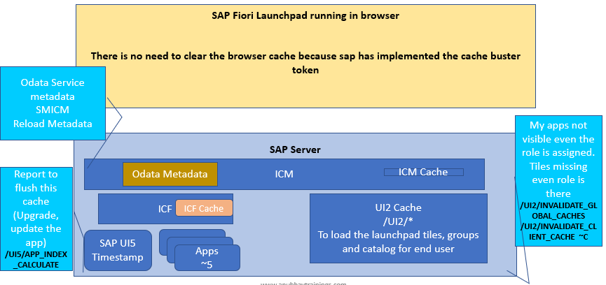

Though SAP has done the Cache control is automatically then if there is any problem, we will use the below programs.

1. If there is any problem with OData metadata load then we will go to the transaction **SMICM** and invalidate cache locally or globally but that is also not a right approach because it will do for all the OData services, which doesn’t have problem also. Rather we will go to /IWFND/MAINT_SERVICE and filter the service and click on Load Metadata.

**SMICM:**

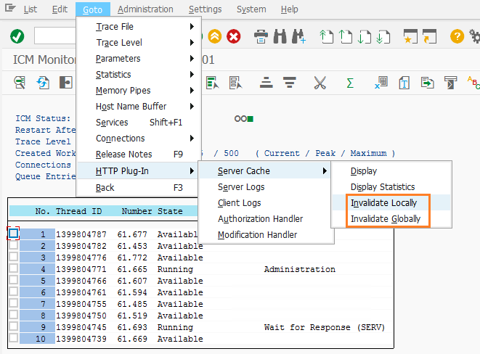

**Load Metadata Service:**

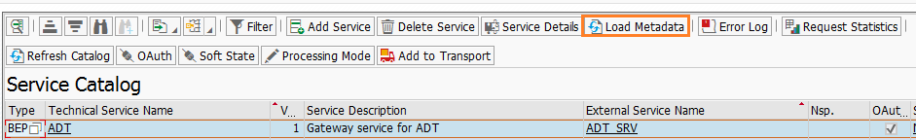

1. If there is a problem with APP is not visible, add the Catalog but not visible, add the role but not showing the App in those cases we will use below reports.
   1. **/UI2/INVALIDATE_GLOBAL_CACHES**
   2. **/UI2/INVALIDATE_CLIENT_CACHE (~C** Means this is for classical apps which are not running on Component.js file which are very old projects**)**
2. If there is any problem with the App and the changes of the App is not loading after the changes also then we will use **/UI5/APP_INDEX_CALCULATE** report

# How SAP handling the Cache concept

SAP handling the Cache concept using time stamp, when we first time load the launchpad it also loads the bootstrap the UI5 app, that time browser is sending the timestamp to the server that this is the latest version I have and is there any change between these times and if server says no then it will load the resources which are already cached in the browser otherwise it will load all the files from browser. And the timestamp will go in between **~~** symbols like below.

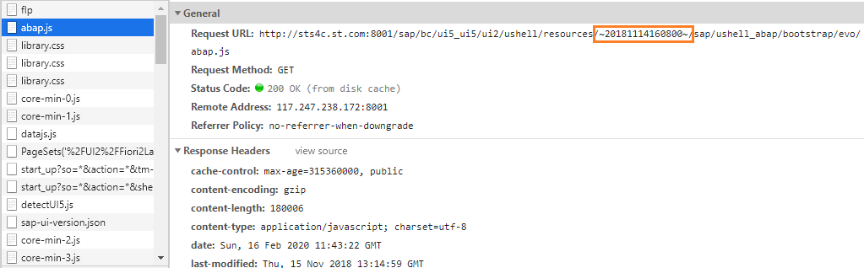

It will show **~5** for the UI5 apps. Like below this is our App.

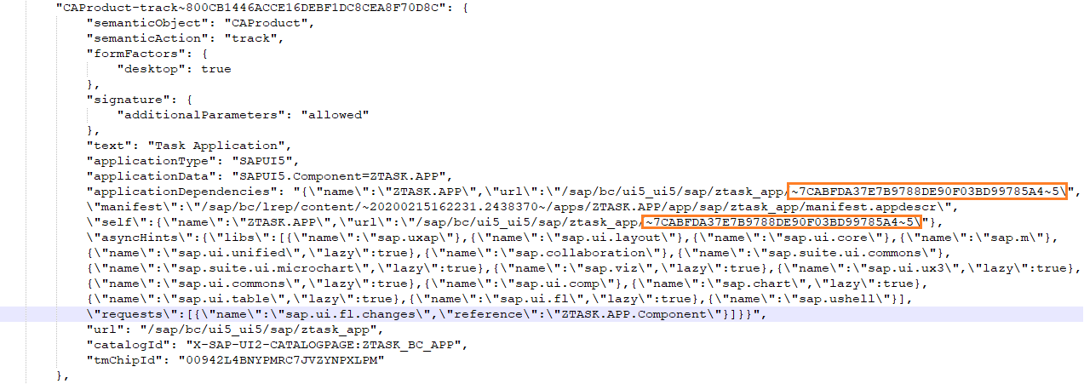

For App related things can be found in **start_up** file.



# What is Backend Catalog and How to configure the in front end

**Step1:** Will you do all VA01, MM01, ME21N,…. Standard transaction as a tile manually one by one yourself.

You can create these tiles automatically by SAP’s pre delivered Technical Catalog which are known as technical backend Catalog. (TC_BE), sap delivers all the classical UI references.

All the BC reference these apps from the TC_BE, these backend Catalog in a central hub scenario exist in sap Backend server. Hence you will get an error called reference lost for the classical tiles.

**Step2:** Steps to import this technical backend Catalog in front end system so that we can use standard Classical app tiles directly:

1. Check the table SUI_TM_MM_APPS in SE11 for desired TCode/webdynpro app and its backend Catalog name (TC*BE)
2. When we want to replicate the technical backend Catalog to front end, this is done by using a connection between frontend and backend. The connection is needed both at design time (Type 3 – Simple RFC), and runtime (H Type means HTTP connection).

There is a strict guideline by SAP to define these connection names. We can find the desired connection reference name in sap maintenance view **/UI2/V_SYSALIAS.**

**Step 3:** To use these apps at design time and at runtime we must have an RFC connection (3) with naming convention as ALIASNAME_RFC and an HTTP connection also with name ALIASNAME_HTTP e.g. S4PLM_RFC and S4PLM_HTTP

**Step 4:** There is a maintenance view named /UI2/V_ALIASMAP contains the mapping between logical destination and actual destination.

Report Name:

**/UI2/GET_APP_DESCR_REMOTE_ALL**

Tcode: /N/UI2/APPDESC_GET

Report to delete the replicated catalog

**/UI2/DELETE_APP_DESCR_CATS**

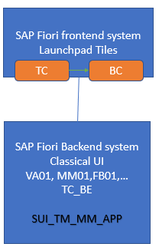

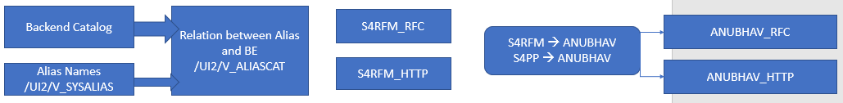

# Is there any way to create a role using Catalogs all at once?

LPD Config > Create Your Catalog > Group > Role > Role to User

So many standard Catalogs and groups, BC, BCG, is there any easy way to create role just with one click.

Report Name: Mass maintenance of business role

**PRGN_CREATE_FIORI_FRONTENDROLE**

# Translation of SAP Standard tiles

To translate our SAP standard tiles, we need to go to transaction code **SMLT** to configure the language. And whichever language is maintained there, those languages can be seen in Fiori Launchpad logon screen.

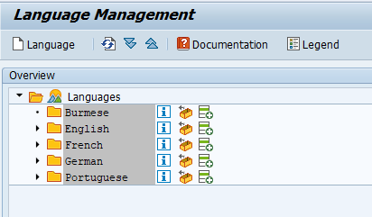

Here 4 languages maintained and if we go to the launchpad then we can see these language in the dropdown list.

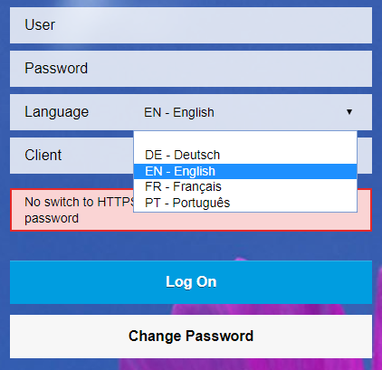

If we select the language it will show the SAP standard tiles in that same language.

Sometimes it will happen that the drop down is not visible and for that we will go to **SICF** transaction and select the service name called **FLP** and then we will choose the option under **UI2** section and go to the **Error Page** tab and select the **Configuration** Button and make sure that the **Language** checkbox is checked.

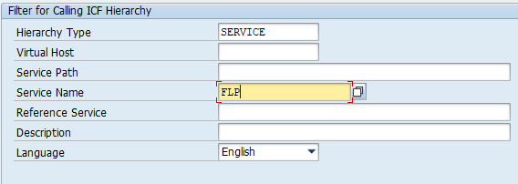

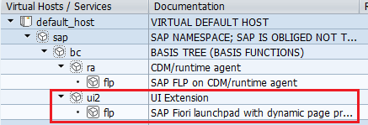

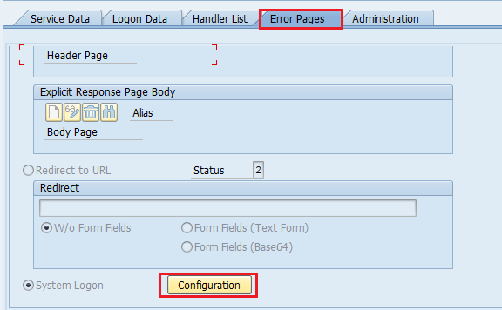

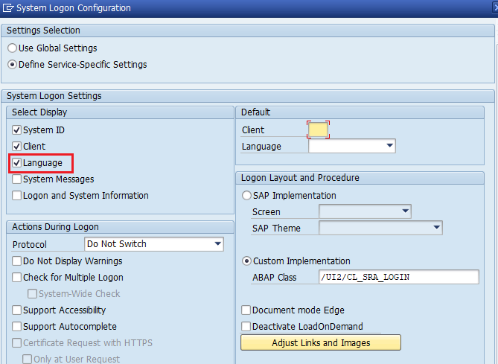

And some times we will see that the Logon screen is coming very old screen like NWBC not like the new section for that we will go to the same Page **Configure Button** and make sure that **Custom Implementation** is maintained as **/UI2/CL_SRA_LOGIN.**

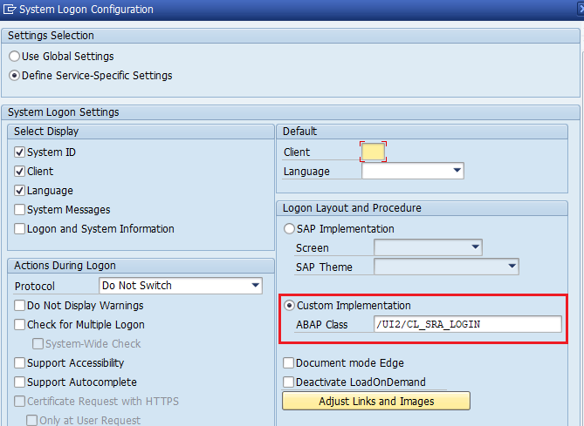

# How to do the translation for Custom app

To translate the Tile Catalog, Group in some other language we will go to the transaction called **SE63** and go to the below **SE63 -> Short Text 🡪 00 TABLE -> *WDY_CONF_USERT2\*** Then put the desired description there.

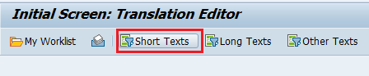

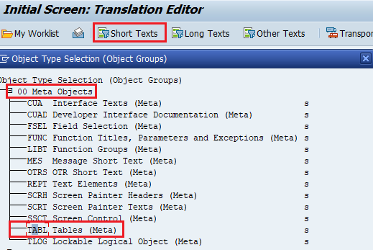

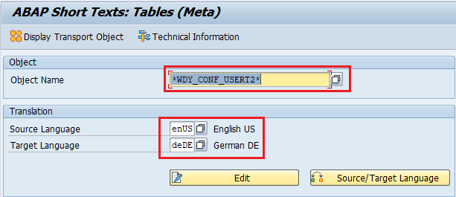

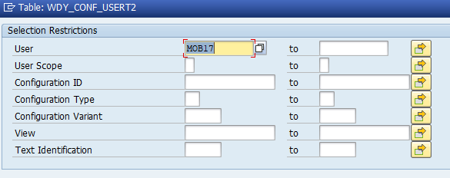

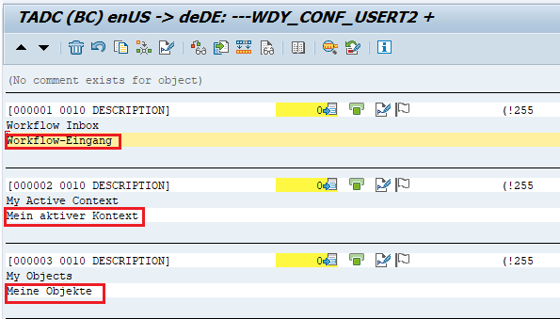

* Now text related to application labels and the tile are translated using the i18n in UI5.

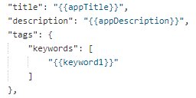

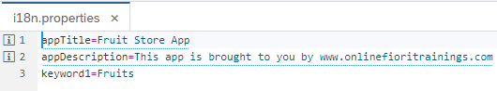

* Application messages SE91 in ABAP
* Data – Text Table

# Logoff Page URL

If we want after logoff it should redirect to my own page, to do that we will go to the **SICF** Transaction and search for **LOGOFF** service and then go to the service under BC/ICF and then we will go to **Error Page** tab and then **Logoff** tab and change the redirect URL.

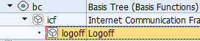

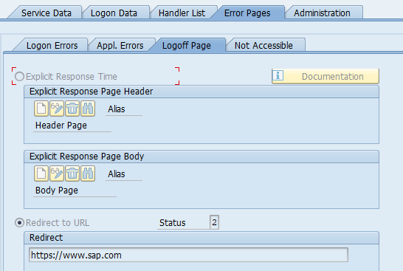

# How to change logon page picture and logo

To do that we will go to mime repository and there we will go **SAP🡪Public🡪BC🡪UI2🡪logon🡪img**

There we will find all the pictures and we can replace those pictures according to our logo or image.

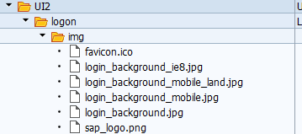

# Theming in Fiori

A brand is created with the help of years of efforts and spent. It makes also sense that we use same colour combination to our launchpad as well to make the whole Fiori experience with the brand colour combination and logos.

SAP Fiori provides and amazing tool called ***theme designer*** which allows us to change the launchpad/apps colouring scheme by creating our own theme.

**Transaction Code:** /N/UI5/THEME_DESIGNER

Apply the effect only when we hover on tile and it will change colour and gives a 3d rotation]

***.sapMGT:HOVER{ background:lime; transform: rotate3d(1,1,1,45deg)}***

***Funda Fox***

After system upgrades, the default theme for all users will be switched back to default. Sometimes, user complaint about theme not working.

Sol: Rebuild the theme in theme designer and deploy again.

SAP Standard: /UI2/NWBC_CFG_SAP

You can set parameter at client level using: /UI2/NWBC_CFG_CUST

# KPI Modeler

KPI modeler is a framework, it allows design of a Key Measure analytics in S/4HANA systems. This comes with pre-delivered SAP apps which allows ***analytic expert*** to create beautiful Fiori Analytic apps w/o coding.

Use Case: in the company we are delivering many orders to customers, department wants to know, what kind of issues are coming in order delivery, for issue what is the quantum.

Dimension – Issue KPI- Measure – Issue count

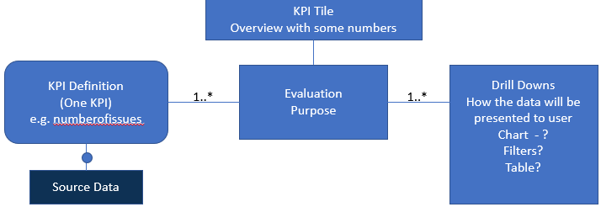

# Steps to create Tile from KPI modeler

To create KPI we must need to have **SAP_BR_ANALYTICS_SPECIALIST** role.

First, we will go to KPI Design and create KPI.

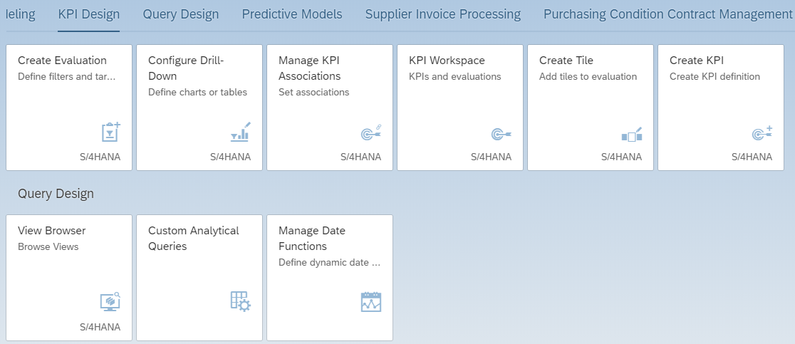

We will go to Create KPI and fill all the necessary details like below.

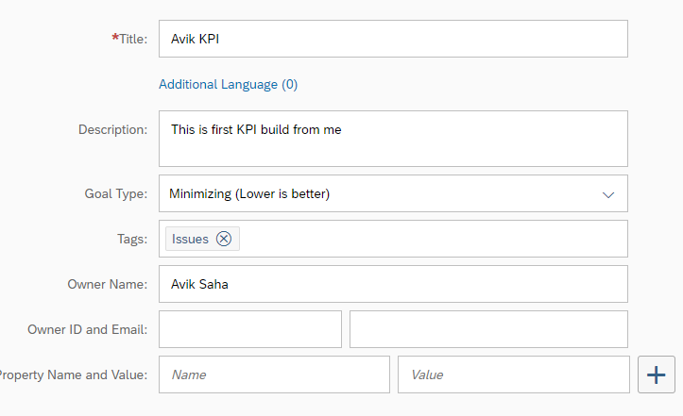

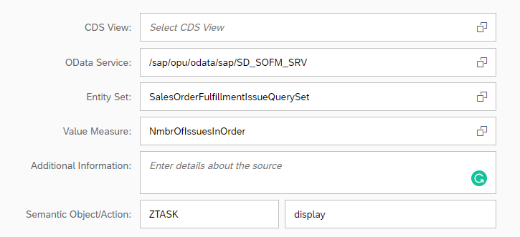

Then click on the **Activate and Add Evaluation** and then fill the details.

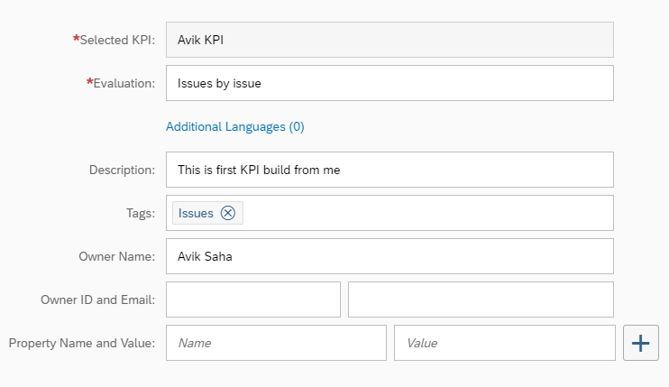

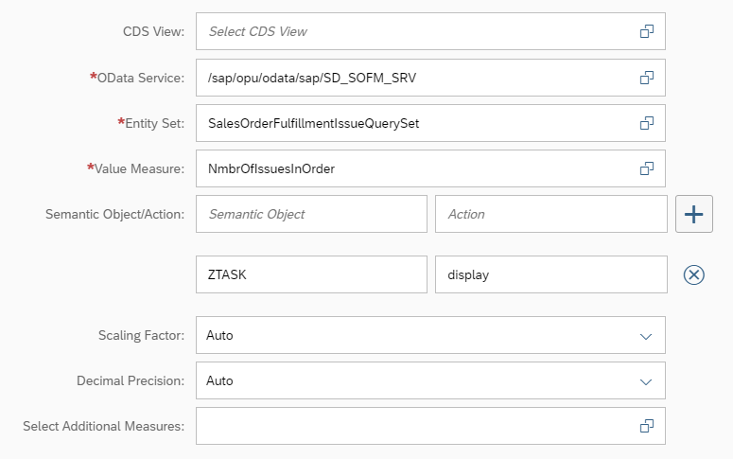

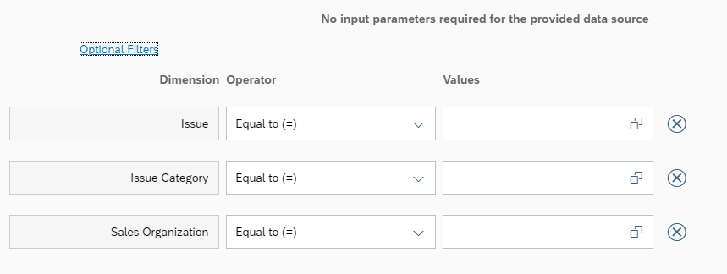

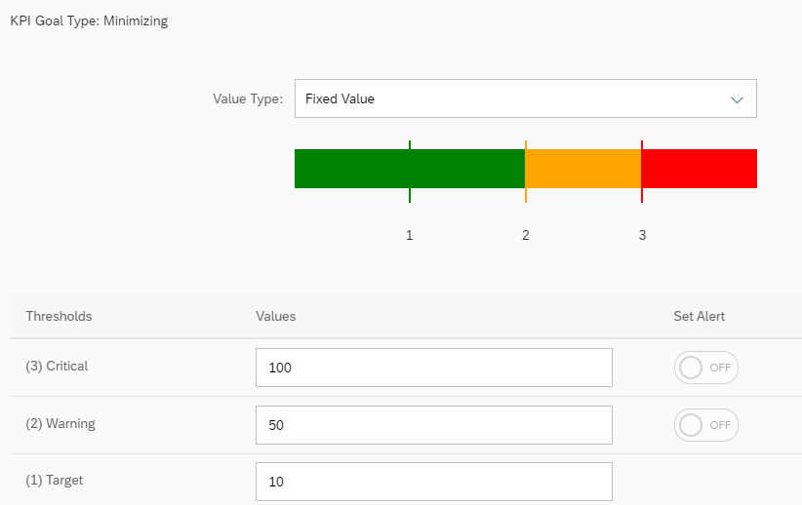

Then click on **Activate and Configure Tile** and there we will fill all the necessary details and select the tile.

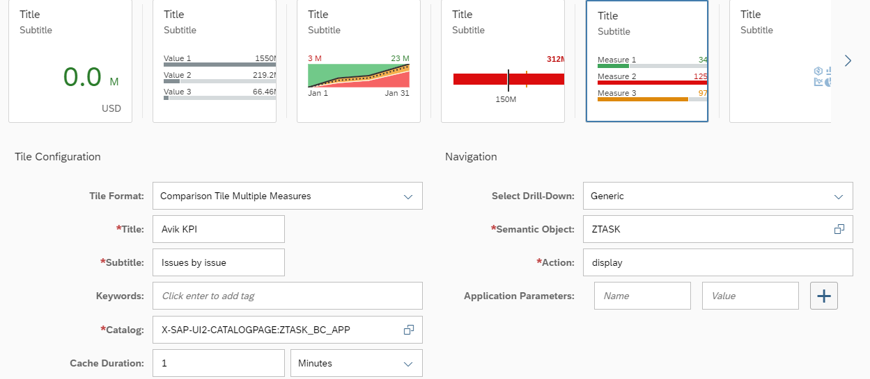

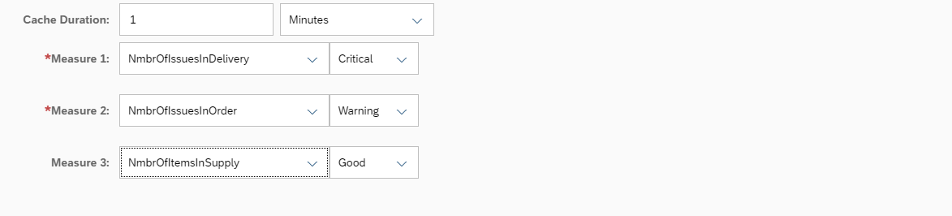

Then will click on the **Save and Drill Down** it will go to the section to add more drill downs and after that we will come to the section Add rile back and click on **Save and Create New.** Then we will go to the main page and add the tile into our desired group.

# Annotations in Fiori

In SAP HANA session we have seen that we can create the UI reports by using CDS Annotations. But someone who is not aware of CDS or the OData which is not from CDS. In those cases, we have annotations in Fiori level to create the worklist, OVP etc. apps.

After generating a project, we will see there is a folder called Annotation and there is an annotation file inside that.

So, we have created one OData from CDS and activated the service **ZCDS_SO_ANUBHAV_CDS**.

We will create a project from template and select worklist application there. After creating the project, we can see the Annotation file like below.

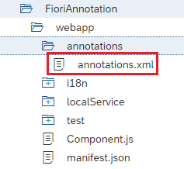

The description file of that annotation can be found in the **manifest.json** file like below.

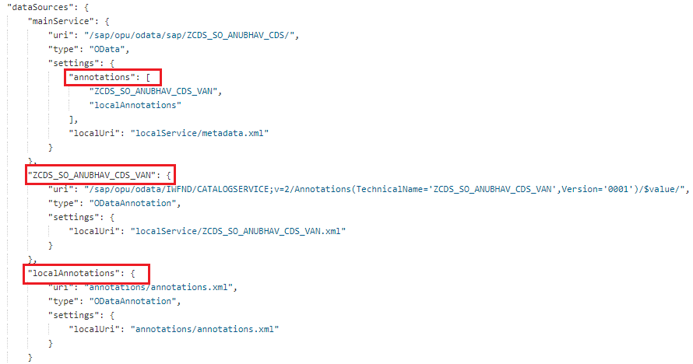

Now we will add the annotations to build our worklist application. To create a filter, we will use the Selection Field, for table column we will use line item and for table header we will use header info.

**Header Info:**

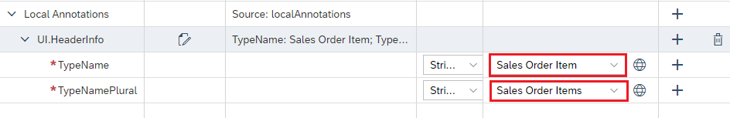

**Selection Fields:**

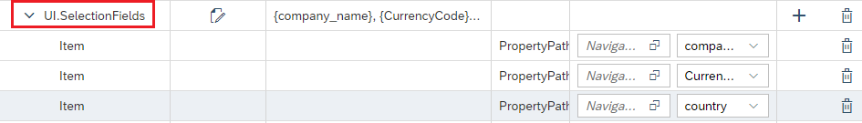

**Line Item:**

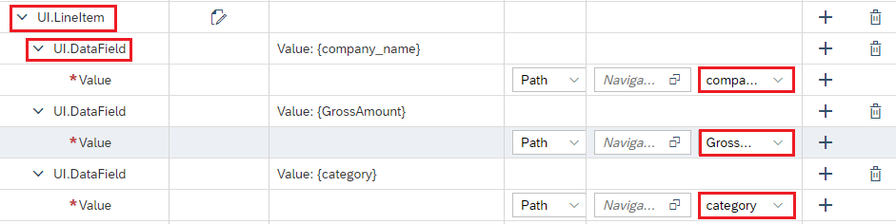

After that we will save the annotation file and run it, we can see all the properties which we have saved will come to UI.

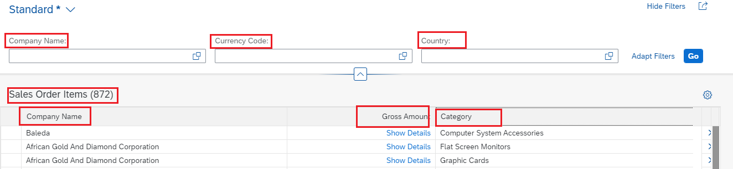

This is for Worklist application annotation.

# What is Presentation Variant?

**Presentation Variant:** How the data will be presented to the user when the card loads first time. TotalSumOrderGrossAmountOnly top 5 companies according to their gross, Bar chart bars by gross sales in descending order

# What is Selection Variant?

**Selection Variant:** What data will be selected when your card loads for the first time from backend. I want to show only orders of USD, USA.

# OVP Page from FIORI Annotation

To create Chart let’s say Donut chart we need to add below items in the annotation.

1. UI.PresentationVariant

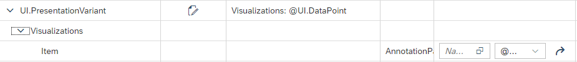

1. UI.Chart

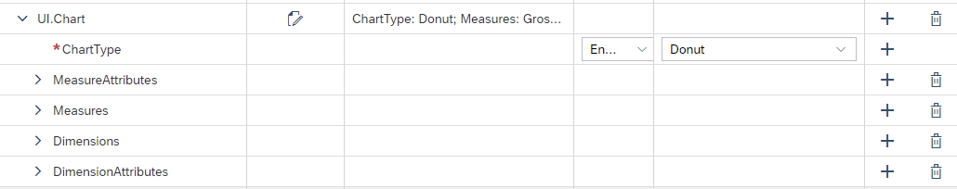

1. UI.KPI

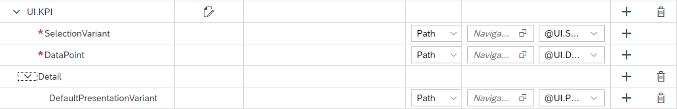

1. UI.DataPoint



1. UI.SelectionVariant



Then we will add a card to the application and with below annotation in manifest.json file.

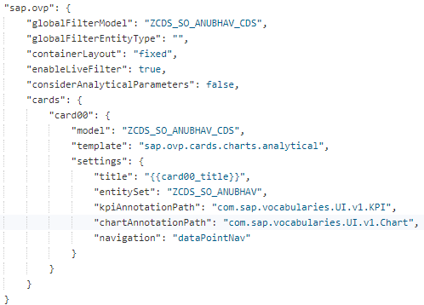

OVP documentation can be found in the below link.

[https://sapui5.hana.ondemand.com/#/topic/65731e6b823240398e33133908efdaa1](https://sapui5.hana.ondemand.com/)

# What is the difference between CDS and Annotation based Analytic apps?

|  |  |
| --- | --- |
| CDS Based Annotation | WEBIDE Based Annotation |
| Lifecycle, because our annotation goes along with code so there is a single transport where all changes are locked. | The annotation file resides in WEBIDE and follows different transport route using the SAP Fiori frontend system |
| Good support of code completion with CDS views. | No code completion |
| Not coupled with the SAP UI5 versions/ SAP WEBIDE version. | UI5 and WEBIDE version |
| Decouples from the UI technology. | Tight coupling with Fiori UX |
| If you are not on S/4, you cannot create CDS with @UI annotation | Non-S/4HANA, still you can create the analytic apps |
| Works with OData which is created on CDS. | Works with any OData service in your company. |

# SAP Guided Answer

<https://ga.support.sap.com/dtp/viewer/#/tree/1741/actions/22619>

[https://ga.support.sap.com/dtp/viewer/#](https://ga.support.sap.com/dtp/viewer/)

# Screen Persona Tutorials

[https://personasgallery-imagineering.dispatcher.us1.hana.ondemand.com/index.html#/Flavor/390](https://personasgallery-imagineering.dispatcher.us1.hana.ondemand.com/index.html)

<https://blogs.sap.com/2016/09/26/getting-started-with-templates-in-sap-screen-personas-flavor-gallery/>

# Fit-to-standard workshop

**Fit-to-standard workshop**

Meeting which is hosted by application developer/architects and solution owners along with business and functional consultants to check together if the standard Fiori application fits to their needs.

At the end of this meeting, the outcome is to list down all the gaps in following categories

1. Standard app available
   1. Perfect fit
   2. Not a perfect fit
      1. Key user adaptations – the same app will get changed with delta. No coding required.
      2. Extensions using WEBIDE/Gateway – Code level changes and new custom app will be created.
2. Not available in standard app

# Bad approach to extend Fiori app.

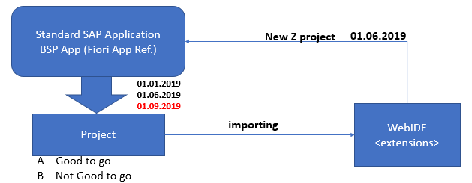

1. In case of a bug, we cannot report issue referring to Z App to SAP.
2. End-less loop of changes download🡪Change🡪Upload
3. Use standard sap feature for FREE is not more an option.

# View extensions types and details

Basically, SAP has 3 options to extend the standard vide please find them below.

* ***sap.ui.viewExtension:*** it provides custom view content at specified point inside of a standard app, where possibly an extension is permitted by adding new UI Control(s). The approach is only possible when SAP offers an extension point to us.

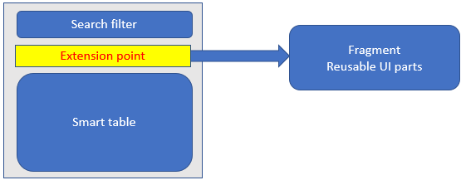

* ***sap.ui.ViewModifiction:*** it used to just override the behavior of UI control(s) on standard view w/o touching standard code. Example: we can hide a control, make a field gray out, change the list paging size…
* ***sap.ui.ViewReplacements:*** replacing the complete standard view with your own view. In this approach, we have to create a view in extension project with same name as the standard view name. NOT A GOOD CHOICE OF EXTENSION BECAUSE. Decoupled from standard hence no new innovations for free. At times, there is a coordination between standard sap view and controller. DO NOT CHANGE THE ID OF THE CONTROLS.

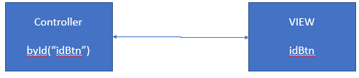

# Controller Extension

There are two ways to do the controller extension. Please find them below.

* ***sap.ui.ControllerReplacement:*** replacing the whole of the controller
* ***sap.ui.ControllerExtension :*** inherit and override. When your app starts, what will be printed on console. For Hook method (onInit, onBeforeRendering,onAfterRendering,onExit – A+B) both method will be called means standard controller hook method and custom controller hook method. And for other methods the overridden methods will only be called.

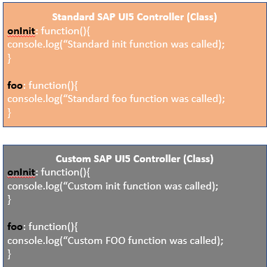

For this the out put will be

***Standard init function was called***

***Custom init function was called***

When your button is calling foo. **For non-hook method, system will call override method only**

***Custom foo function was called***

# WEBIDE tutorial

<https://www.youtube.com/watch?v=1KACIrCTo04>

<https://www.youtube.com/watch?v=GlcpptK221A>

# Steps to do the View extension

The basic step to do extension is that we need to make an extension of the standard project and to do so we need to have the BSP application name and this can be found in Fiori app library in Extensibility section like below.

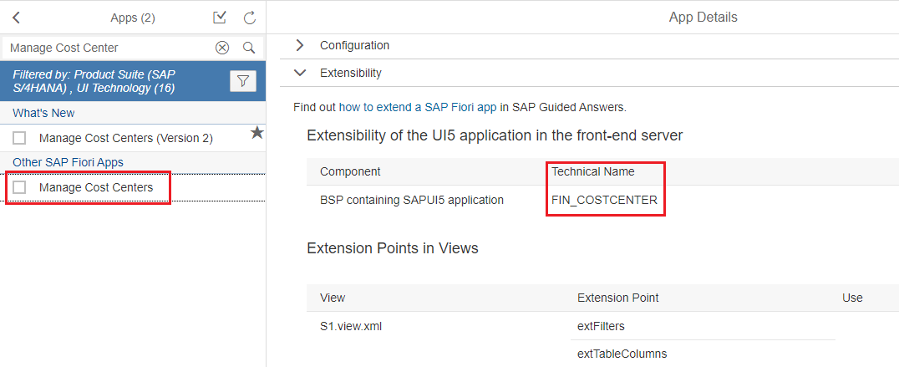

Then for some apps we will find the extension points for Fiori apps in the apps library and those can be found in Fiori apps library in the extensibility tab.

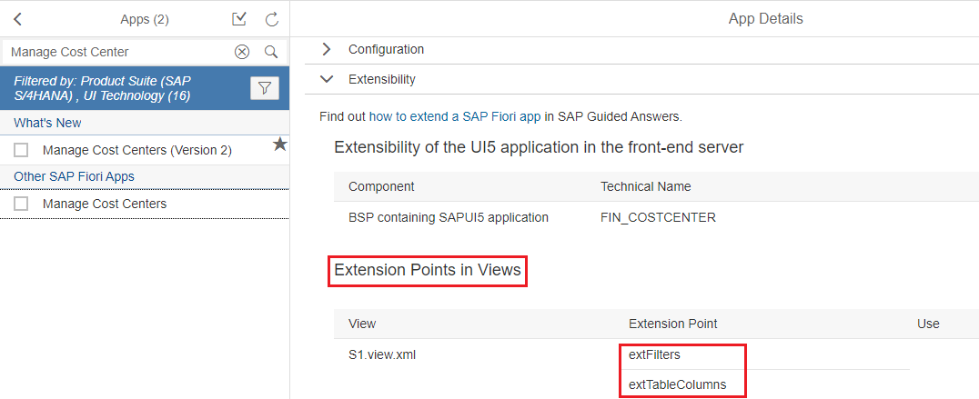

Then we will create the extension of the standard project, like right click on the workspace and click on the **New 🡪 Extension Project**

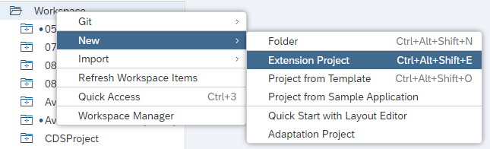

While extending the app if we Check the **Import original Application** the along with extension project it will import the original project also.

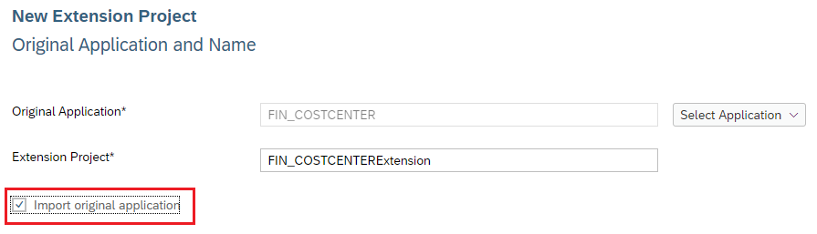

Then here we will give the standard application name. After that all are finished it will open an extensibility pane. And in that extension pane in the Outline section we can see the extension points and we can do basic extension from here.

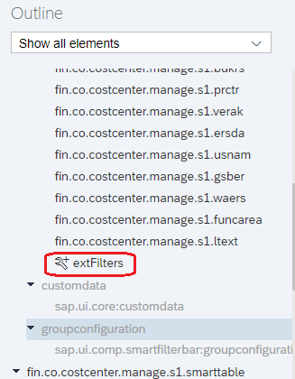

Like in extensibility pane we can delete a field from view, like select the field in the pane and hide the field.

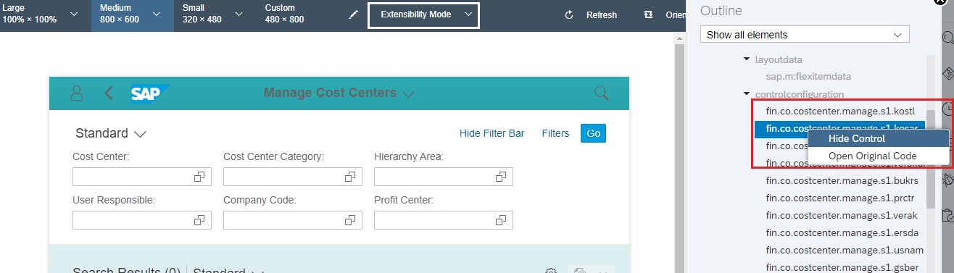

After the field hiding manifest.json file we will see the view modification entry.

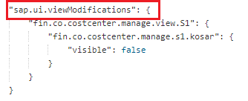

After extension the project will look like below.

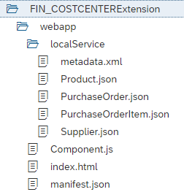

To do the extension we will right click on the project and click on new and then click on Extension.

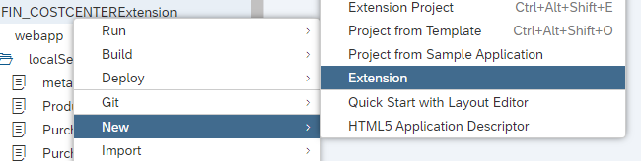

And there we will find lot of options and here we are doing extend view like below.

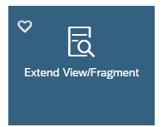

Now we are extending the S1 view and we will add one new filter.

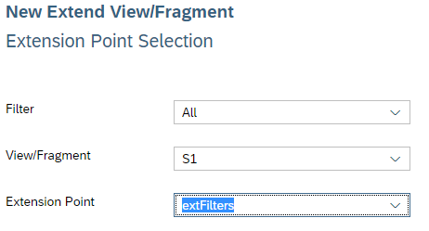

After that the new extension view will open and there, we will add our new field like below.

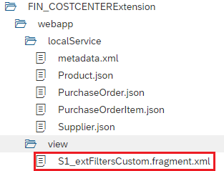

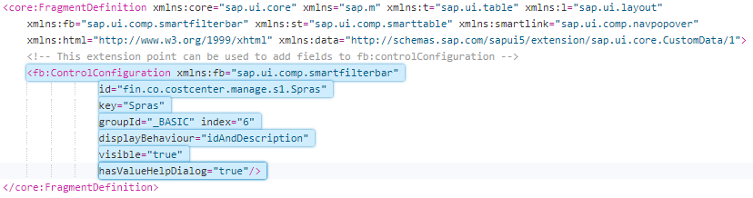

Once we are done with the extension, we can see there is an entry inserted in the manifest.json file like below.

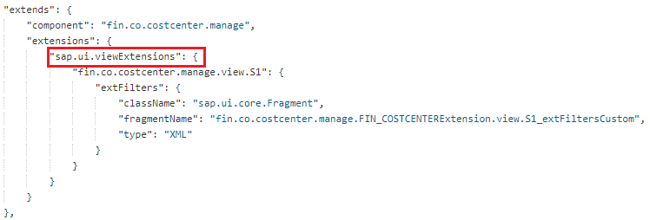

We can do the View Replacement but this is not at all recommended. But the below way we can do that. Right click on the project click on new and then extension. Then we will select Replace View.

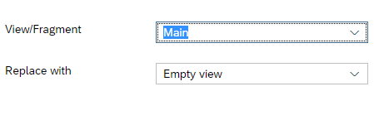

Then in the new replaced view will add the controls.

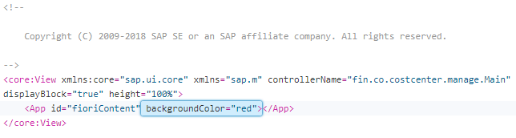

And there will an entry in manifest.json file for view replacement.

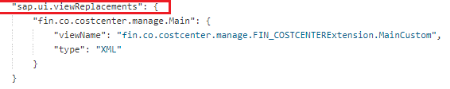

# Steps to do Controller Extension

To do controller extension we will follow the same procedure. Right click on the project and click on New and then click on Extension. And then we will click on Extend Controller.

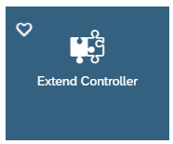

In the below Custom Controller, we have added below code so that it should work and for all the Hook methods it will call the original and overridden method so there will not be any problem in our app and it will show an extra alert.

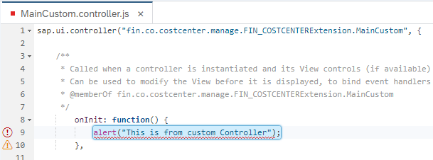

After that we will see an entry is being added to manifest.json file.

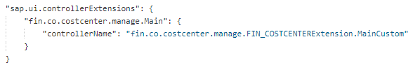

Ultimately the manifest.json file will look like below.

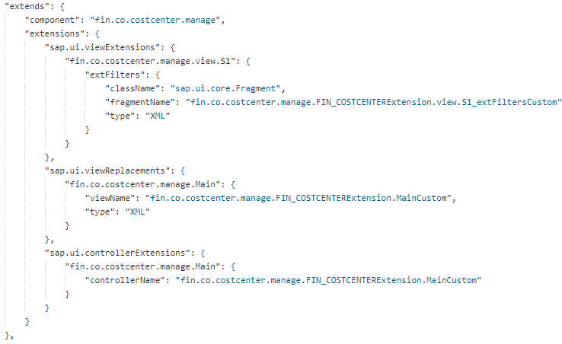

# OData Extension

Yes, it is possible to enhance the Standard OData sometimes in Fiori enhancement we may get some requirement to add some field and, in those cases, we need to enhance the standard OData. We will follow the below steps to enhance the standard OData.

Let’s say we have a standard OData **HCM_TIMESHEET_MAN** we will enhance the standard OData.

To do that we will create one custom OData first in **SEGW.**

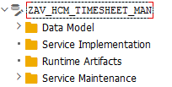

Then we will right click on the Data Model and Click on **Redefined** and then click on **OData Service (SAP GW).**

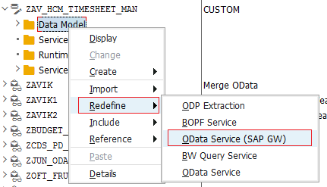

And there we will give the standard OData name there.

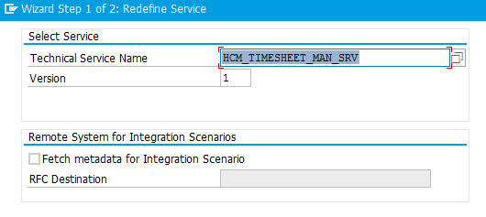

Then we will get the options to select the entity sets, maybe we don’t need to enhance all we need to enhance one or two.

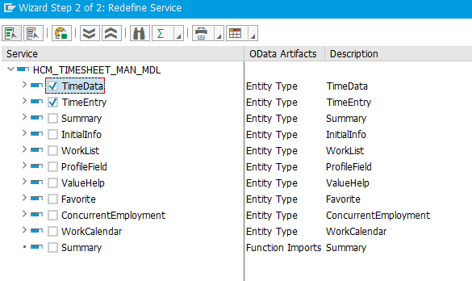

Then we will click on **Finish** and we will see our project structure is ready with the selected entity sets.

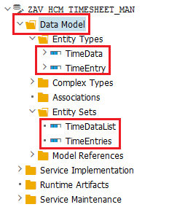

Now we will generate the service and activate the service and **ZAV_HCM_TIMESHEET_MAN_SRV** is my new service name.

# Service Extension in Fiori App

Now after doing the OData enhancement we need to add our all field to Fiori app and to do that we need to go to Fiori project enhancement and replace the service. After creating the Extension Project from the standard project (HCM_TSH_MAN) we will right click on the project and click new then click on Extension.

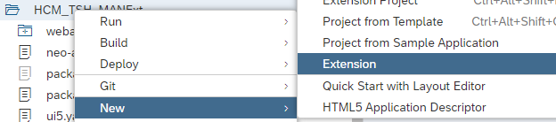

After that we will get options to replace Service.

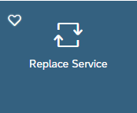

Later we will select our custom OData and click on finish it will replace the standard service with our new service and a new entry can be seen in the component.js file.

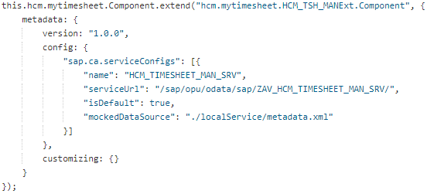

Now will do the necessary view extension and add the view fields.

# I18N Extension

We can do the enhancement for i18n as well and to do so we will right click on the project and select new then click on Extension. And after that we will select **i18n Resource Text Customization**

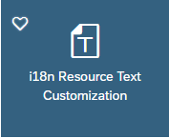

# Golden Rules for Good Extensibility

* Check if the requirement can be managed functionally using the SPRO customizing
* Check if you can make In-app Extension using Adapt UI tool – S/4HANA
* Check if you can do basic extension for Fiori App – WEBIDE
* Advance Extensions (Replacement) – WEBIDE

# Cross Application Navigation in UI5

The below code will show how to call another app from one app and this code will work only in Fiori launchpad.

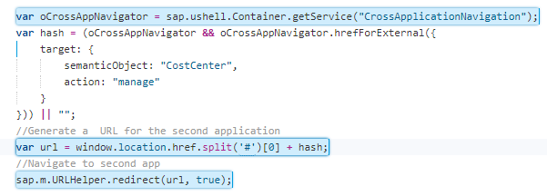

# Extend Hook in Fiori

If SAP has given some external points in controller object those can be implemented by using Extend Hook Method options.

So here we have one standard app and SAP has given two extension hook method

* extHookChangeHeaderFooterOptions
* extHookChangeObjectBeforePost

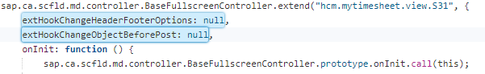

Now there is some requirement to fulfil that we need to implement these methods to do that we will right click on the project then click on New then click on Extension and there we will select **Implement UI Controller Hook**.

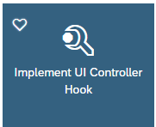

And once we select the above option, we will get the list of hooks automatically like below.

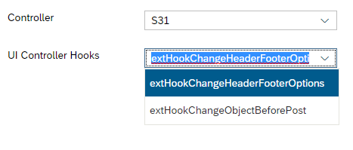

Then we will get a custom controller and we will get the hook method open to implement our custom code.

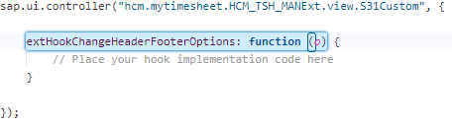

For every hook method implementation SAP will supply an object or array with all of data like here SAP provided **“o”** object for footer section and using this we can add our button in footer. Sample code can be found in below screen.

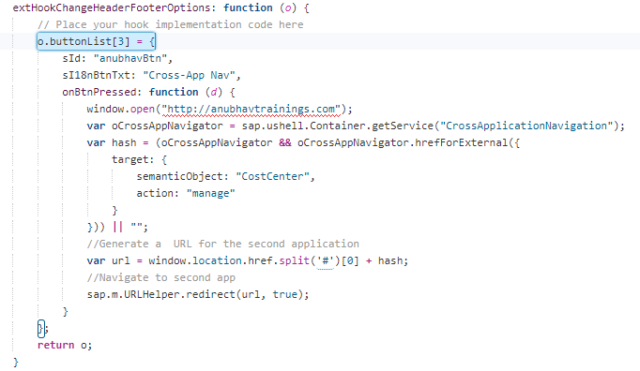

Same way we have another hook method and for that we have code below.

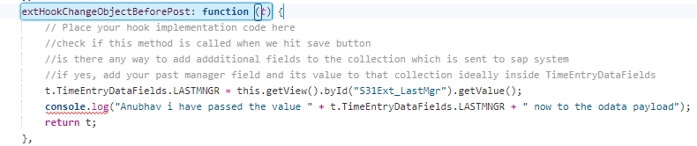

# Replacement of Hook Method

As we already know that if we override the hook (**onInit, onBeforeRenderring, onAfterRenderring, onExit**) methods, those will be called in standard code as well as in our custom app. So, here we have one requirement and which is not fulfilling by extend. That’s why we have replaced our hook method like below.

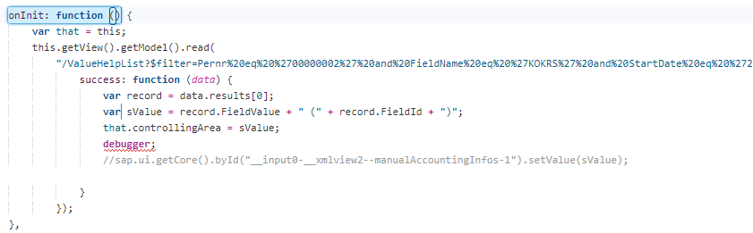

# Cross App Navigation in Annotations

The cross-app navigation is possible in annotation based OVP pages as well. For that we will add an annotation inside the chart annotation and there we will give the Semantic Object and Actions to navigate like below.

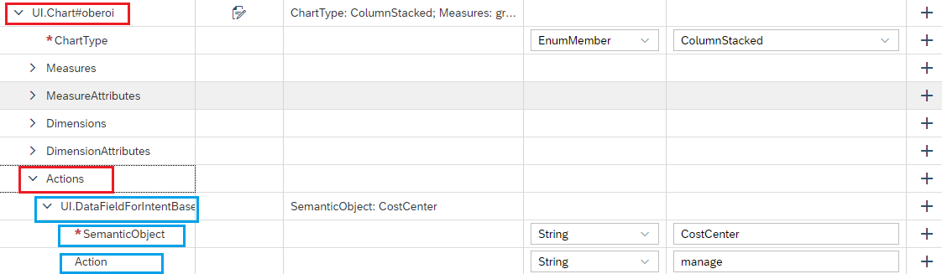

# Cross App Navigation Tutorial

* <https://blogs.sap.com/2016/06/20/cross-application-navigation-between-sapui5-applications/>
* <https://blogs.sap.com/2017/06/23/cross-app-navigation-in-sap-fiori-launchpad/>

# Design of an SAP Solution

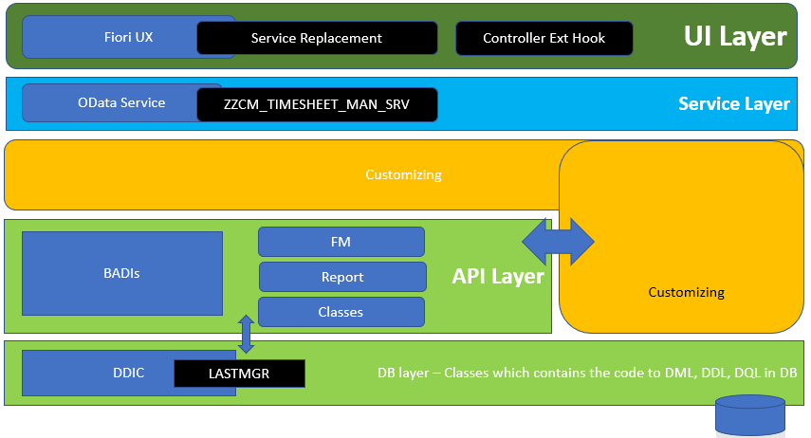

# Issue with Launchpad HTML

Sometimes it will show that the launchpad cannot load the views and controllers. This issue is basically with the **URL** parameter value below we will show the same.

Like below for URL we have used “./” because our html file is in **WEBAPP** folder, it is in another folder then we will use it some other values based on the folder situations.

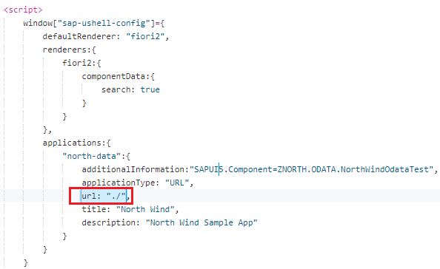

**Folder Structure:**

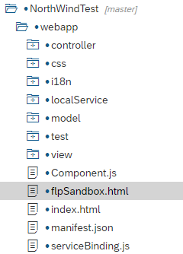

# Generate Test Structure in UI5 from WEBIDE.

In some projects we don’t have test folder which is automatically generated from WEBIDE like the below project doesn’t have any test folder.

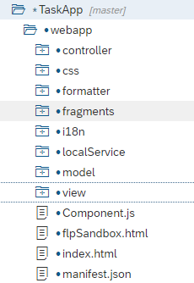

To generate test folder from WEBIDE we will right click on the project and select new and then select test structure like below.

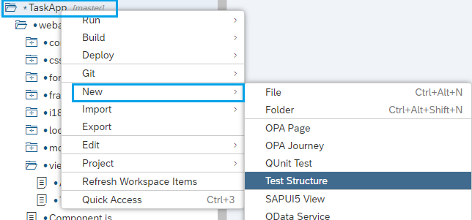

Once we click on that it will generate a test structure including OPA and Q Unit out of the box.

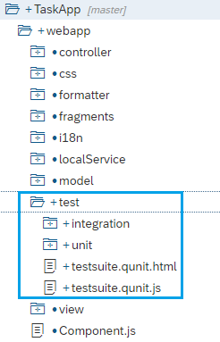

# Code to click on the list item in OPA5

The below code will trigger the list item in list control after search.

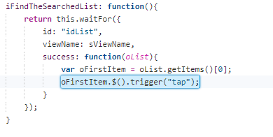

# Search with click and go to detail view Code

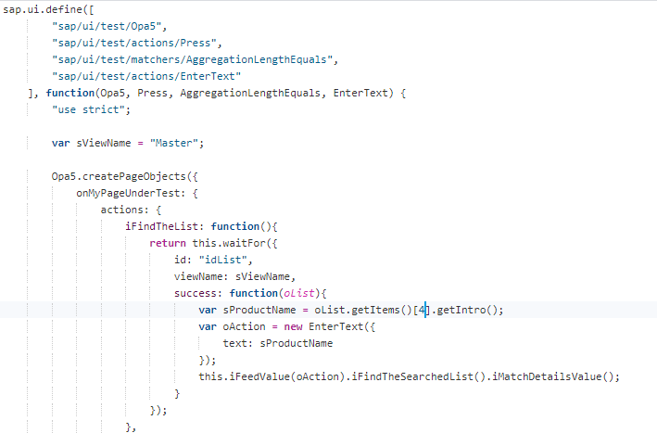

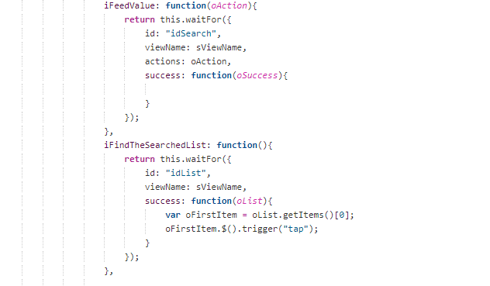

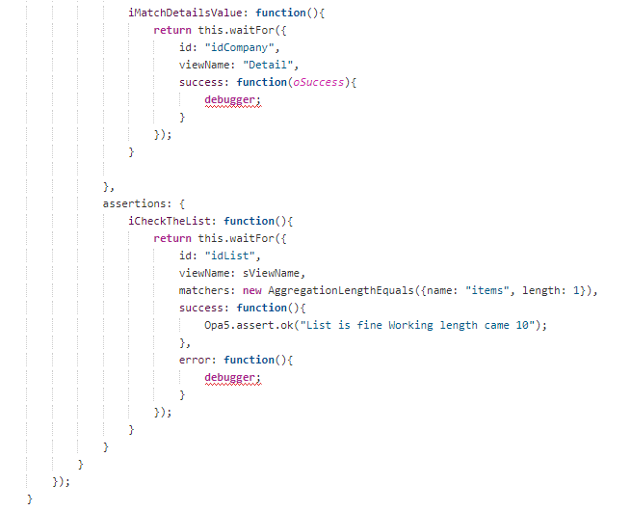

# How to see the Roles of PFCG using Catalog id in ui5

Yes, it is possible to see the roles from Catalog id or Group id. Using **/UI2/FLC** is the transaction to see all the details.

Once it is open in the layout option, we will select **All** option to see everything about the tile or Catalog or Group.

# Tear Down OPA Page

Once we are done with the OPA test then we need to close the app otherwise it will always be in the front of the screen and to do that we have a method iTeardownMyUIComponent() of OPA5 class. And we will call that in the assertion so that after assertion successful then page will be closed.

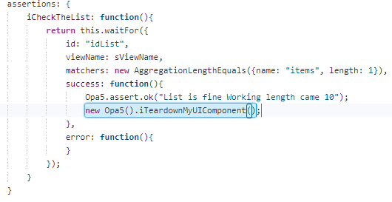

# What is FIORI Launchpad and Explain it?

As we know there are more than 500 FIORI applications, SAP has provided a Shell or single point place from where we can access the all the applications. This serves as a home page for all the FIORI applications provided to. This shows tile-based UI where every UI redirect to assigned FIORI application. This Launchpad is fully customizable according to your needs like theming and all.

# Fiori Design Principles

The design philosophy of SAP Fiori is based on five core principles. SAP Fiori user experience is role-based, adaptive, simple, coherent, and delightful.

* **ROLE-BASED:** SAP Fiori is designed for your business, your needs, and how you work. It draws from our broad insights on the multifaceted roles of today’s workforce. SAP Fiori provides the right information at the right time and reflects the way you actually work.
* **DELIGHTFUL:** Apart from making you work smarter; SAP Fiori also enriches your work experience by allowing you to simply do your job.
* **COHERENT:** Whether you fulfil a sales order, review your latest KPIs, or manage leave requests – SAP Fiori adheres to a consistent interaction and visual design language. Across the enterprise, you enjoy the same intuitive and consistent experience.
* **SIMPLE:** With SAP Fiori, you can complete your job intuitively and quickly. SAP Fiori helps you focus on what is important – essential functions are easy to use and you can personalize the experience to focus on your relevant tasks and activities.
* **ADAPTIVE:** SAP Fiori enables you to work how and where you want, regardless of the device you use. And, it provides relevant information that allows for instant insight.

# Version Comparison in Git WEBIDE

It is possible to do a version comparison in WEBIDE. To do so we will go to the Git history tab in the WEBIDE and then select the desired version which I you want to compare with the current version. And then double click on the section and see the version comparison.

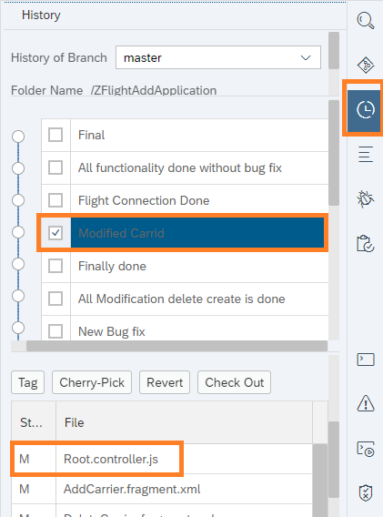

Then Double click on the desired version and see the Comparison. Like here we clicked on **Root.controller.js** file.

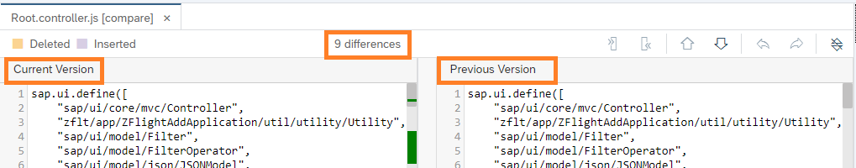

# What are Fiori Elements?

To reduce the amount of front-end code while developing an SAP Fiori app and to keep the design consistent, SAP introduced a framework to generate UIs; it’s called SAP Fiori elements.

SAP Fiori elements uses metadata annotations and predefined templates to generate an SAP Fiori app. With the latest release of SAPUI5 (version 1.44), the floorplans shown below are available with SAP Fiori elements.

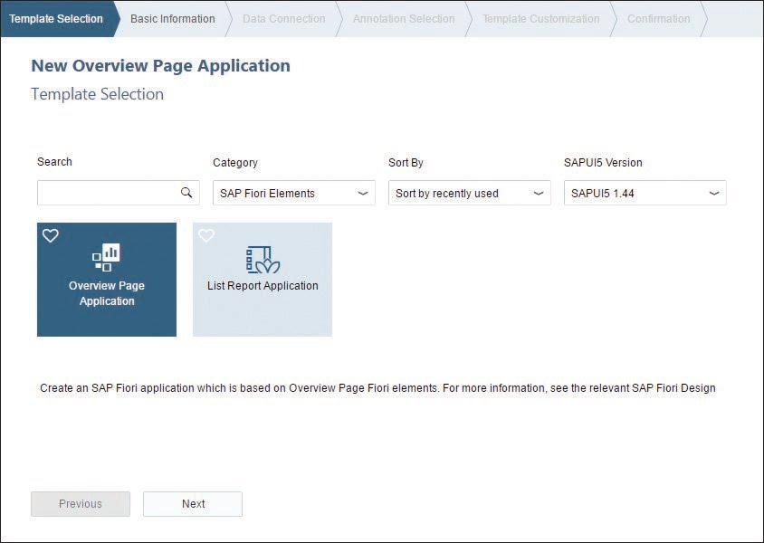

# Types of SAP Fiori Element Floorplans

* **Overview Page:** The SAP Fiori overview page application is a type of floor plan with a UI framework that provides quick access to vital business information at a glance. This is in the form of actionable cards on a single page, enabling users to make faster decisions and focus on their most important tasks.

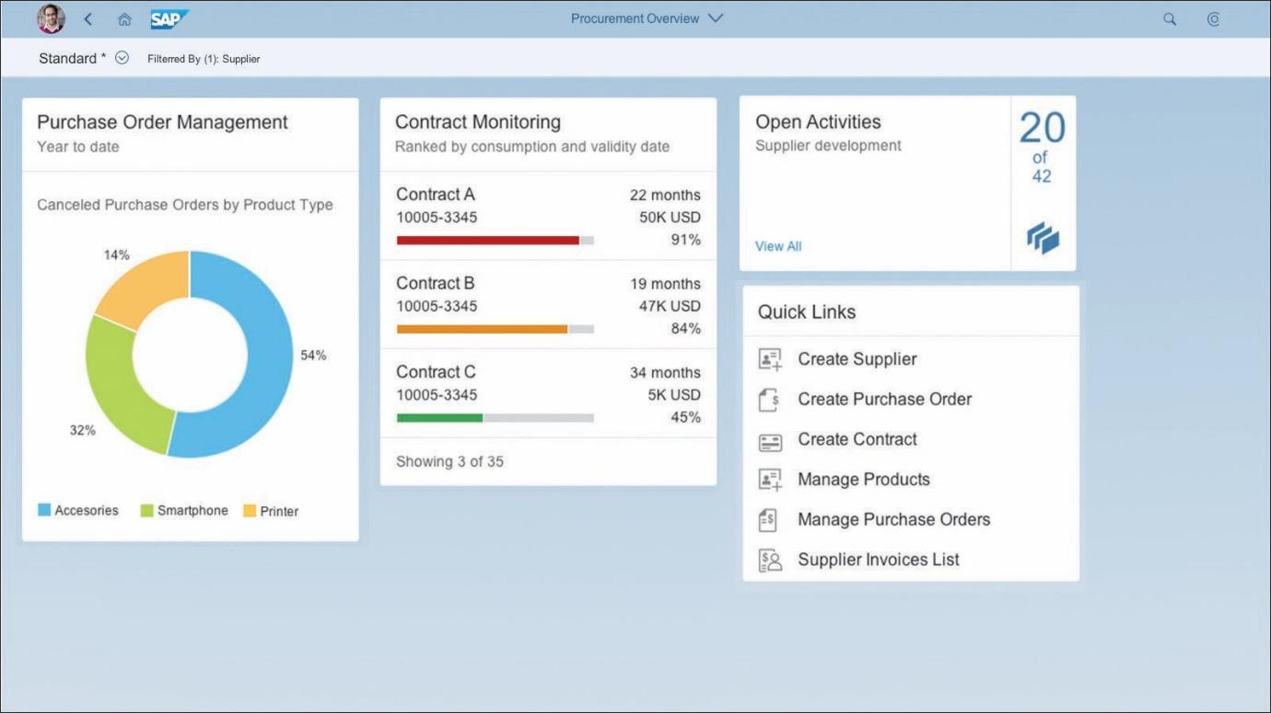

Cards are containers for app content, and they represent an entry-level view of the most relevant app data for a given topic. The SAP Fiori overview page contains five types of cards, shown in this figure:

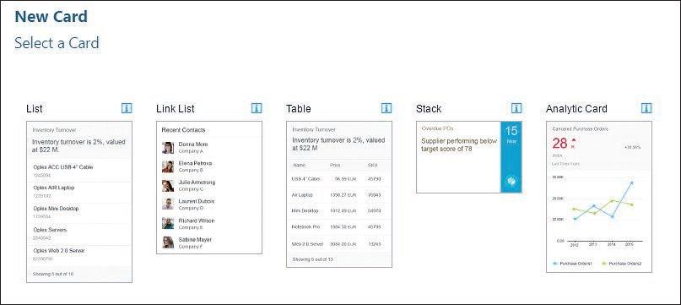

Each type of card allows users to visualize information in an interactive and efficient way:

* + **List:** List cards display items in a vertical list.
  + **Link list:** Link list cards display items as links or images that can navigate to a target or open a pop-up window with additional information.
  + **Table:** Table cards display items in a table format.
  + **Stack:** The stack card is a special type of card that displays a collection of single object cards. This type of card has two clickable areas; the left area navigates to the parent app, and the right area opens the object stream.
  + **Analytic:** Analytic cards consist of two areas: a header area that displays the aggregated values of a KPI and a chart area that displays data in a graphical format.
* **List Report Floorplan:** The second type of floorplan is the List Report application, a reusable floorplan template that allows users to work with large lists of items and act on each one.

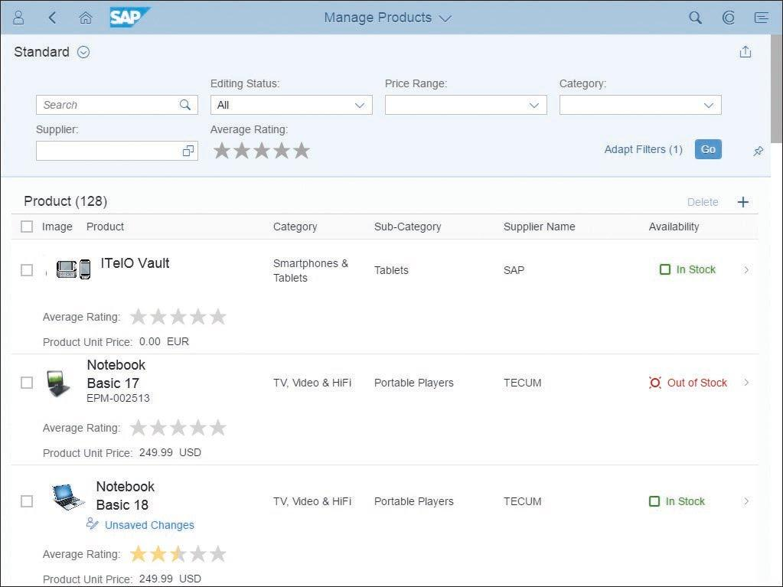

* **Object Page Floorplan:** Object Page (as seen below) is another type of floorplan template, which allows users to display, create, or edit an item. The Object Page floorplan can be implemented using the pre-built SAP Fiori element.

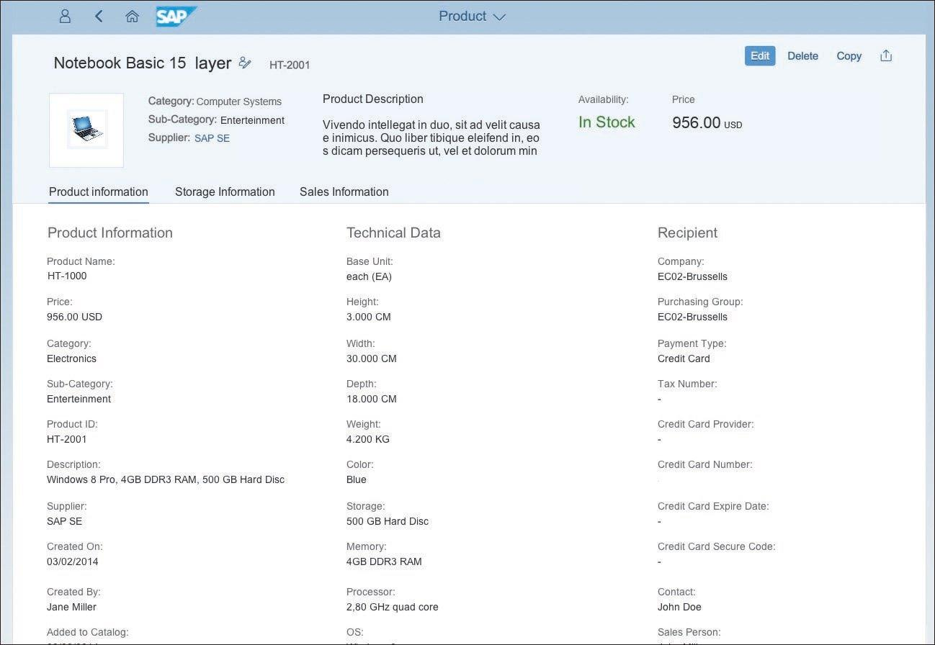

# Annotation Based Knowledge Documentation

SAP guided Documentation can be found in the below link.

* + <https://help.sap.com/viewer/b4b7cba328bc480d9b373c7da9335537/2.08/en-US/83c89ccef12f48ab98f6c3811bd025b3.html>
  + <https://help.sap.com/viewer/b4b7cba328bc480d9b373c7da9335537/2.08/en-US/3cdebeebb04b4205908140242c9d6817.html>
  + <https://help.sap.com/viewer/b4b7cba328bc480d9b373c7da9335537/2.14/en-US/83c89ccef12f48ab98f6c3811bd025b3.html> (Latest)

# Annotation Based List Report Fiori Application

Along with UI5 project we can use the Annotations in Fiori also to create the application. To do that we will use the Fiori Element while creating the project. Below step will guide you the same.

Will create project like below.

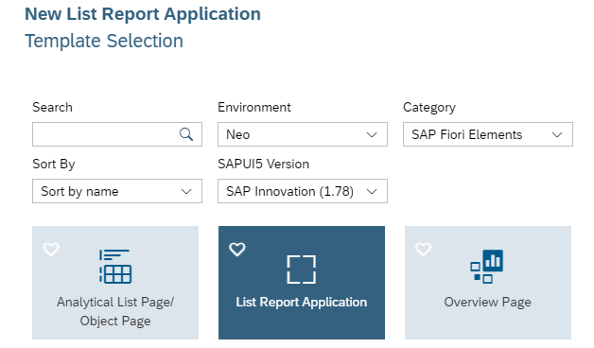

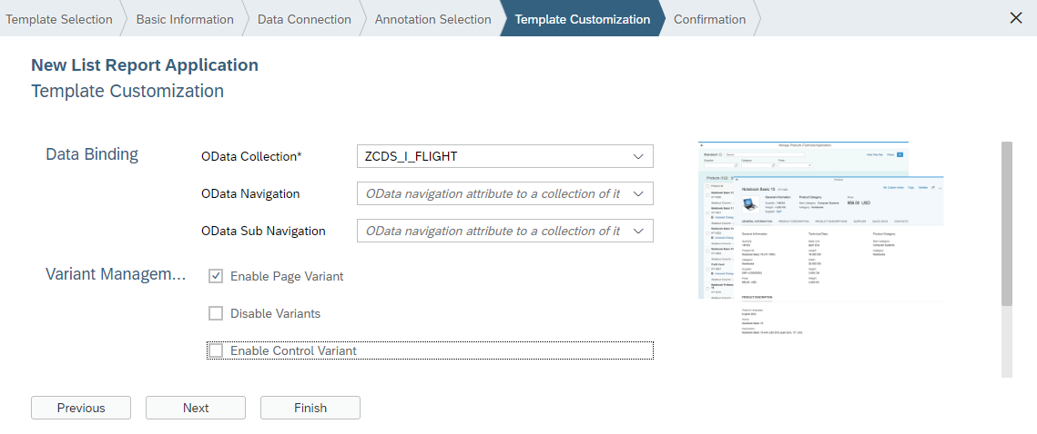

Then Finish it will create new project.

Initial project structure will look like below.

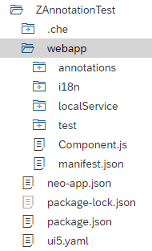

Then we will add the Annotation file (**Right Click on WebApp 🡪 New 🡪 Annotation File)** like below.

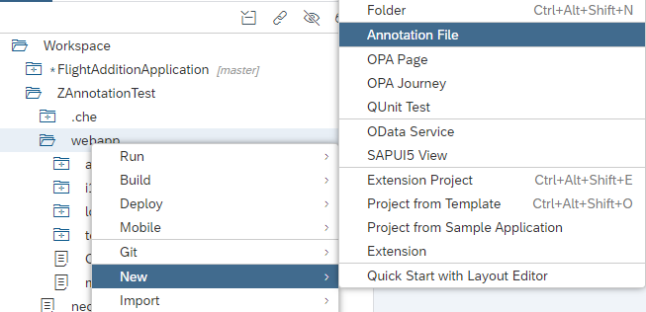

Will provide the Annotation file details and finish.

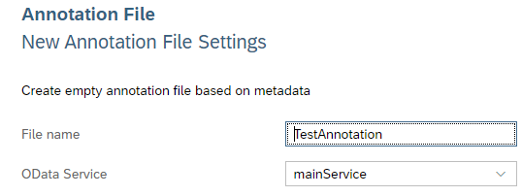

After creation of the Annotation file we will see one record is been added in Manifest json file like below.

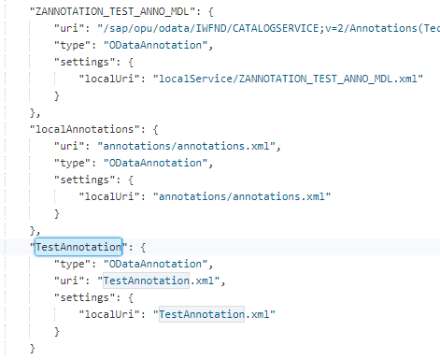

The Annotation file will look like below.

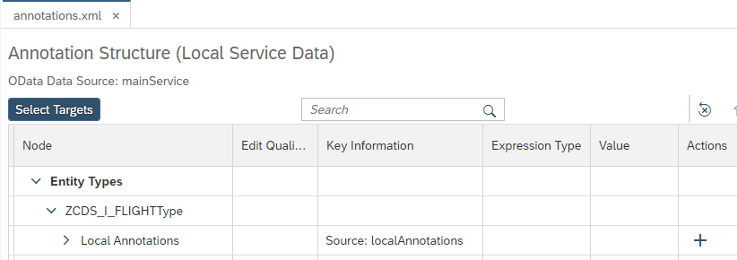

The Local annotations node is where we will add our all the annotations. in other words, they are “local” to this external file, as opposed to “remote”, based inside the metadata document.

## LineItem

Now we will add the Line item and for that we will use the **Plus (+)** symbol in the Actions column. **Line item** will be the item which will show in the table.

Once we click on the **Line Item,** we will see lot of options and we can search as well.

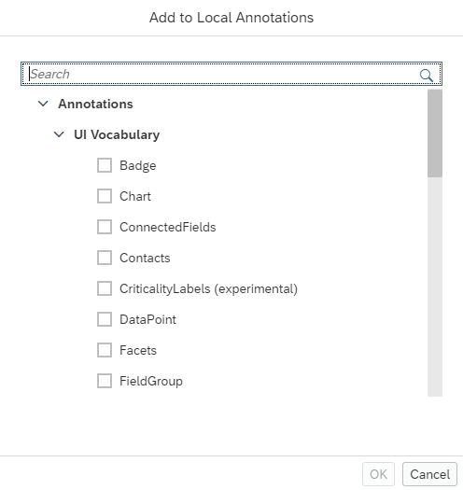

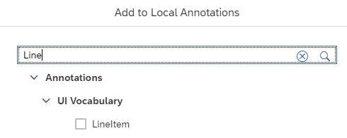

## DataFieldWithUrl

Now create a node within the **UI.LineItem** by using its plus symbol and choosing **DataFieldWithUrl** from the dialog box that appears – the dialog box will be similar to the previous one, but with different choices.

Make sure you are using the right plus buttons each time you add annotations

Now here we will add the **DataFieldWithUrl** annotation from the **Plus (+)** button.

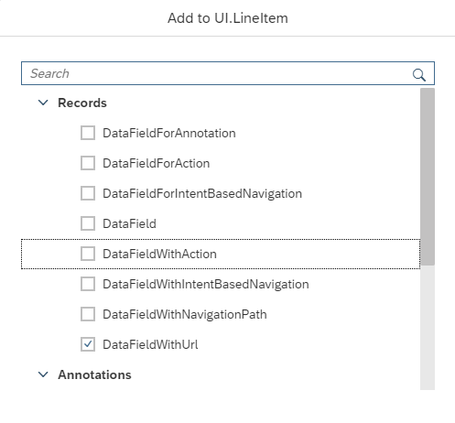

After adding the annotation, it will look like below and we need to choose the Path from the OData from the dropdown list.

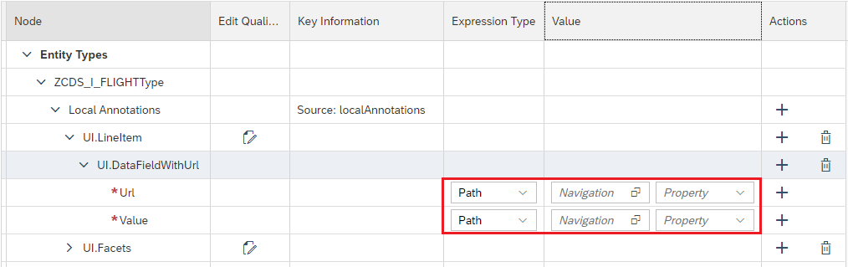

Let’s say here we have chosen **airportfrom** field from the OData like below.

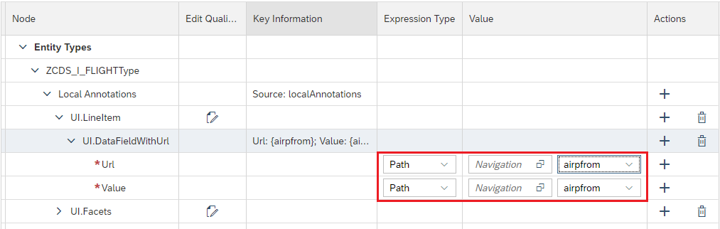

Now if we execute this, we will see a field in the table. Since we have added **DataFieldWithUrl** then we will see the value with link like below.

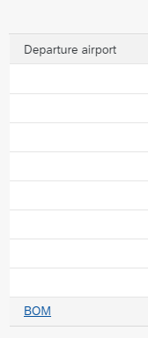

If we click on this it will navigate to the mentioned URL.

## DataField

Now we will add a simple **DataField** from the **Plus (+)** button (Inside **UI.LineItem** node) and we will see simple value is coming on the Table on the screen and there is no link for that.

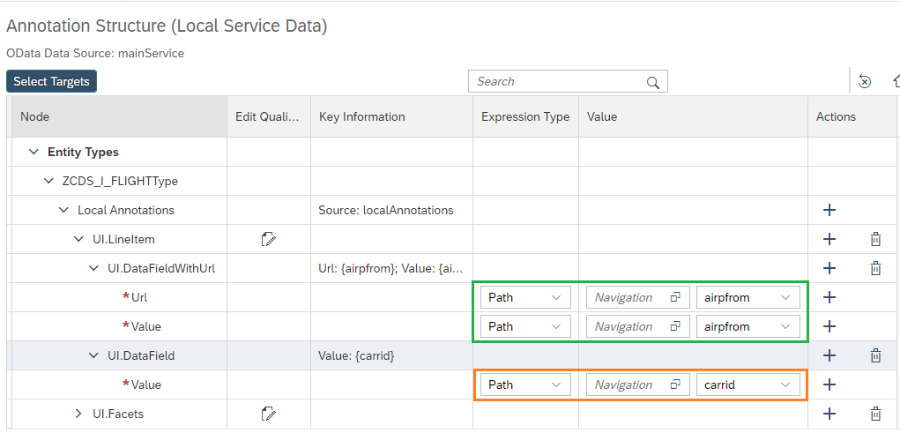

Now if we go execute that we will see new field in the Table which doesn’t have any link because we have added the **DataField** not DataFieldWithUrl. The Table will look like below.

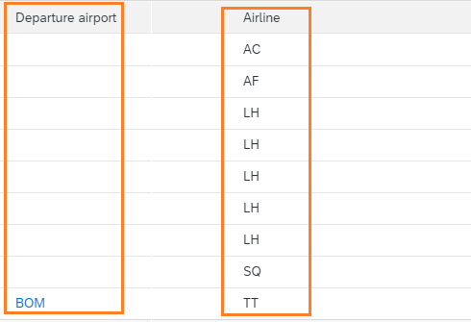

## PresentationVariant

Now the data is not in sorted order to sort them up we will add a **PresentationVariant** annotation in the local annotations section using the **Plus (+)** button. And inside **UIPresentationVariant** we will add the **SortOrder** annotation and inside that we will add the **SortOrderType** annotation and provide the property name by which it will be sorted like below.

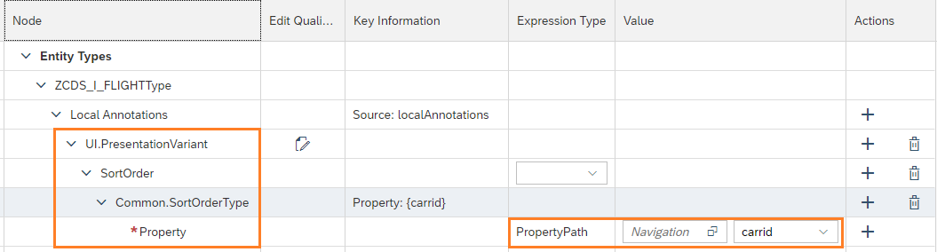

## HeaderInfo

Now we will add the Header info Annotation which is responsible for Table header. For that we will use **HeaderInfo** annotation. And in that Annotation, we need to provide the name and plural name it can be by String, String Path or I18n.

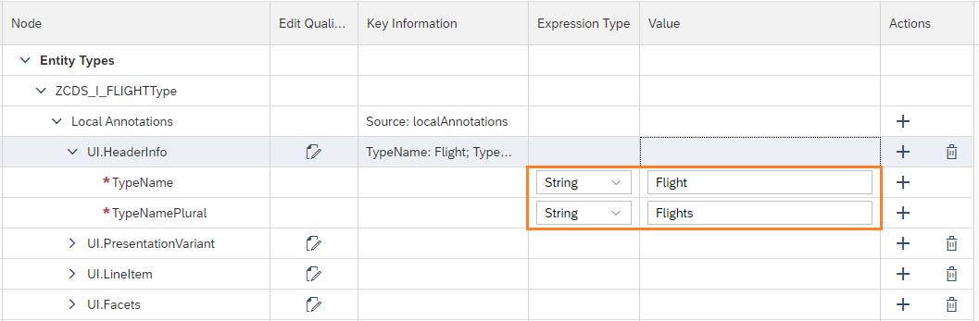

After execution it will look like below.

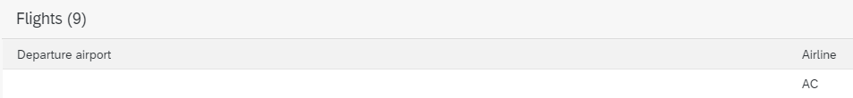

## SelectionField

Now we will add the **SelectionField** annotation which will come on the top for asking for the value. And inside the **SelectionField** node we will add **Item** annotation so that we can add the fields. And after adding it will look below.

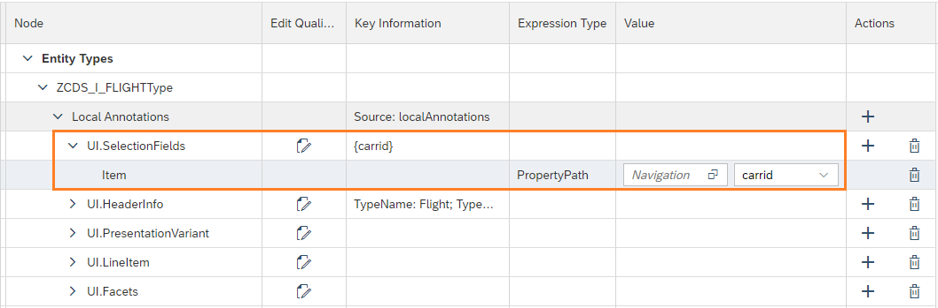

After execution of the code it will look like below.

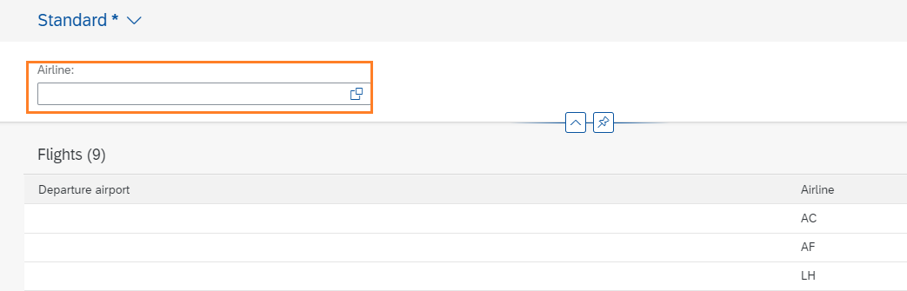

## Criticality & Importance

Sometime we get some requirement on stock options to show if the product is available or not. So basically, we show on the screen that product is **Available** or **Not Available** with color. To make this happen we use **UI.DataField** annotation is the parent annotation and inside that we use three more annotation:

* + 1. **Value:** This will give the Value of the product stock value like Available or Not Available like this.
    2. **Criticality:** This will be the stock value like 1 or 2 or 0 like this.
    3. **UI.Importance:** This will ENUM Number and if we make this low then it will show color red if the value is small number like 0 or 1 if we make it high then it will show red for the high numbers.

In the below screen we have **Availability** field which has value of [**Available/Not Available**] and **seatsocc** is having value like 0, 1, 10, etc. and then **UI.Importance** is low because I am showing not available for less numbers.

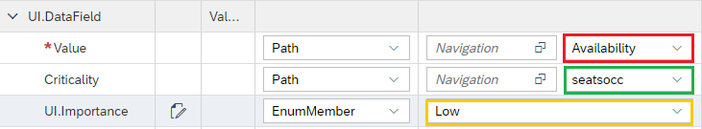

## UI.DataFieldForAnnotation

Sometimes we need **Rating** indicator in the List table and for that we use **UI.DataFieldForAnnotation** and inside the Data field annotation we will have two property

* + 1. **Label:** Label for the column label.
    2. **Target:** Target is for the annotation path which is available in CDS view.

Below screenshot will show how to prepare Rating indicator in List Report.



And in CDS View we will use the below annotation and this is mandatory annotation without the CDS annotation it will not work. CDS annotation will be **@UI.dataPoint.visualization: #RATING**

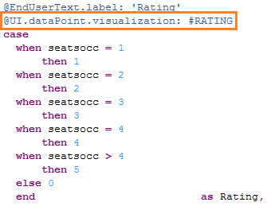

Table will look like below.

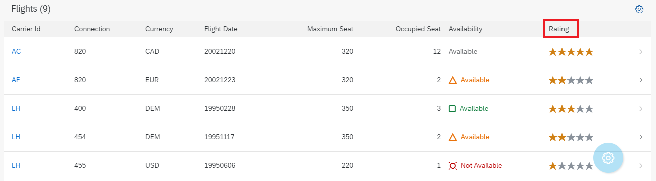

## UI.DataPoint

Now let’s say we have List report with Table and our requirement is, if we click on any record of the table then it should move to next page which can be any Object Page. And Using **UI.DataPoint** annotation we can create a Title in next page. We will add the **UI.DataPoint** annotation inside local annotation section.

In the below screenshot we have created the **UI.DataPoint** annotation inside the local annotation section and I have given a **Qualifier** name for this annotation.

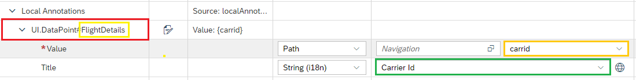

Now if we execute and click on the table row we will see below screen.

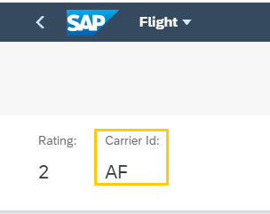

## UI.FieldGroup

Now let’s say in the Navigated page (Navigated from table row) we want some group of fields together under one section, to add those fields together we have **UI.FieldGroup** annotation and this annotation will come under **Local Annotations** section.

And inside **UI.FieldGroup** we will have below annotations.

* + 1. **Data:** This annotation is to collect all the **DataFields.**
    2. **UI.DataField:** This annotation will represent the Field Value and label.

Below screenshot will display the same. Here we have added this annotation under one **Qualifier** called **FlightDetails**.

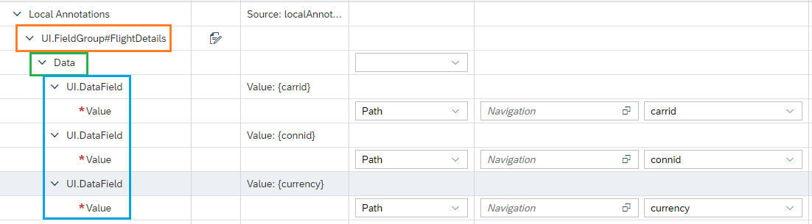

## UI.ReferenceFacet

Now created field group we will add under one section, to create the section we have **UI.ReferenceFacet** annotation and this annotation will come under **UI.Facets** annotation section and here in this annotation we have two property mainly

* + 1. **Target:** In that we will mention the field group which we have created earlier like we have created **UI.FieldGroup#FlightDetails** so here we will mention this as an annotation path**”@ UI.FieldGroup#FlightDetails”**.
    2. **Label:** This is the label for the section.

Below screenshot will show you the same.

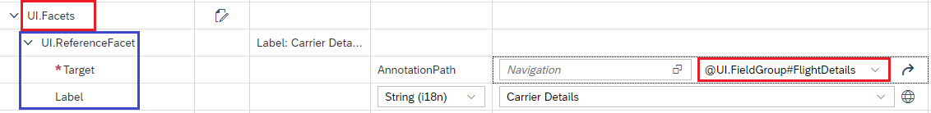

Now if we execute this, we will see a new section is been create called **Carrier Details** and under that we have all the fields which we have created earlier (CarrierId, ConnId, Currency).

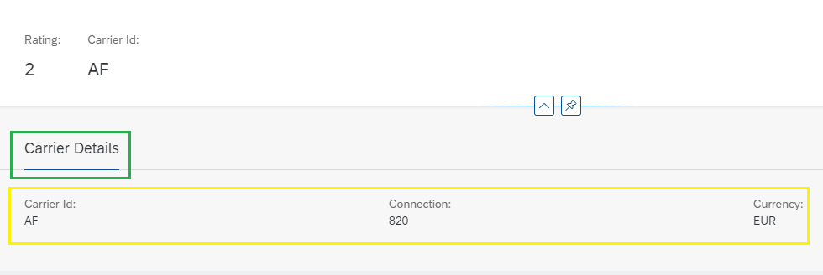

Now we have added one for **UI.ReferenceFacet** and for that we will see one more section added on the screen.

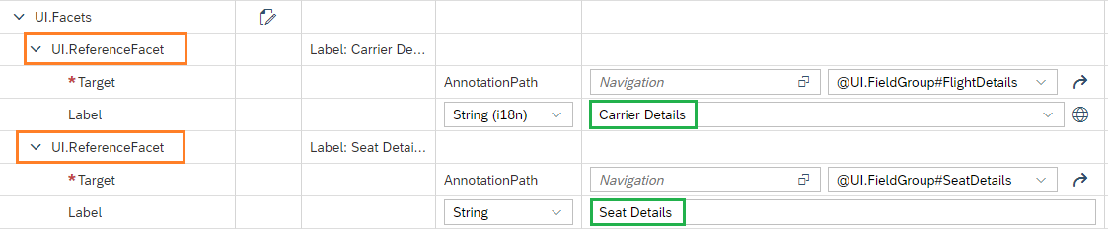

And if we execute it, we will see two section is been created on the screen like below.

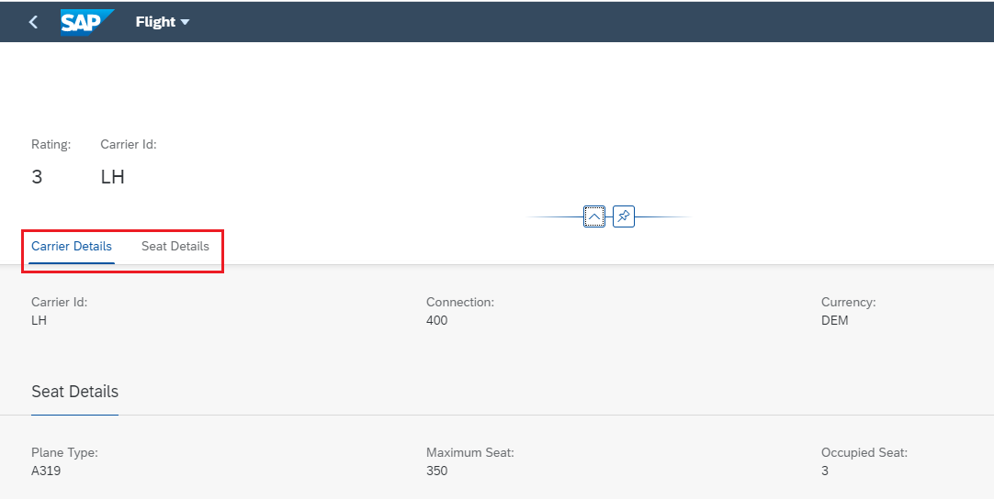

## Pages

Now let’s say we have requirement that we need only first page and we don’t want to navigate to next page if we click on the table row for that we will delete the **“pages”** json from **manifest.json** file. Like below.

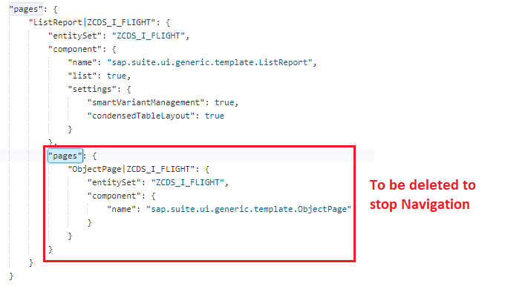

If we remove this then we will not see navigation option in list report table like below.

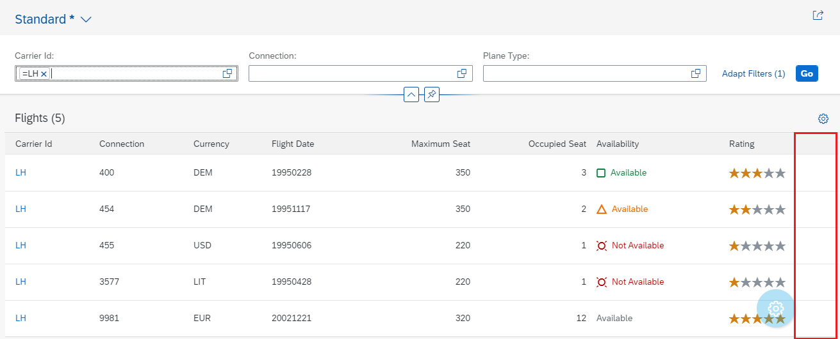

## DataFieldForAction

Sometime we get a requirement that we need to create some actions like to create a button may be delete or create or copy etc. And the button can be inside the Table or at the Table header level or it can be at the footer level. To do so we have an annotation called **UI.DataFieldForAction** and for that we need to create one Function import after clicking the Button it will trigger the function import.

* **For Header:** For Header table button we will use **UI.DataFieldForAction** annotation and this annotation will come under **UI.LimeItem** annotation and this annotation will have couple of attributes like below.
  + **Action:** Here we will provide the OData function import and it will come automatically in the dropdown. Here it is **CopyData.**
  + **Label:** This is for the button label like here we gave **Copy.**
  + **InvocationGrouping:** For invocation grouping we will provide **Isolated** and it will create the button at the header level. Below screen shot will show the same.

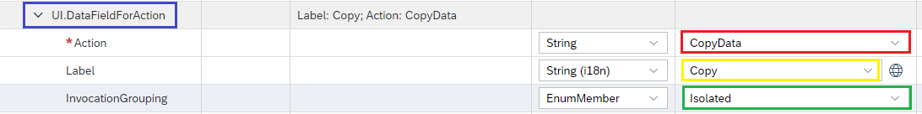

Once we execute this, we will see the Button at the header level like below.

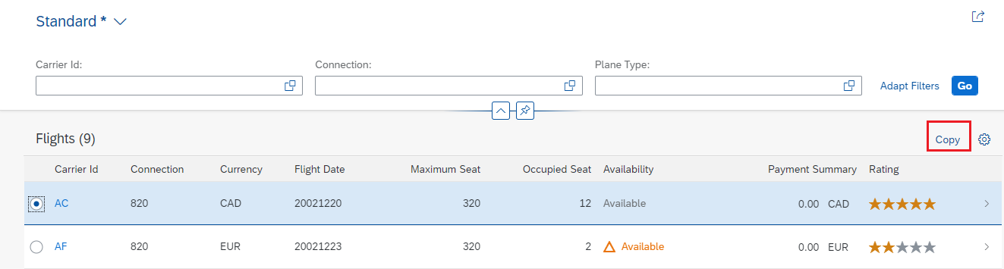

* **For Footer:** If we want this button to be in the footer section of the table then we use the same **UI.DataFieldForAction** annotation. And we will use the below attributes to make this happen.
  + **Action:** Here we will provide the OData function import and it will come automatically in the dropdown. Here it is **CopyData.**
  + **Label:** This is for the button label like here we gave **Copy.**
  + **InvocationGrouping:** For invocation grouping we will provide **Isolated** and it will create the button at the header level. Below screen shot will show the same.
  + **Determining:** We will put the **Determining** value to be true which is responsible for footer section. Below screenshot will show the same.

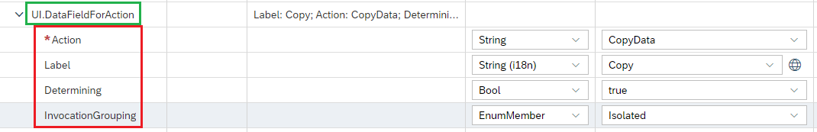

If we execute this, we can see the below output on the screen.

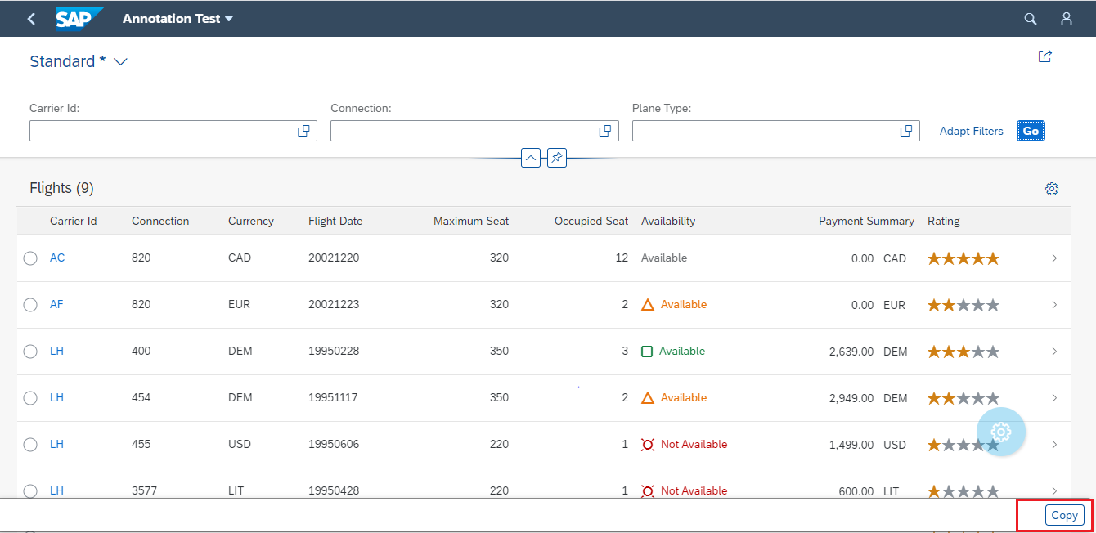

* **For Table Column:** Now if we want this field inside the table content and we want this in every row of the table then we will use the same **UI.DataFieldForAction** annotation and we will use the below attributes for that.
  + **Action:** Here we will provide the OData function import and it will come automatically in the dropdown. Here it is **CopyData.**
  + **Label:** This is for the button label like here we gave **Copy.**
  + **InvocationGrouping:** For invocation grouping we will provide **Isolated** and it will create the button at the header level. Below screen shot will show the same.
  + **Inline:** For inline property we will provide value **true** this is responsible for making this button inside the table. Below screenshot will show you the same.

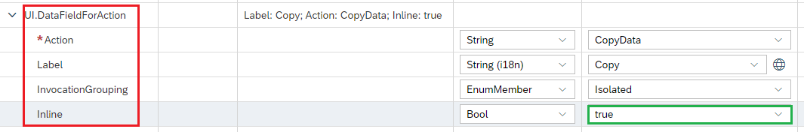

After executing this code, it will look like below.

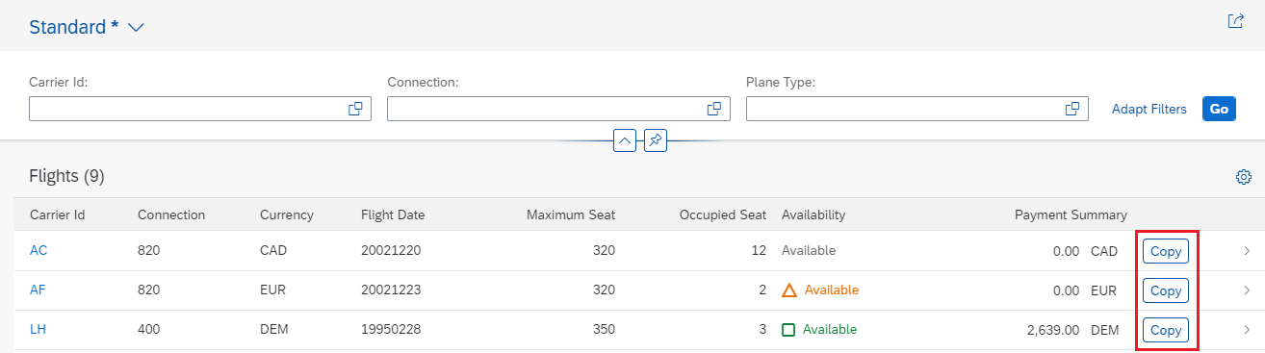

## UI.Identification

To make customizing in the object page which will be navigated from the table row we use **UI.Identification** annotation. In some cases we need the button in the object page and for that we use the same annotation **UI.DataFieldForAction** and for object page this annotation will come inside **UI.Identification** annotation.

* **For Footer:** If we want this button to be in the footer section of the table then we use the same **UI.DataFieldForAction** annotation. And we will use the below attributes to make this happen.
  + **Action:** Here we will provide the OData function import and it will come automatically in the dropdown. Here it is **CopyData.**
  + **Label:** This is for the button label like here we gave **Copy.**
  + **InvocationGrouping:** For invocation grouping we will provide **Isolated** and it will create the button at the header level. Below screen shot will show the same.
  + **Determining:** We will put the **Determining** value to be true which is responsible for footer section. Below screenshot will show the same.

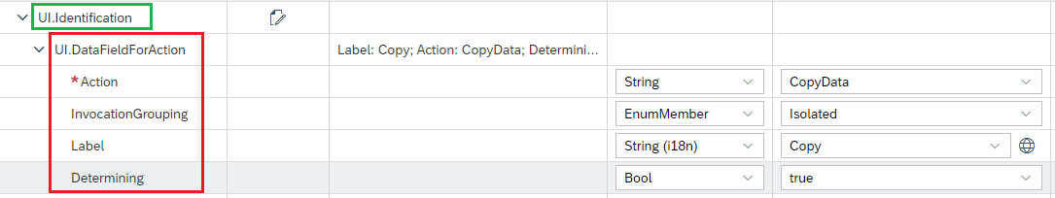

If we execute this code we can see below result.

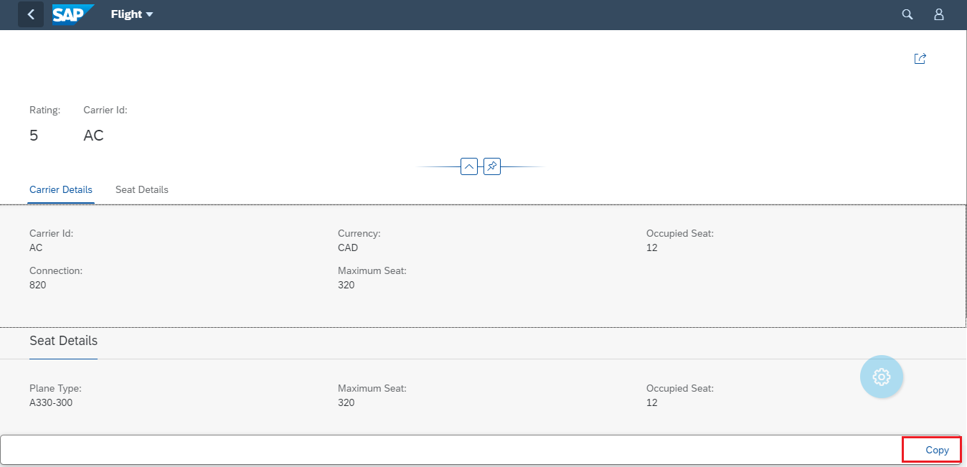

* **For Header:** For Header table button we will use **UI.DataFieldForAction** annotation and this annotation will come under **UI.Identification** annotation and this annotation will have couple of attributes like below.
  + **Action:** Here we will provide the OData function import and it will come automatically in the dropdown. Here it is **CopyData.**
  + **Label:** This is for the button label like here we gave **Copy.**
  + **InvocationGrouping:** For invocation grouping we will provide **Isolated** and it will create the button at the header level. Below screen shot will show the same.

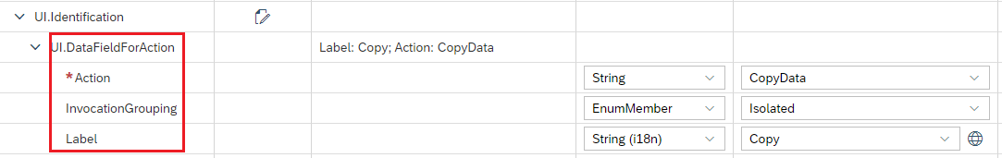

If we execute the below code then we will see the below result.

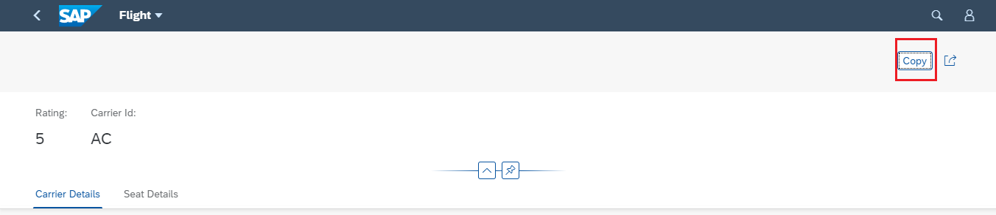

## Standard Search

Generally, we need the standard search operation by this search operation we can search globally and it is very useful at times. To make this happen we need **Searchable** annotation in the CDS view. The important annotations for the search are below.

1. **@Search.searchable:** We make the value of this annotation true and if we add this annotation then we must need to add the at least one **DefaultSearchElement** annotation for field and let’s say we have added this for 4 attributes so this search will work for those 4 attributes only.
2. **@Search.defaultSearchElement:** We make this annotation true for how many attributes we need, like here we did for 3 attributes.
3. **@Search.fuzzinessThreshold:** This is for fuzzy search and the threshold of the fuzzy search. Below screen shot will show the same.

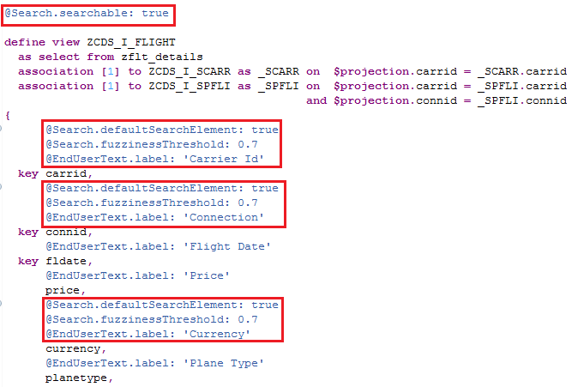

Once we execute this, we will get the below output.

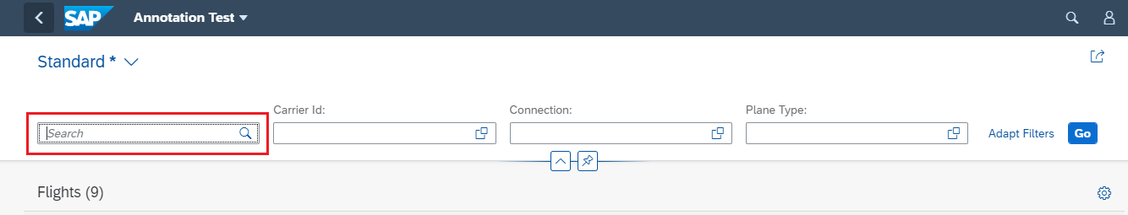

So here we mentioned this search for 3 attributes (Carrid, Connid, Currency) so we can give a search for all these attributes.

We can do search fuzzy search.

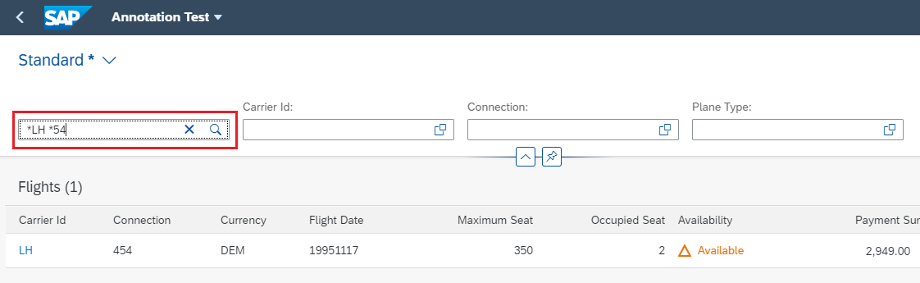

## Mandatory Parameter

Sometimes we come across situation that we need to make the selection field mandatory and for that we need annotation in CDS view. We need **@Consumption.filter: {mandatory: true}** annotation. For which ever field we make this true then that field will become mandatory and validation will be taken automatically.

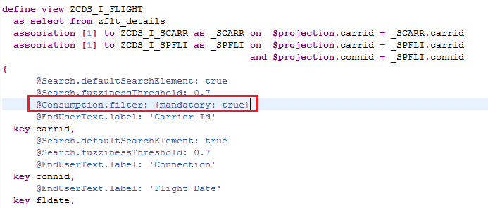

So here we have made the **Carrid** mandatory and after execution we will see carrid is mandatory parameter.

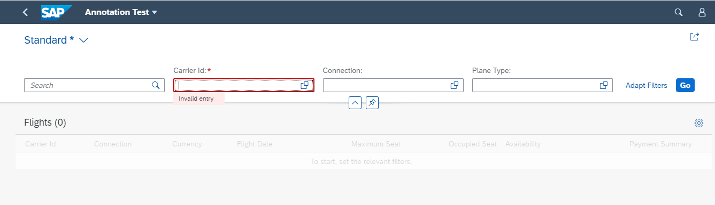

## Object Page Header

Now if we move to the Object page then we need to add the title in that page and to do so we have **UI.HeaderInfo** annotation. This annotation will come under **Local Annotations.** The annotation we have already added for Table header info now if we add the **Title** and **Description** property there then it will show up in Object Page. Below is the screenshot of the annotation.

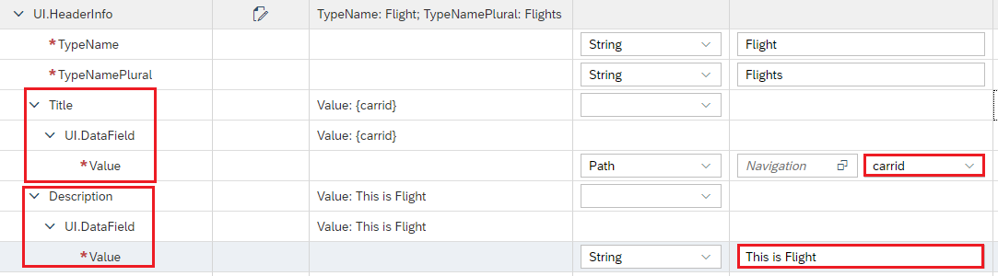

Now if we execute this, we will see the **Header** in the Object Page with **Description.**

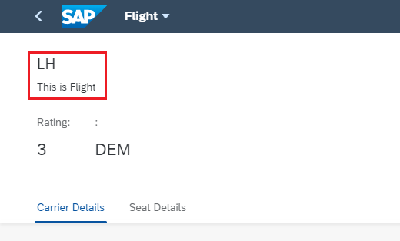

## UI.DataFieldWithNavigationPath

Now let’s say in Our CDS view we have lot more exposed associations and we would like to use them and want take the field from them in those cases we use **UI.DataFieldWithNavigationPath.** Using this annotation, we can directly access all the associations in the CDS view all the exposed one and ad hoc one will come automatically.

It has mainly two mandatory property and they are listed below.

* + 1. **Target:** Here we will mention the Association and we will click on the value help section and select our desired association from there.
    2. **Value:** Here in this section we will select the value from that selected association.
    3. **Label:** Label here we have maintained because we need the Column Label for this field.

Let’s say I have two association here in this CDS one is **_SCARR** and another one is **_SPFLI** and when we click on the value help, I can see both like below. They will come in the format **to<association name>.** Using this rule for us it will be **to_SCARR** and **to_SPFLI**.

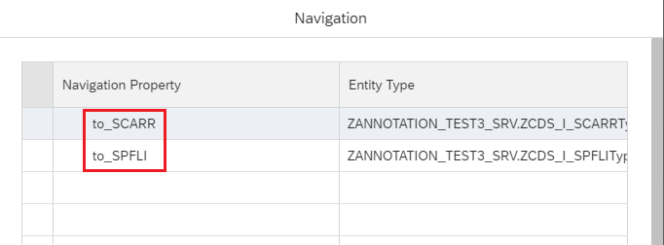

Now I will select one and click ok then it will come in the **Target** section. And we will select a value from it in the **Value** section like below. Here we have selected **Carrname.**

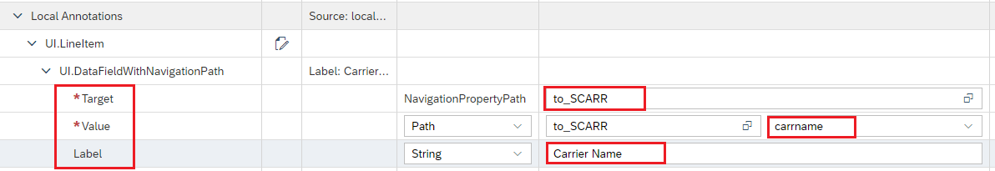

Now after execution we will see the selected attribute on the screen.

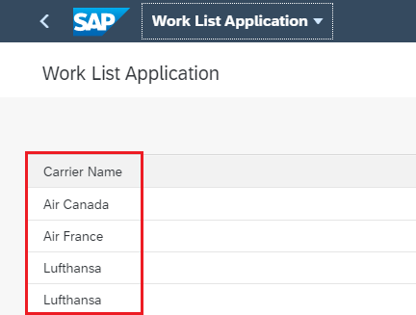

## Line Item in Object Page

Now we came across a situation that we need to show a table in the Object page. To do that we need to first create a table in the respective entity type. Then we will include that table in the **UI.ReferenceFacet** annotation with Label.

**Note that this table will only work if the Association cardinality is 1..* or 0..* otherwise this table will not be visible.**

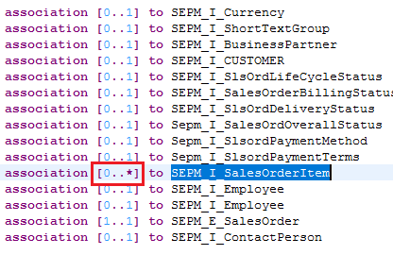

After that we can see that table in the Object Page section under that section.

Below way we will create the LineItem in the entity type.

Click on **Select Targets** and then select the entity type from the list.

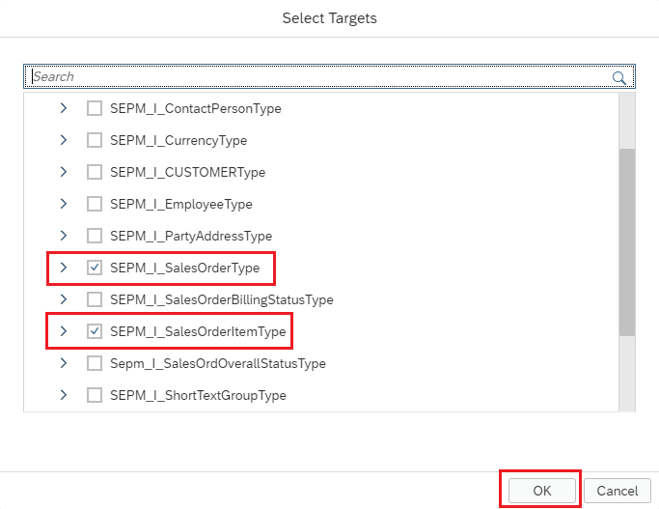

Then create an **UI.LineItem** inside the Entity name and just give one Qualifier name. Then add all the fields inside that **UI.LineItem** annotation. This **UI.LineItem** will come under **Local Annotations** section.

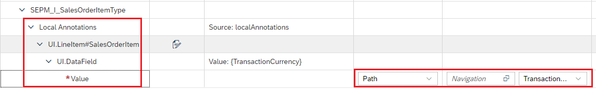

Now we will add this **UI.LineItem** in the **UI.ReferenceFacet** section as a Target like below with a label so that it can show us the name of the section.

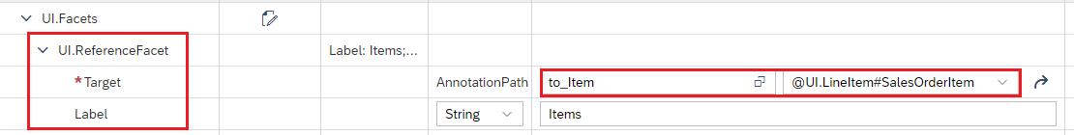

Once we execute this, we will see a Table in Object Page like below.

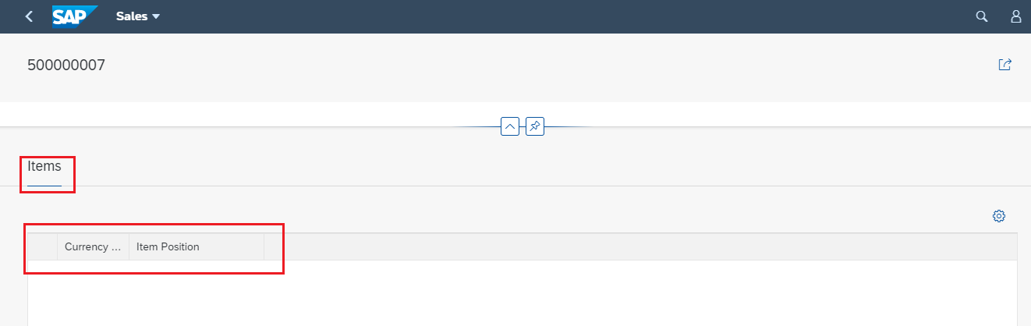

## Excel Download

Sometimes we get requirement that we need to download the data from the table of the list report. To do that we need to a minor change.

**Right Click** on the project and select **SAPUI5 Visual Editor** like below**.**

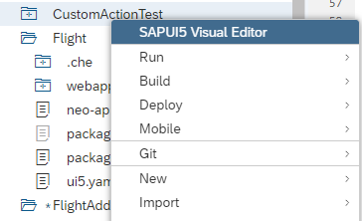

Then once it is open then we need to open it in the edit mode like below.

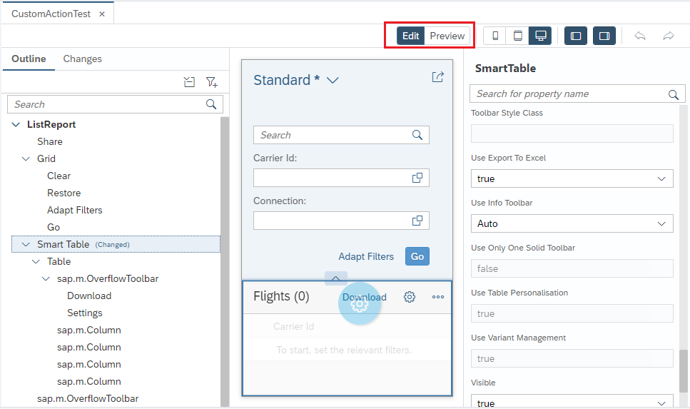

After that we need to select the **Smart Table** option and make **Use Export to Excel** to **true** like below**.**

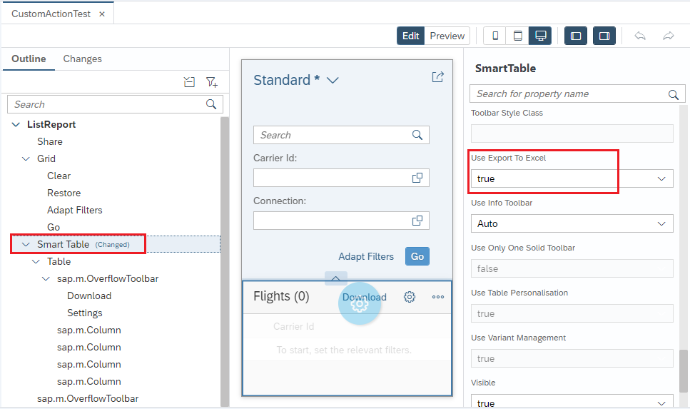

Then once we execute this, we will see the download option on the screen.

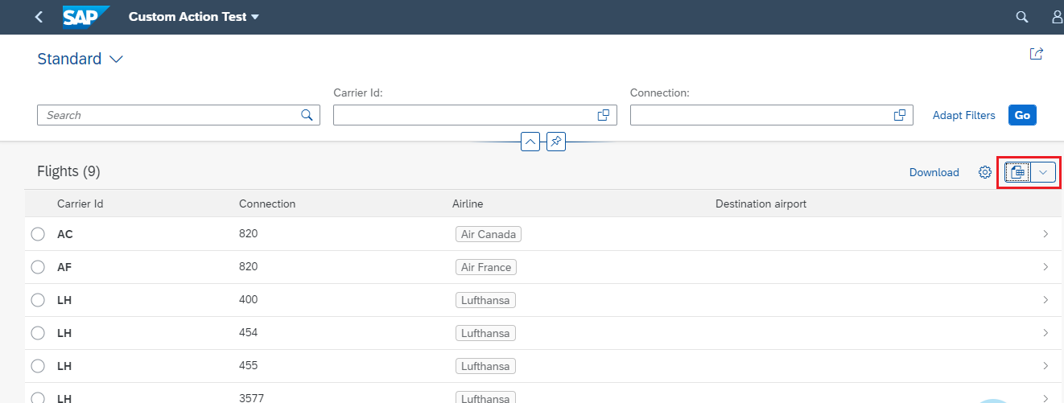

## Custom Control or View

Now let’s say some time we need some custom action or custom view in our list report and to do that we will use the extension option.

So, to do the extension we will **Right** click on the **WEBAPP** folder and click on **New** and then select **Extension.**

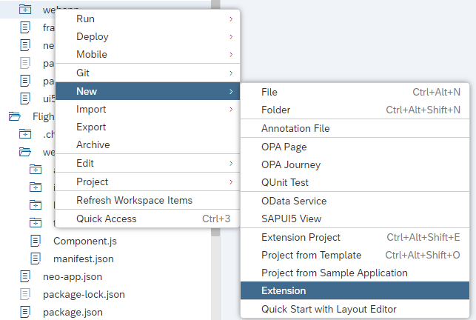

Create a button on top of the **Connection Table** and that table is in **Object Page** and under one **Reference Facet.**

In the next page we will select the **Object Page Extension** and click on **Next**.

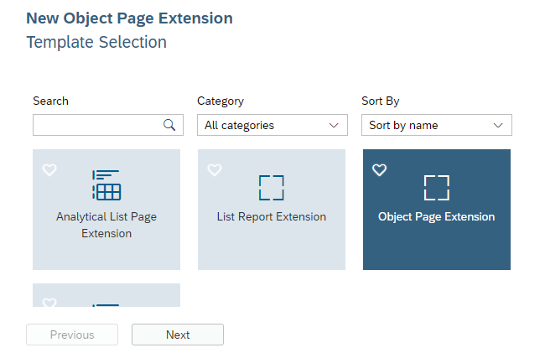

After **Next** it will ask for what I need to extend like Facet, Action, Column, etc. So, here we will extend an Action button which name is **Delete.** And we will give the details which we need like Entity set name, Table Id, Action Label, etc. Like below.

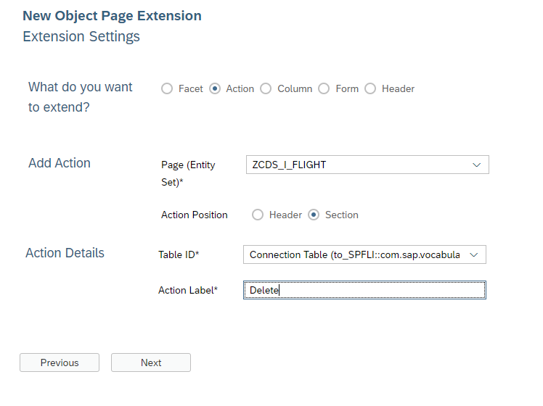

After executing the code, we will see the **Delete** button on top of the Connection Table like below.

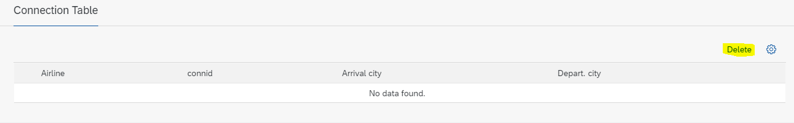

# Annotation Based Work List Report Fiori Application

Here we will try to build one Work List application, here in the Worklist application we don’t have selection criteria. So, there is no need of **UI.SelectionFields** annotation. Because there is no Smart Filter bar, you will NOT need annotation **UI.SelectionFields**.

## UI.HeaderInfo

Here also we will use the **UI.HeaderInfo** annotation to give the header details of the Work List items. Below screenshot will show the same. This Annotation will come under Local Annotations.

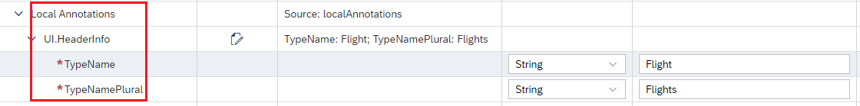

If we execute this, we will see the below result. Here we don’t have any field because we have not added any Line Item yet.

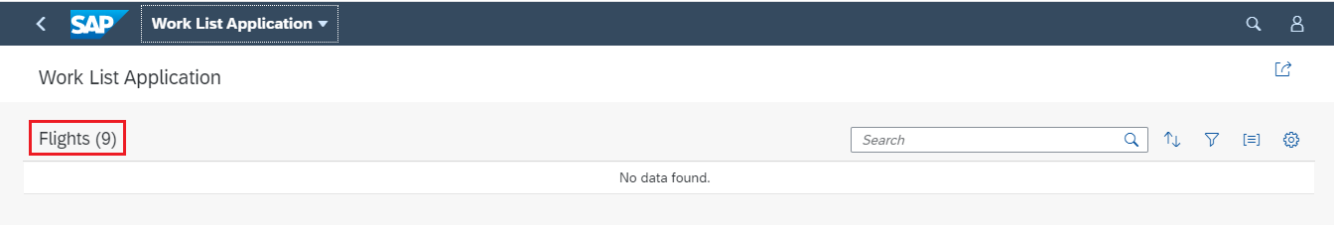

## UI.LineItem

Now after the Header Info we have added **UI.LineItem** and added 4 **DataField (Carrid, Carrname, Currency, Connid)** property inside this annotation which will make the columns in the Work List report. And this **UI.LineItem** will come inside the Local Annotations section. Since we don’t have any selection field so we will not have any **Go** button here and Data will be loaded at the time of opening the Application.

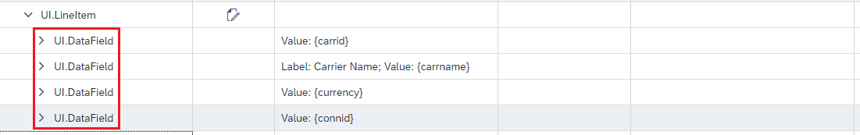

If we execute this, we will see these 4 fields on the screen.

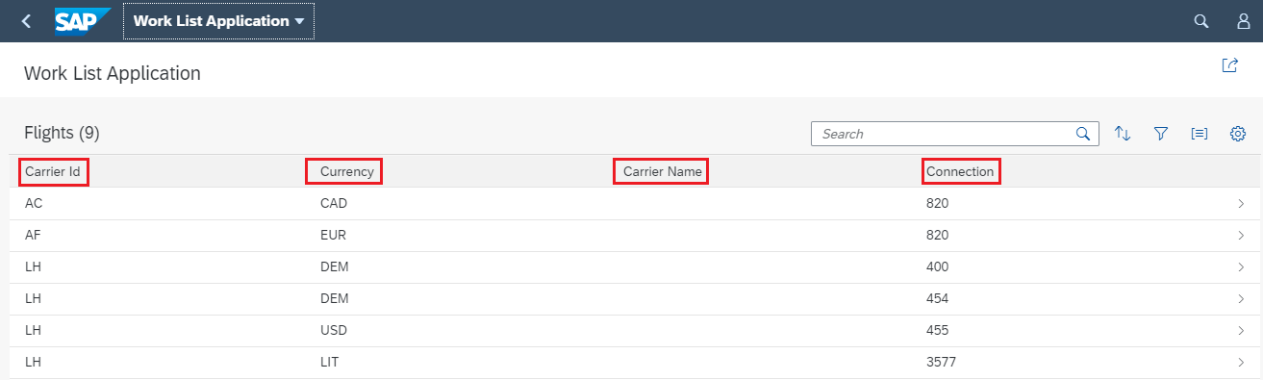

## UI.HeaderInfo

Now if we click on the row of the table then it is navigating to the **ObjectPage** and here we have mentioned the **Title** and **Description** property inside the **UI.HeaderInfo** annotation and we will see these values on the screen.

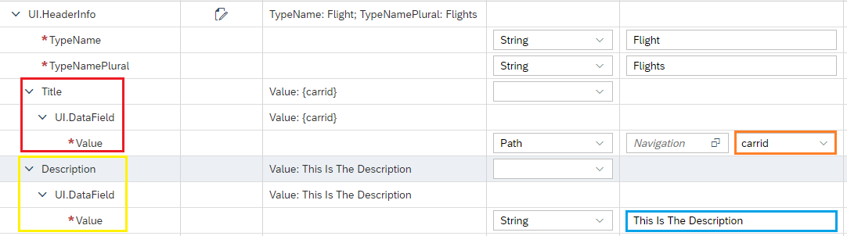

Now if we execute this, we will see these things on the Object Page header like below.

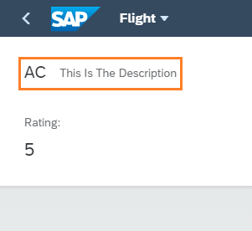

## DataFieldForAction

Sometime we get a requirement that we need to create some actions like to create a button may be delete or create or copy etc. And the button can be inside the Table or at the Table header level or it can be at the footer level. To do so we have an annotation called **UI.DataFieldForAction** and for that we need to create one Function import after clicking the Button it will trigger the function import.

* **For Header:** For Header table button we will use **UI.DataFieldForAction** annotation and this annotation will come under **UI.LimeItem** annotation and this annotation will have couple of attributes like below.
  + **Action:** Here we will provide the OData function import and it will come automatically in the dropdown. Here it is **CopyData.**
  + **Label:** This is for the button label like here we gave **Copy.**
  + **InvocationGrouping:** For invocation grouping we will provide **Isolated** and it will create the button at the header level. Below screen shot will show the same.

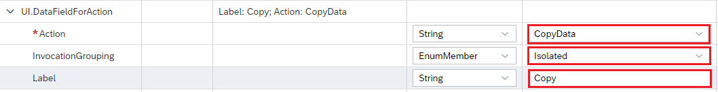

Once we execute this, we will see the Button at the header level like below.

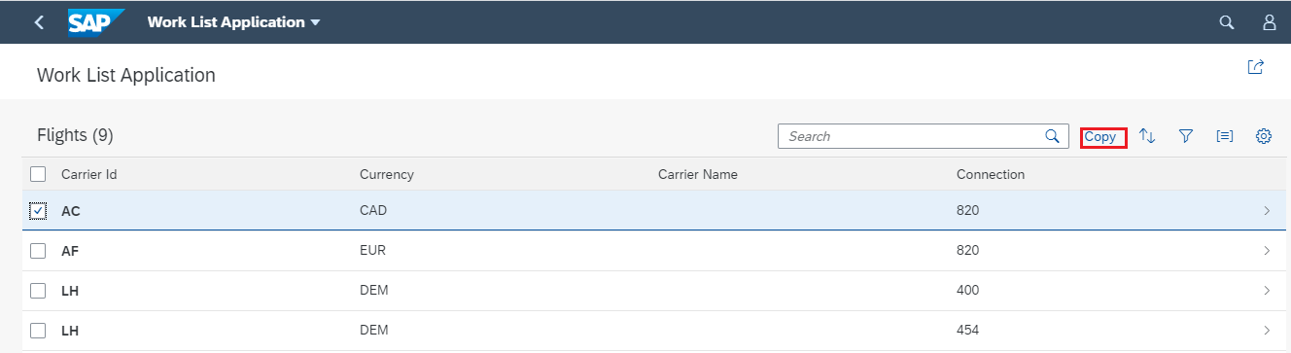

* **For Footer:** If we want this button to be in the footer section of the table then we use the same **UI.DataFieldForAction** annotation. And we will use the below attributes to make this happen.
  + **Action:** Here we will provide the OData function import and it will come automatically in the dropdown. Here it is **CopyData.**
  + **Label:** This is for the button label like here we gave **Copy.**
  + **InvocationGrouping:** For invocation grouping we will provide **Isolated** and it will create the button at the header level. Below screen shot will show the same.
  + **Determining:** We will put the **Determining** value to be true which is responsible for footer section. Below screenshot will show the same.

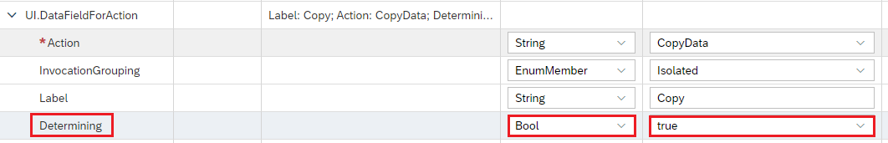

If we execute this, we can see the below output on the screen.

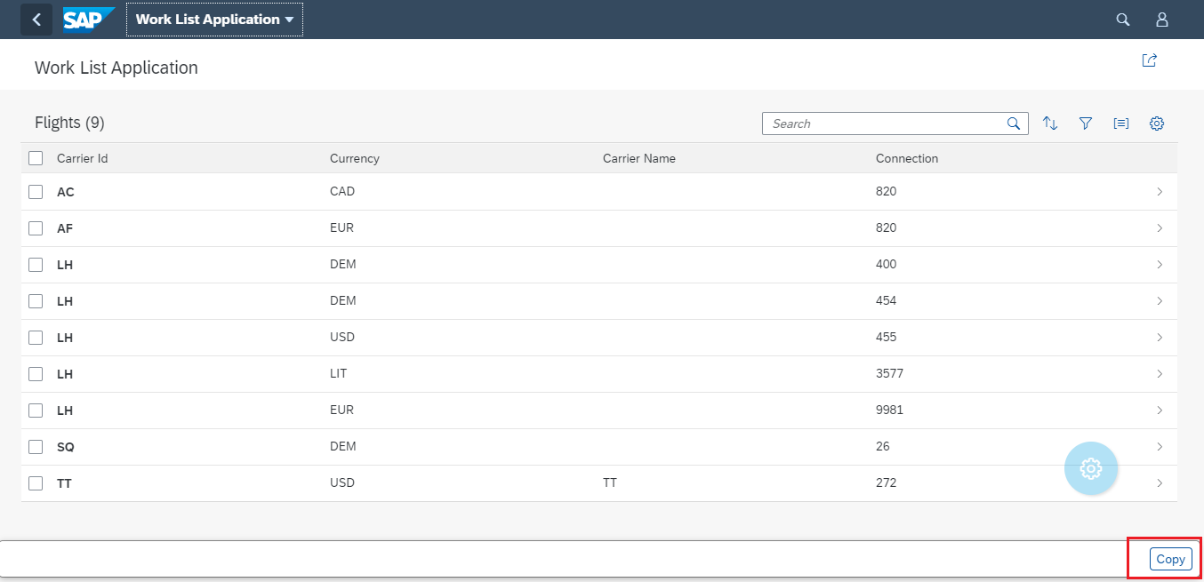

* **For Table Column:** Now if we want this field inside the table content and we want this in every row of the table then we will use the same **UI.DataFieldForAction** annotation and we will use the below attributes for that.
  + **Action:** Here we will provide the OData function import and it will come automatically in the dropdown. Here it is **CopyData.**
  + **Label:** This is for the button label like here we gave **Copy.**
  + **InvocationGrouping:** For invocation grouping we will provide **Isolated** and it will create the button at the header level. Below screen shot will show the same.
  + **Inline:** For inline property we will provide value **true** this is responsible for making this button inside the table. Below screenshot will show you the same.

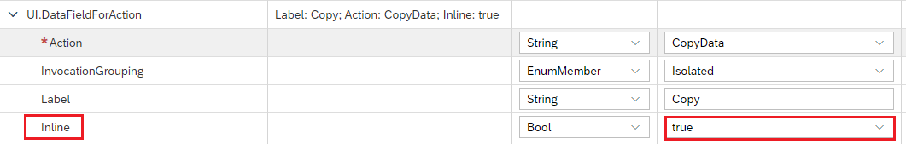

After executing this code, it will look like below.

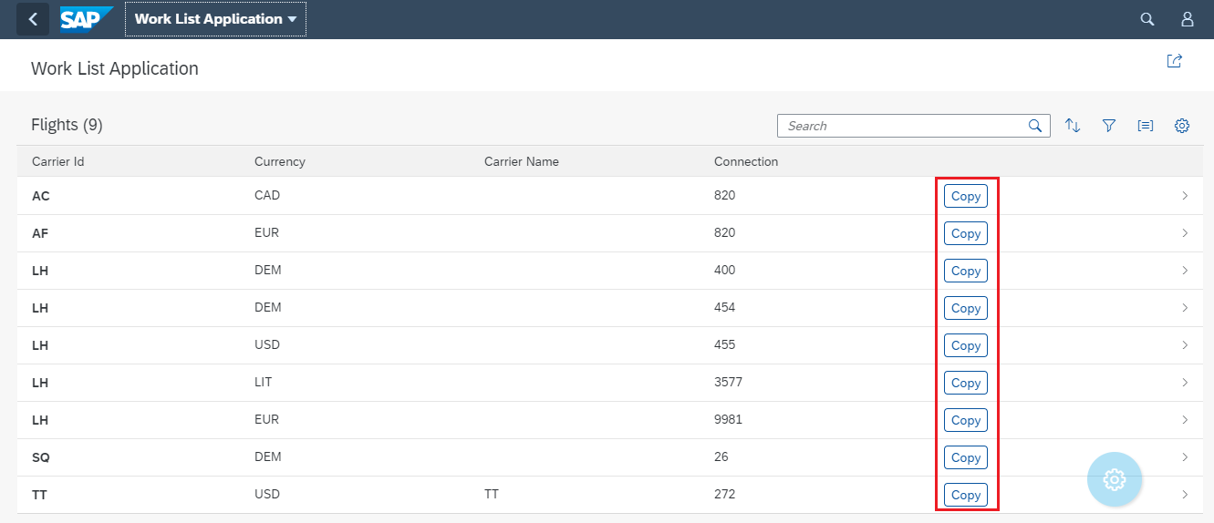

## UI.Identification

To make customizing in the object page which will be navigated from the table row we use **UI.Identification** annotation. In some cases we need the button in the object page and for that we use the same annotation **UI.DataFieldForAction** and for object page this annotation will come inside **UI.Identification** annotation.

* **For Footer:** If we want this button to be in the footer section of the table then we use the same **UI.DataFieldForAction** annotation. And we will use the below attributes to make this happen.
  + **Action:** Here we will provide the OData function import and it will come automatically in the dropdown. Here it is **CopyData.**
  + **Label:** This is for the button label like here we gave **Copy.**
  + **InvocationGrouping:** For invocation grouping we will provide **Isolated** and it will create the button at the header level. Below screen shot will show the same.
  + **Determining:** We will put the **Determining** value to be true which is responsible for footer section. Below screenshot will show the same.

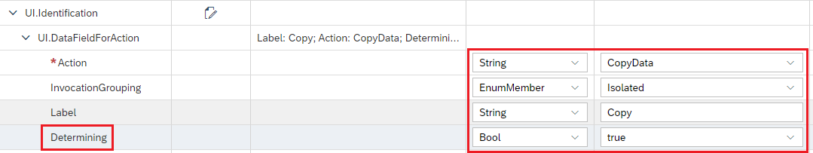

If we execute this code we can see below result.

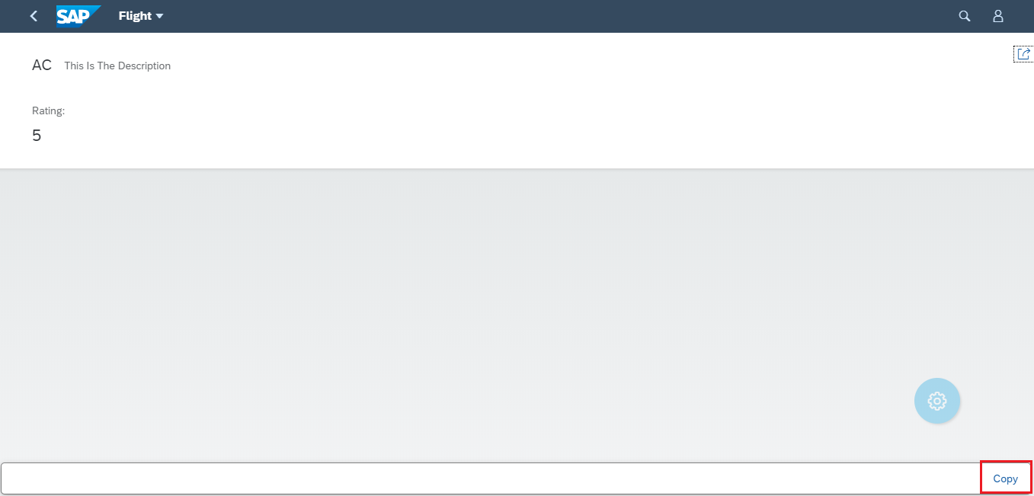

* **For Header:** For Header table button we will use **UI.DataFieldForAction** annotation and this annotation will come under **UI.Identification** annotation and this annotation will have couple of attributes like below.
  + **Action:** Here we will provide the OData function import and it will come automatically in the dropdown. Here it is **CopyData.**
  + **Label:** This is for the button label like here we gave **Copy.**
  + **InvocationGrouping:** For invocation grouping we will provide **Isolated** and it will create the button at the header level. Below screen shot will show the same.

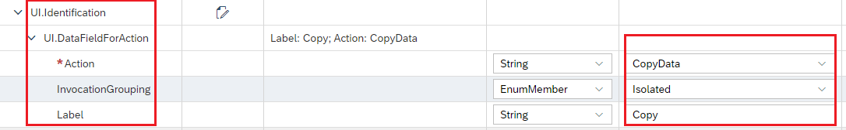

If we execute the below code then we will see the below result.

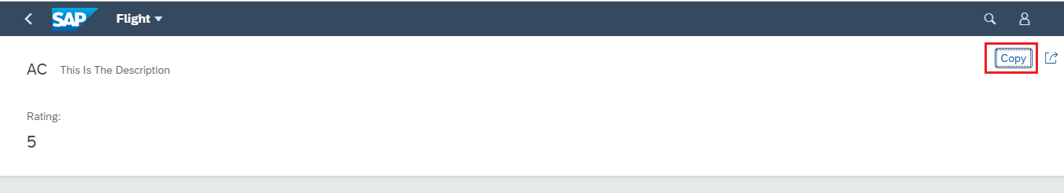

## UI.FieldGroup

Now let’s say in the Navigated page (Navigated from table row) we want some group of fields together under one section, to add those fields together we have **UI.FieldGroup** annotation and this annotation will come under **Local Annotations** section.

And inside **UI.FieldGroup** we will have below annotations.

* + 1. **Data:** This annotation is to collect all the **DataFields.**
    2. **UI.DataField:** This annotation will represent the Field Value and label.
    3. **UI.DataFieldForAction:** If we need any button inside the section then we use this annotation. Like here we have used one inside Flight Details section.
    4. **Label:** If we want the Label for this section then we use Label property like here we have used **Flight Details** and **Seat Details**.

Below screenshot will display the same. Here we have added this annotation under two **Qualifier** called **FlightDetails** & **SeatDetails**.

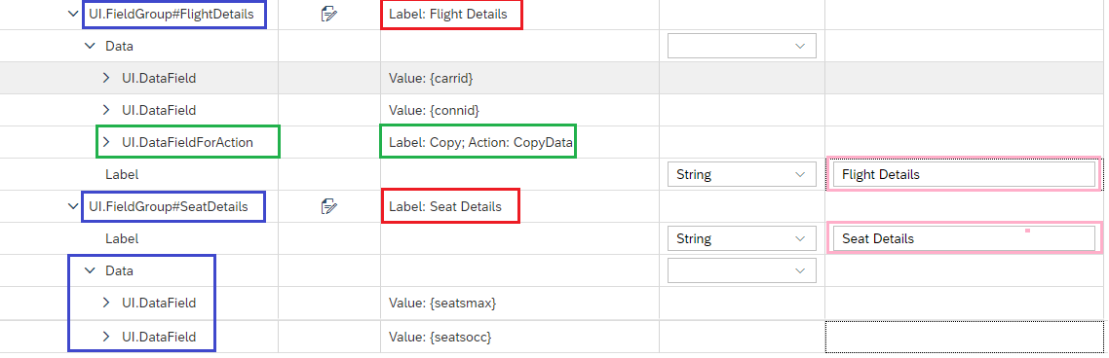

## UI.ReferenceFacet

Now created field group we will add under one section, to create the section we have **UI.ReferenceFacet** annotation and this annotation will come under **UI.Facets** annotation section and here in this annotation we have two property mainly

* + 1. **Target:** In that we will mention the field group which we have created earlier like we have created **UI.FieldGroup#FlightDetails** so here we will mention this as an annotation path**”@ UI.FieldGroup#FlightDetails”** and **”@ UI.FieldGroup#SeatDetails”**.
    2. **Label:** This is the label for the section.

Below screenshot will show you the same.

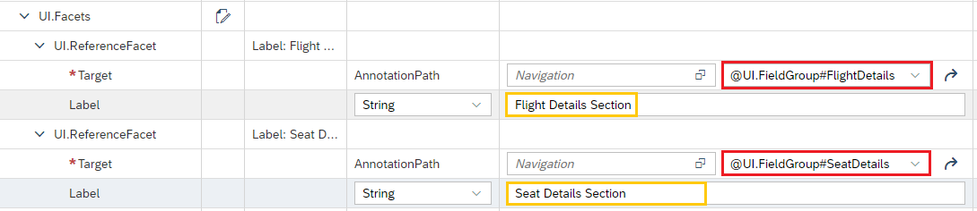

Now if we execute this, we will see a two new section will be created on the screen **Seat Details** and **Flight Details** and a button inside **FlightDetails** section.

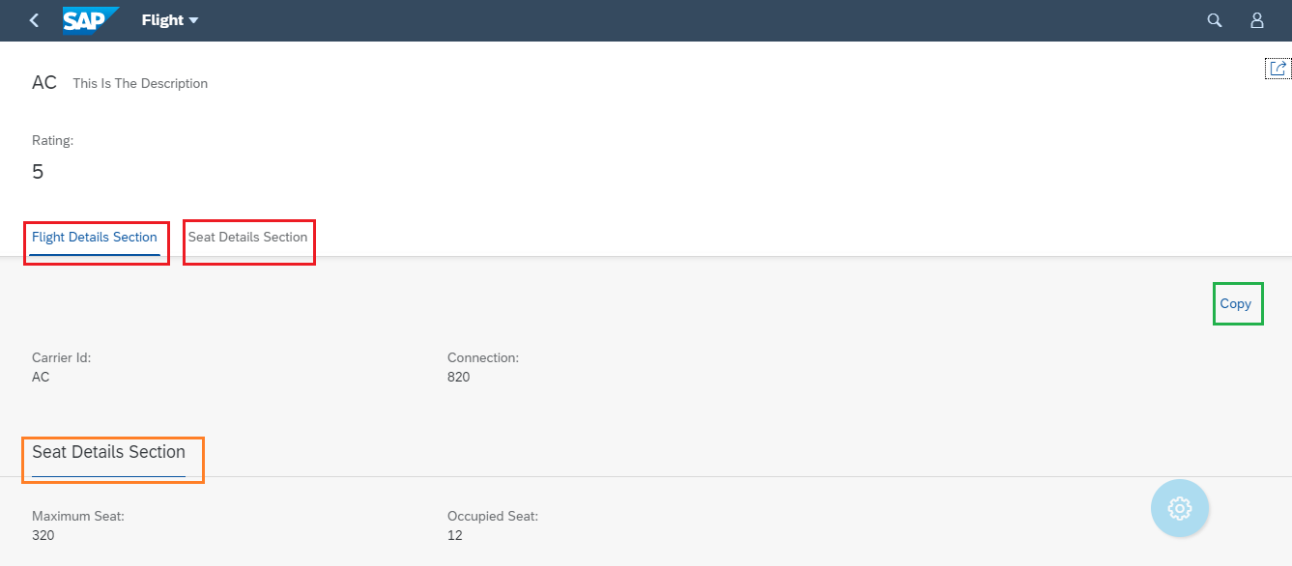

## UI.DataPoint

Now let’s say we have List report with Table and our requirement is, if we click on any record of the table then it should move to next page which can be any Object Page. And Using **UI.DataPoint** annotation we can create a Title in next page. We will add the **UI.DataPoint** annotation inside **Local Annotations** section.

In the below screenshot we have created the **UI.DataPoint** annotation inside the local annotation section and I have given a **Qualifier** name for this annotation.

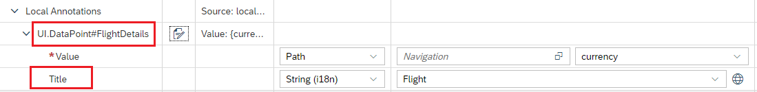

Now if we execute and click on the table row we will see below screen.

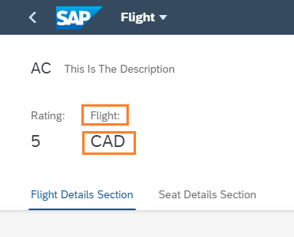

## Standard Search

Generally, we need the standard search operation by this search operation we can search globally and it is very useful at times. To make this happen we need **Searchable** annotation in the CDS view. The important annotations for the search are below.

1. **@Search.searchable:** We make the value of this annotation true and if we add this annotation then we must need to add the at least one **DefaultSearchElement** annotation for field and let’s say we have added this for 4 attributes so this search will work for those 4 attributes only.
2. **@Search.defaultSearchElement:** We make this annotation true for how many attributes we need, like here we did for 3 attributes.
3. **@Search.fuzzinessThreshold:** This is for fuzzy search and the threshold of the fuzzy search. Below screen shot will show the same.



Once we execute this, we will get the below output.

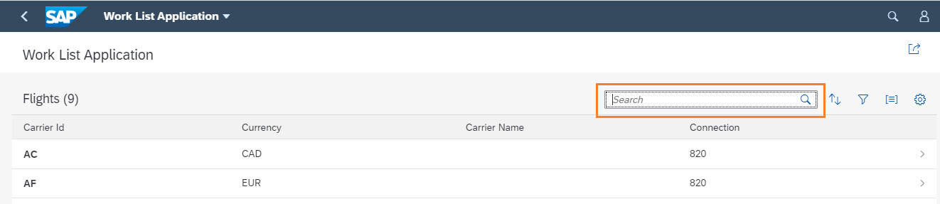

So here we mentioned this search for 3 attributes (Carrid, Connid, Currency) so we can give a search for all these attributes.

We can do search fuzzy search.

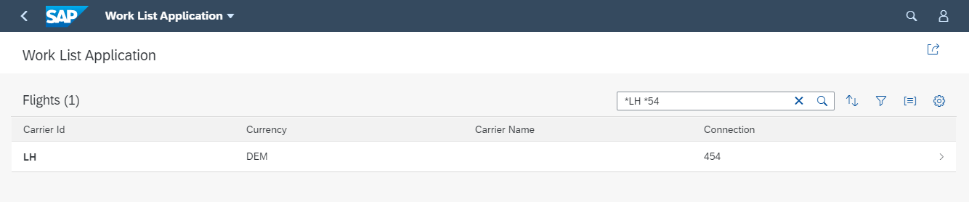

## UI.DataFieldWithNavigationPath

Now let’s say in Our CDS view we have lot more exposed associations and we would like to use them and want take the field from them in those cases we use **UI.DataFieldWithNavigationPath.** Using this annotation, we can directly access all the associations in the CDS view all the exposed one and ad hoc one will come automatically.

It has mainly two mandatory property and they are listed below.

* + 1. **Target:** Here we will mention the Association and we will click on the value help section and select our desired association from there.
    2. **Value:** Here in this section we will select the value from that selected association.
    3. **Label:** Label here we have maintained because we need the Column Label for this field.

Let’s say I have two association here in this CDS one is **_SCARR** and another one is **_SPFLI** and when we click on the value help, I can see both like below. They will come in the format **to<association name>.** Using this rule for us it will be **to_SCARR** and **to_SPFLI**.



Now I will select one and click ok then it will come in the **Target** section. And we will select a value from it in the **Value** section like below. Here we have selected **Carrname.**



Now after execution we will see the selected attribute on the screen.



## UI.SelectionVariant

Sometime the situation come that we need different tab in the report. To make different Tab we use **UI.SelectionVariant** annotation. This annotation comes under **Local Annotations.** Inside this annotation we are using Below annotations.

1. **Text:** This is the text for the Tab Name. Like here we are using **Expensive** and **Cheap.**
2. **UI.SelectOptions:** This annotation will come under **UI.SelectionVariant** under this we have below annotations**.**
   1. **UI.SelectOptionType:** This is for select option type and inside this we have below attributs.
      1. **PropertyName:** This property is for comparison.
      2. **Ranges:** This property is to specify the ranges. This annotation has one more annotation inside this.
         1. **UI.SelectionRangeType:** This is completely for Ranges. It has three attributes like below.
            1. **Sign:**
            2. **Option:**
            3. **Low:**

Below screen shot will show the same how the annotation is been set up.

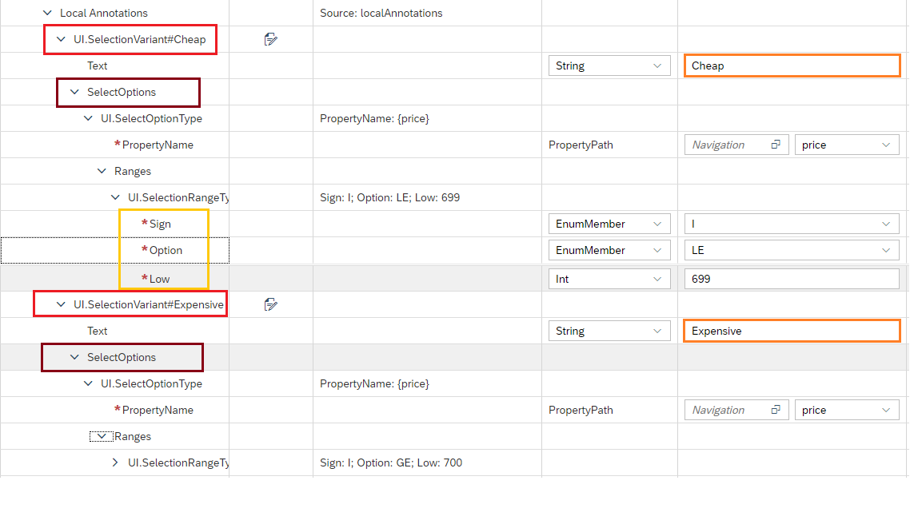

Once this is done then we need to alter the **manifest.json** file so that we can see the tabs on the screen.

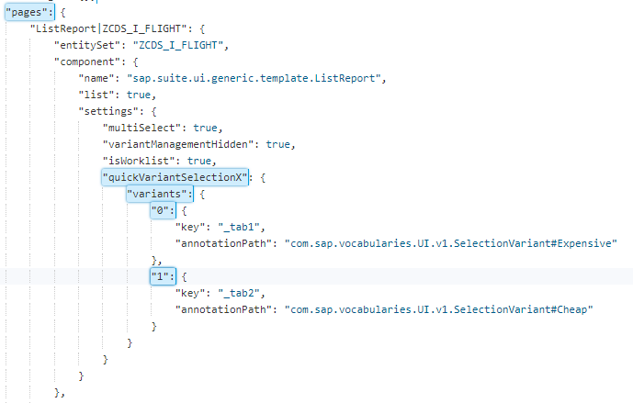

So, after execution of the code then I will see the below output on the screen.

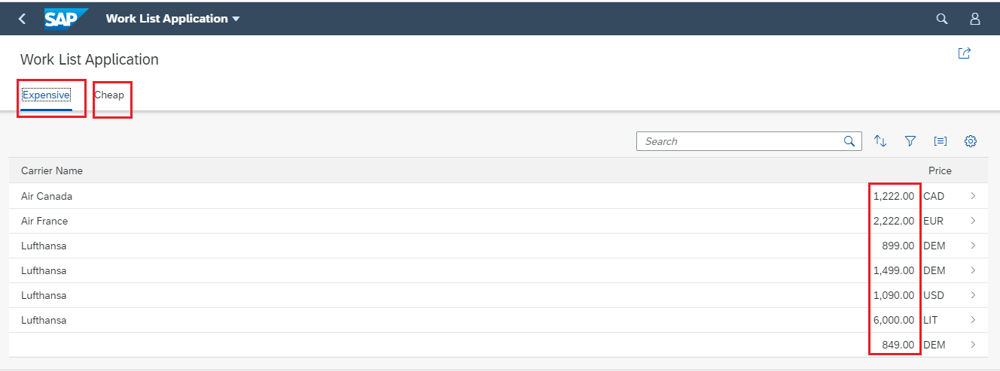

## UI.HeaderFacet

At Times we need the header in the Object page as we all know that we can add the **Title** and **Description** using **UI.HeaderInfo** annotation. But there is something which we can add at the Object Header level that is the Header portion of the **ObjectHeaderPage.**

For this purpose we use the **UI.HeaderFacet** annotation. So, for this first we will create the Field Group annotation and add those fields inside the **FieldGroup** annotation and then we add the Field Group to the UI.HeaderFacet.

In this development we have below annotations and properties inside **UI.HeaderFacet** annotation.

* + 1. **UI.ReferenceFacet:** This is to hold the field group.
       1. **Label:** This is for the title of the field groups.
       2. **Target:** Here we will provide the FieldGroup annotation path here it is **@UI.FieldGroup#FlightHeader** below screen shot will show the same.

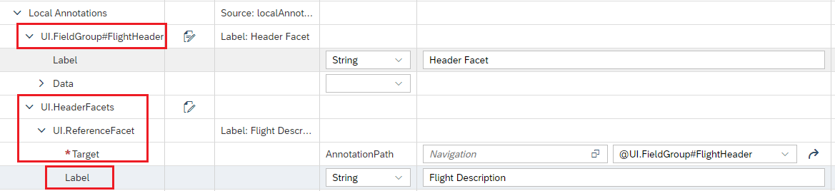

Once we execute this, we will see the below page on the screen.

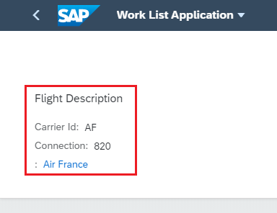

## Line Item in Object Page

Now we came across a situation that we need to show a table in the Object page. To do that we need to first create a table in the respective entity type. Then we will include that table in the **UI.ReferenceFacet** annotation with Label.

**Note that this table will only work if the Association cardinality is 1..* or 0..* otherwise this table will not be visible.**

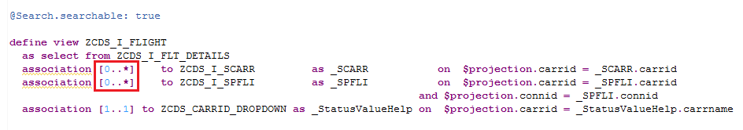

After that we can see that table in the Object Page section under that section.

Below way we will create the LineItem in the entity type.

Click on **Select Targets** and then select the entity type from the list.

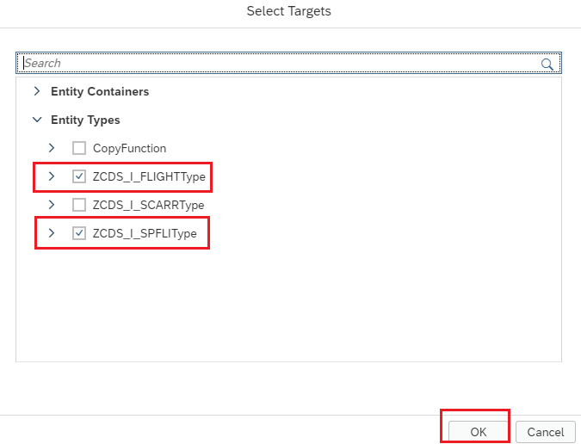

Then create an **UI.LineItem** inside the Entity name and just give one Qualifier name. Then add all the fields inside that **UI.LineItem** annotation. This **UI.LineItem** will come under **Local Annotations** section.

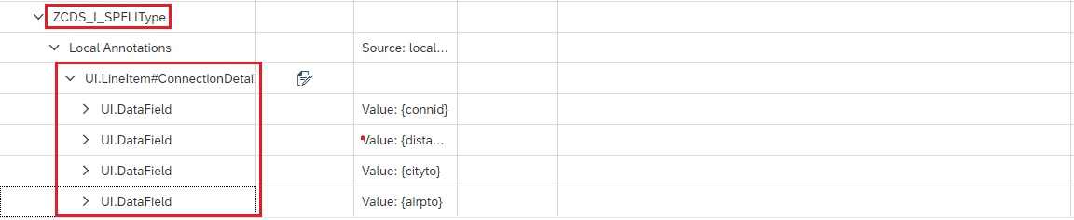

Now we will add this **UI.LineItem** in the **UI.ReferenceFacet** section as a Target like below with a label so that it can show us the name of the section.

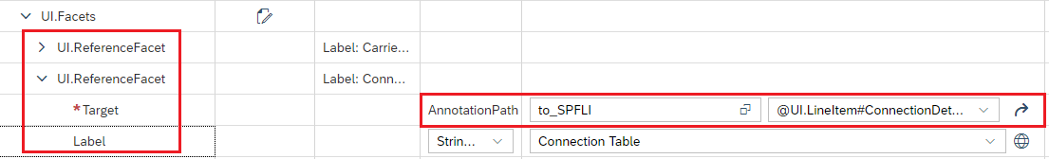

Once we execute this, we will see a Table in Object Page like below.

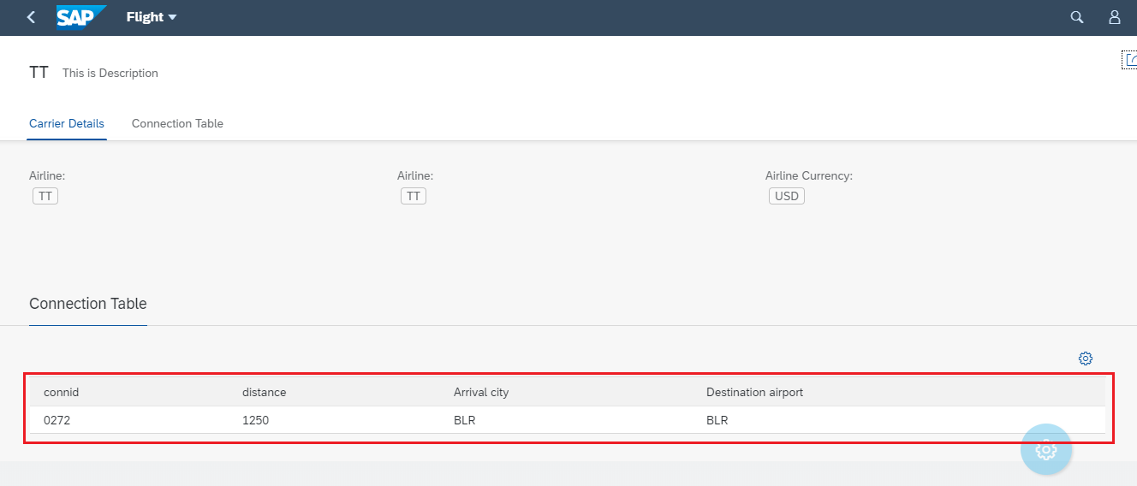

## Collection Facet

In the **UI.ReferenceFacet** annotation we will have different Tabs to be created for respective **UI.FieldGroups** but in our case we want more than one Field Group in one section and for that reason we have **UI.CollectionFacet** annotation. Now the **UI.ReferenceFacet** annotation will come under the **UI.CollectionFacet** annotation. This **UI.CollectionFacet** annotation will come under **UI.Facet** annotation. So, we have couple of annotation and properties inside that, please find them below.

* **Facet:** This is to hold the facets whether it can be any facet reference or any other here we are using Reference facet.
  + **UI.ReferenceFacet:** Here inside the Facet annotation we are having **UI.ReferenceFacet** and in that we are mentioning the Field Groups. Below screenshot will show the same.

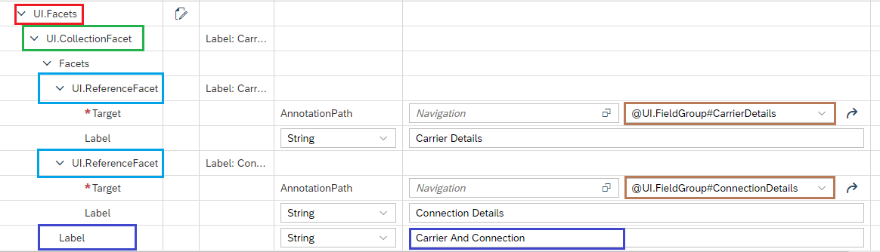

After execution of this we will see that these two-field group will come together in one section called **Carrier and Connection.**

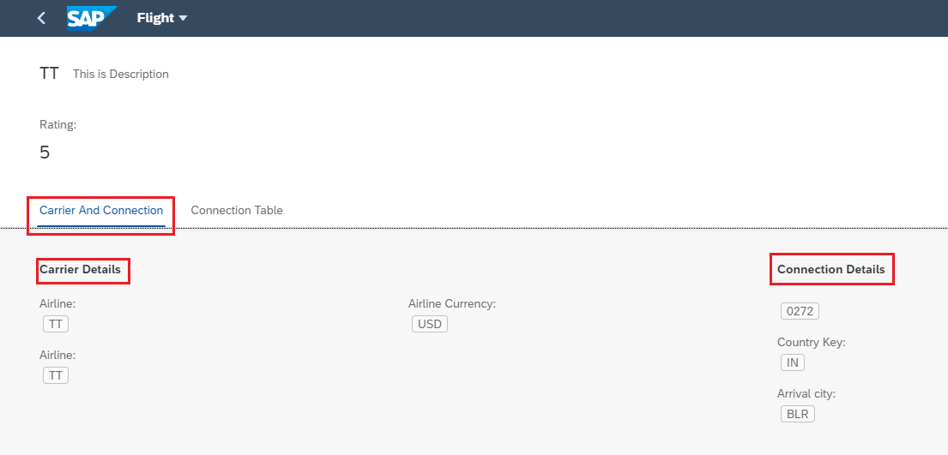

## Contact Card

Now at times we get requirement to create contact card for some Product or Some client or some business partner. To do so we have **Communication.Contact** annotation. First of all we will create the **Communication.Contact** annotation and then we will add this annotation to the field using **UI.DataFieldForAnnotation** and then if we click on the **Data Field** we will see the contact card. The annotation **Communication.Contact** will come inside **Local Annotations** section.

Inside the **Communication.Contact** annotation we can add all the details like Title, Name, Gender, etc. Here we have added **fn** which will be the Field name.

Below screen will show how to create **Communication.Contact** annotation.

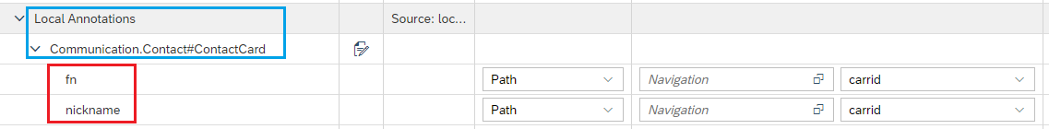

Below screen will show how to add this **Communication.Contact** inside the field using **UI.DataFieldForAnnotation.** Here we have added the filed inside the **UI.LineItem** annotation so it will come inside the table.

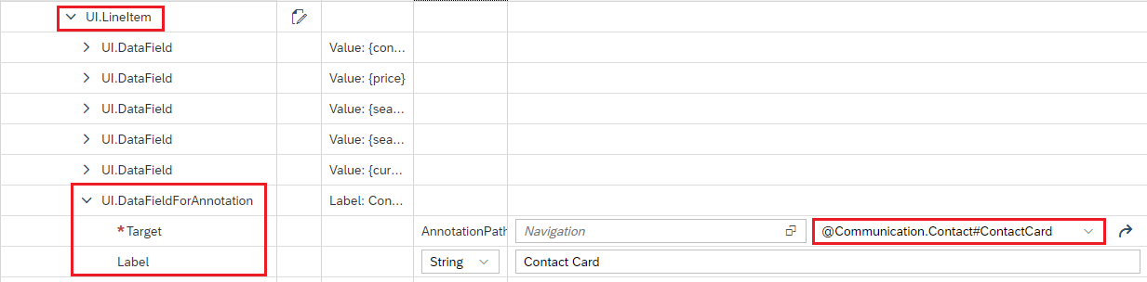

Once we execute this, we will see the **Contact card** Field in the table and with link option.

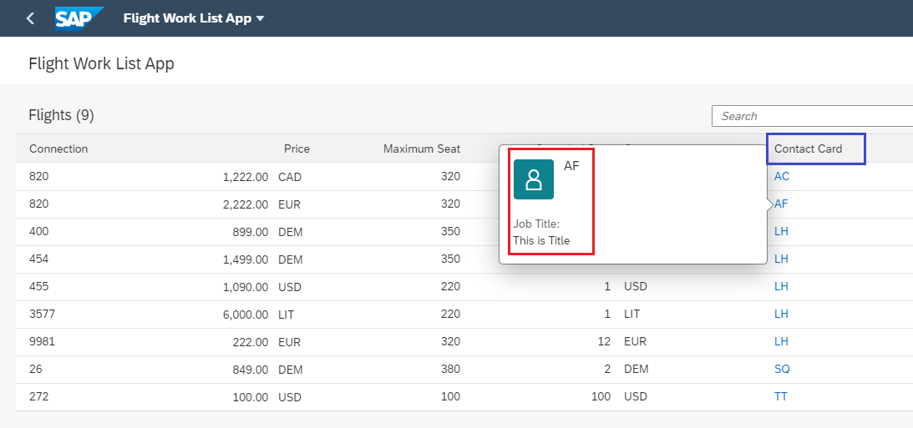

Similar way we can add them in the Object Page or so.

# Annotation Based Analytical List Report Fiori Application

As any other Fiori elements application, an ALP application is also contained inside a shell bar. Majorly an ALP application can be broadly divided into 3 components:

* **Title area:** The title area of an ALP application may contain variant management, Global KPIs, Visual/compact filter switch button and share menu.
* **Filter area**: The Filter area of an ALP application contains filters bar. ALP in addition to a smart filter bar (known as the compact filter in ALP) also provides an option to represent the filters as charts, known as the visual filter. The filter area also contains the adapt filter and go button.
* **Content area**: The content area of an ALP application may also contain filterable KPIs. The content area of ALP application may contain a chart subsection and a table subsection or both. The content area also has action buttons along with other toolbar buttons at chart and table toolbar.

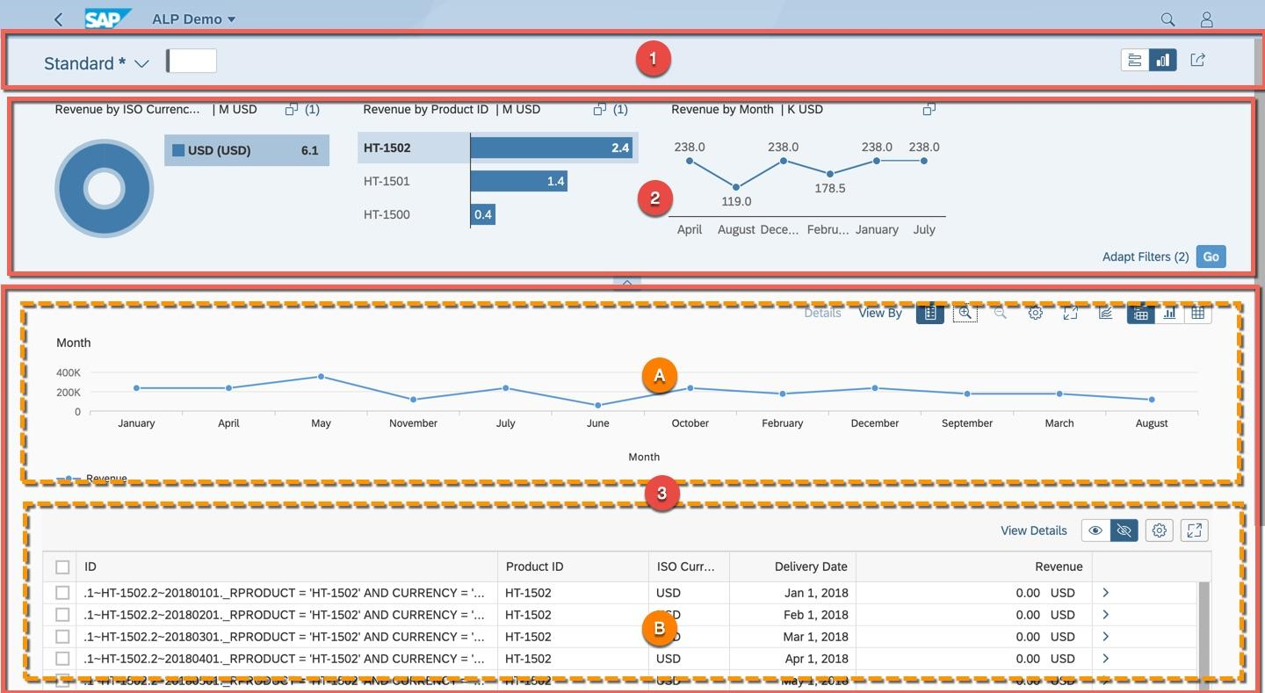

To Create the project, we will **Right** click on the **Workspace** and select **New** and then select **Project from Template.** After that we will select **Analytical List Page/Object Page** and provide all the details like project name, description, namespace, etc. Then we will provide all the OData details and all and click on **Finish.**

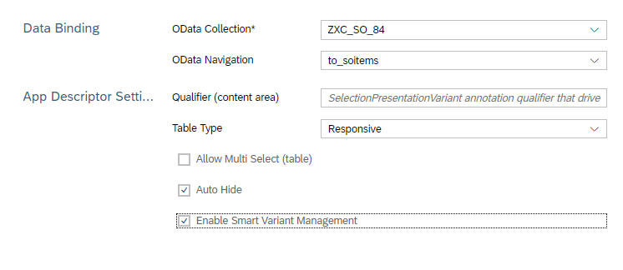

In the generated project we will find one Annotation file and there we will add our Annotation to create it.

The Responsible CDS views are below for this application.

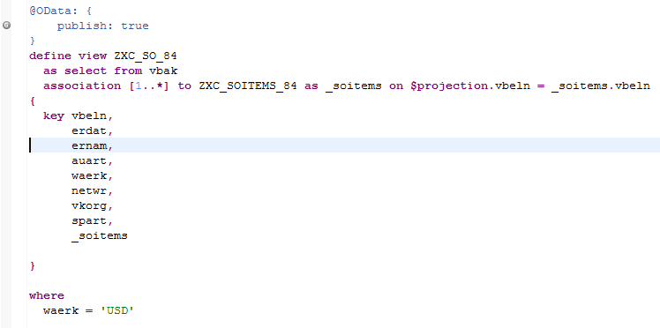

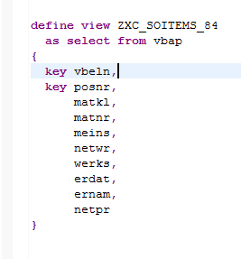

Now we will start adding the annotations so that we can see those Chart and selection field on the screen.

## @UI.LineItem

This annotation is for adding the table columns.

## @UI.SelectionField

This annotation is for adding the selection fields.

## @UI.DataPoint

This annotation is for adding the header in Object Page

## @UI.FieldGroup

This is to add the fields inside the facet.

Now we will add the **UI.LineItem, UI.DataPoint, UI.SelectionField** and we will execute this and will see the screen.

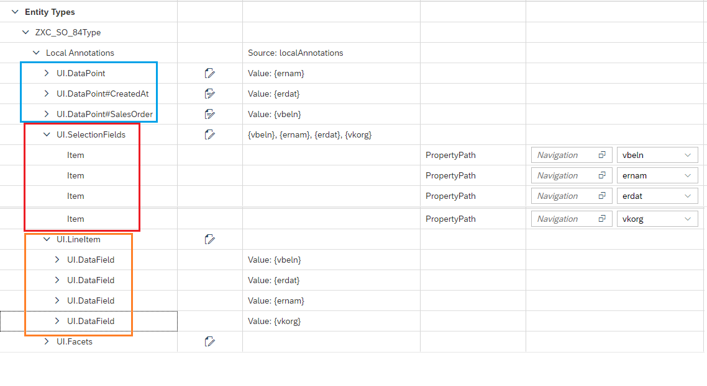

Once we execute this, we will see the below on the screen.

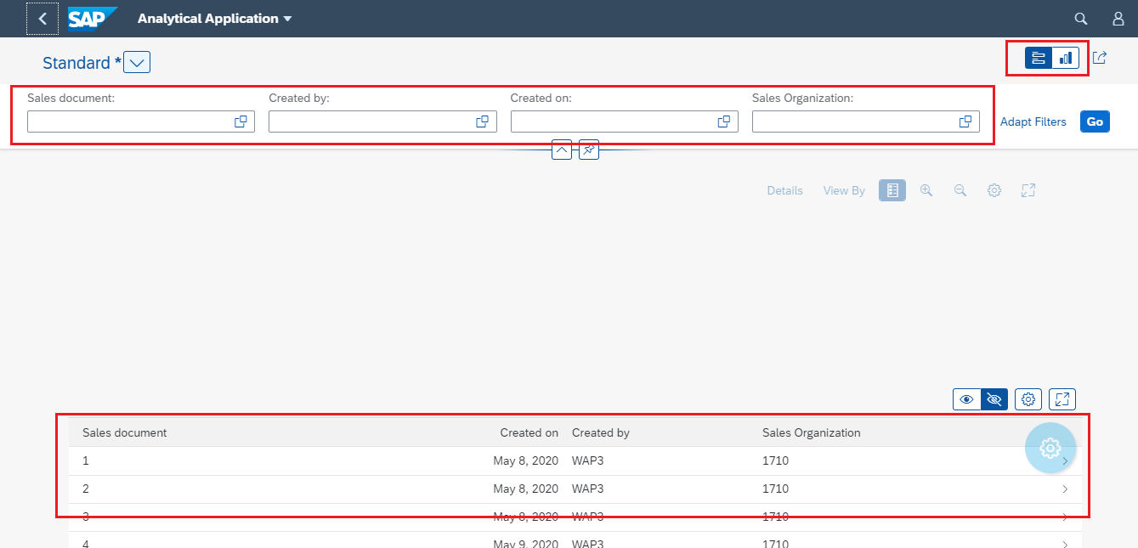

If we click on the table record then we will see the Object Page like below.

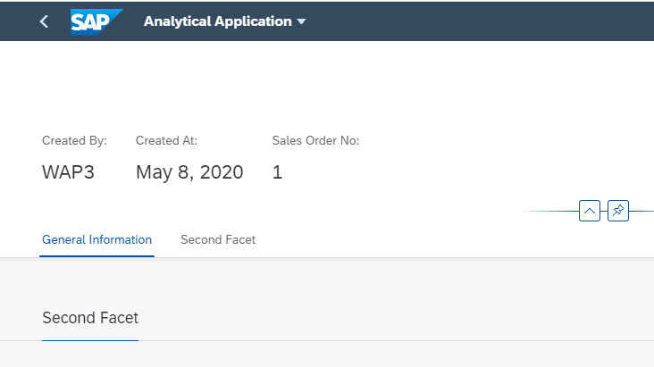

## @UI.Chart

Now we will add the Chart so that it can be visible in content area. This **UI.Chart** will come under Local Annotations section.

This **UI.Chart** will have below properties.

* **Title:** This will give the title of the chart
* **Description:** This will give the description of the chart
* **Measures:** It will give the Y axis if it is column chart. It will be the measure part.
* **Measure Attributes:** Here we will have Role and Category. Role will say about the axis and Measure will talk about the values.
* **Dimension:** This will give the X-Axis part. Same like Measure we will have here also Dimension and Dimension Attribute.
* **Chart Type:** This will specify whether this is Donut or Column or etc. chart.

Below screen show will show the same and here we have marked the chart as Column chart and we have **NETWR** is in dimension and **COUNTER** in on measure. So, Counter will come in the Y Axis and NETWR will come in Y axis.

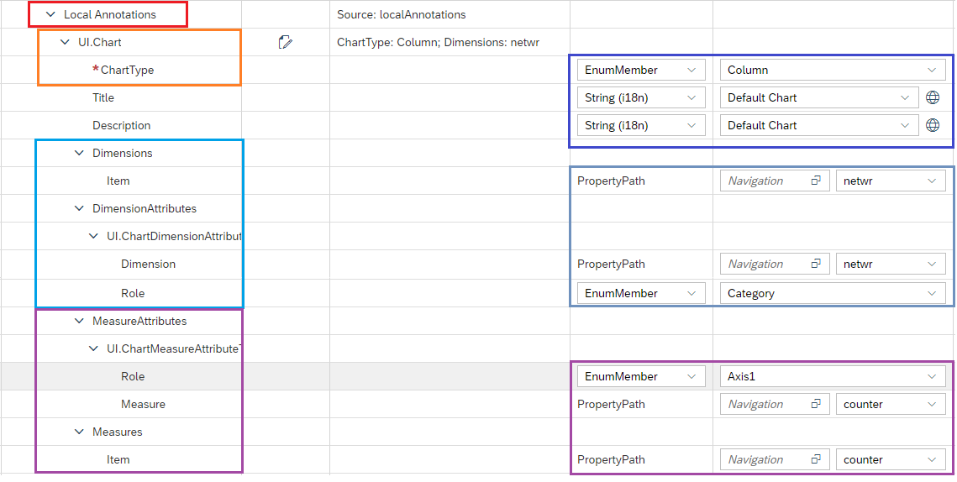

Once we execute this, we will see the below on the screen.

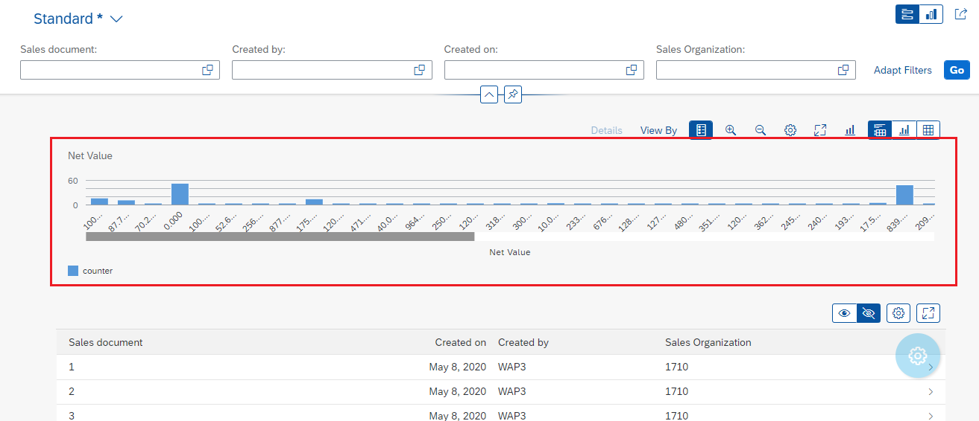

## Selection Variant, Presentation Variant and Selection Presentation Variant

In the above section we have added a table and a chart in the content area. Now we will add the chart filter for that we will create a **Chart** and add that in the Selection Field and the above chart we will add in the presentation layer.

The below steps we will follow.

* + 1. First we will give the default chart a Qualifier.

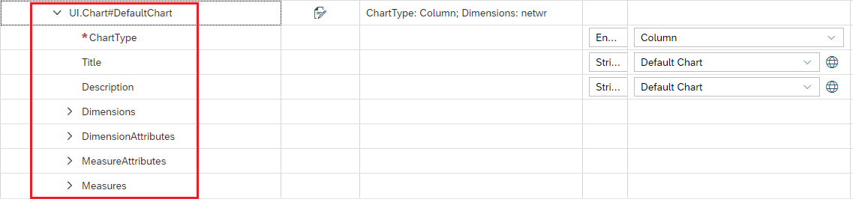

* + 1. Then we will create another chart and we will make measure as chart and dimension as VBELN. Give the qualifier of that chart is SelectionChart

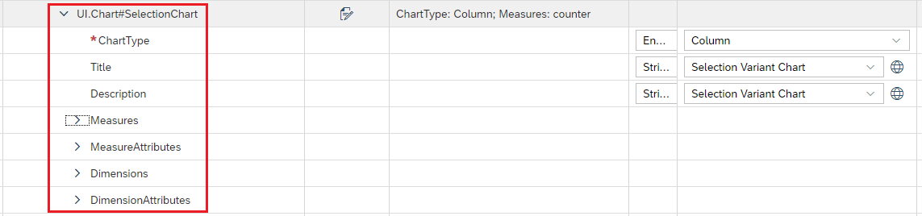

* + 1. Now we have created two presentation variant those will come under Local Annotations section. And in that presentation variant we have added both the chart **Default** one and **SelectionChart**

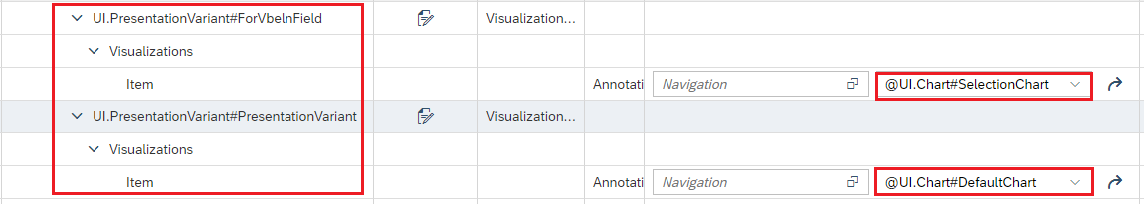

* + 1. Now we have created one Selection Variant and added one parameter in that which is VBELN.

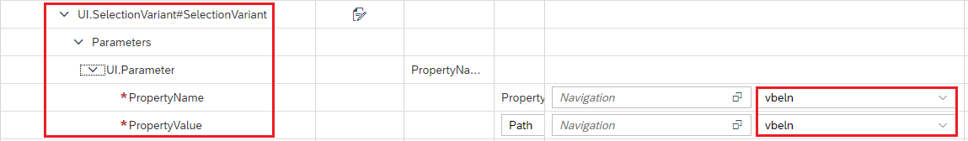

* + 1. Then we have create an annotation called **UI.SelectionPresentationVariant** and added those selection variant and presentation variant in that.



* + 1. Then we have added VBELN field for annotation. For that we have clicked on **Select Targets** and opened the respective type and properties and select the field and click ok.

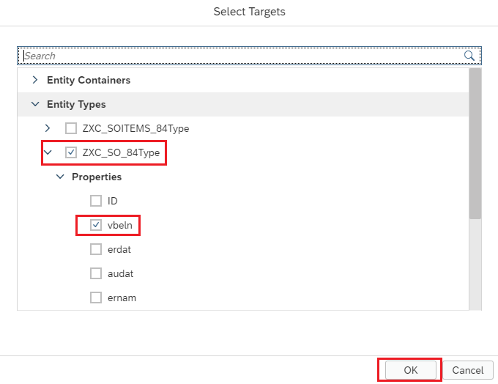

* + 1. Then for that field we have added the below annotations.
       1. Common.ValueList:
          1. CollectionPath: Collection path will be the entity type name where the presentation variant exists.
          2. PresentationVariantQualifier: Here will provide the qualifier name for that presentation variant. This ForVbelnField presentation variant is created before.

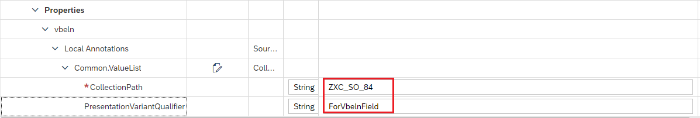

Now once we execute this, we will see the below screen.

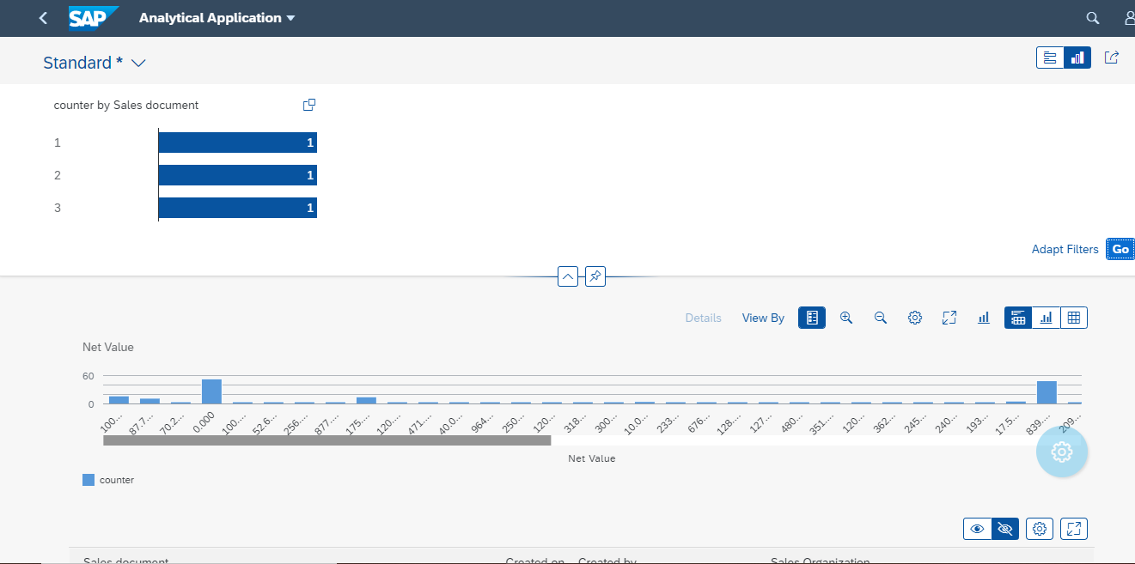

# Annotation Based Overview Report Fiori Application

To create the Over View page we will select the Overview Page option from the Fiori element section and then we will give the below information.

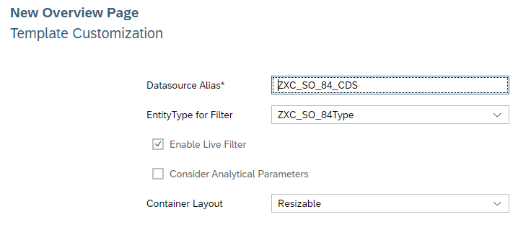

## Table Type Card

Now I want to add any table card and for that I have given some **UI.LineItem** annotation in the CDS view like below.

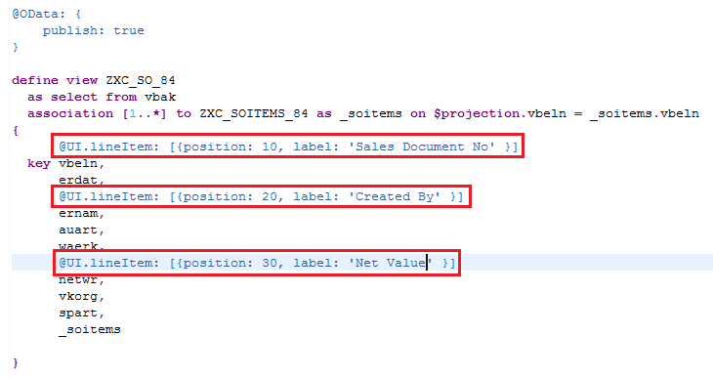

Now we will add the Table card to do so **Right** click on the **WEBAPP** folder and click **New Card** like below.

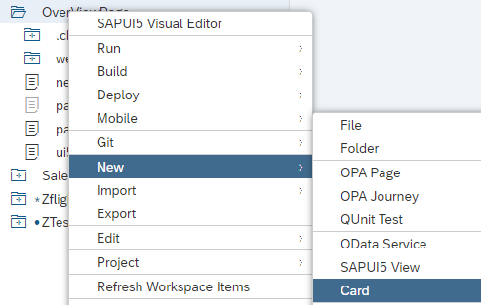

After that we will select the **Table** card. Then we have provided all the details and provided Annotation Path and sorting types like below.

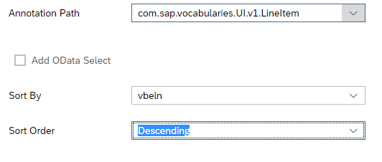

After finishing this we will see a Card is been added in the **manifest.json** file like below.

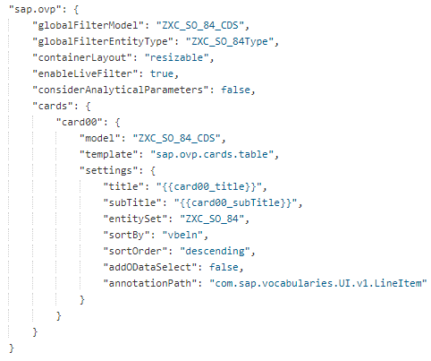

And after that if we execute the program, we will see the Card on the screen like below.

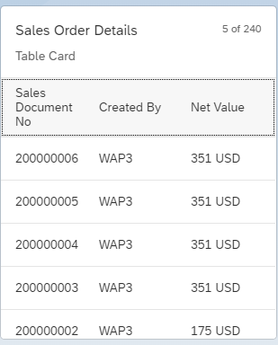

But now I want the Document no to be clickable or navigate to Document Page to do so we add the below annotation in the CDS view for this field VBELN.

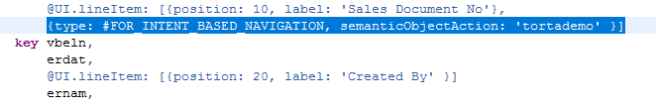

Here we have provided the **type** and **SemanticObjectAction** property.

In CDS we can write the Qualifiers as well like in another example I have created line items with Qualifiers (**TableType, NewTable**) and while creating the new card both the option shown in the dropdown list. Like the below screenshot.

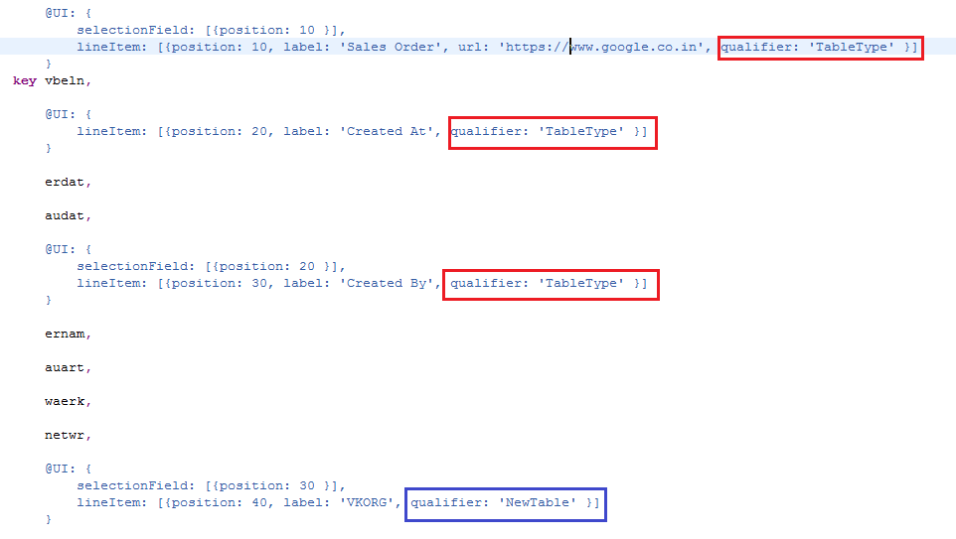

Below the Card Dropdown.

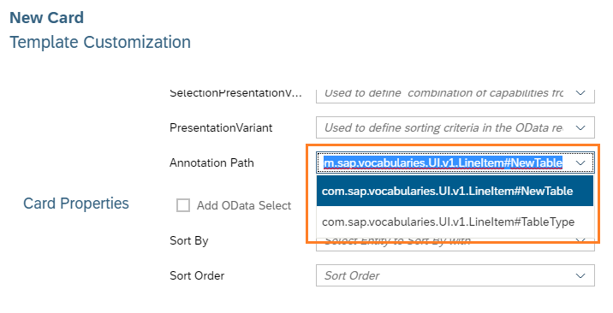

## List Type Card

Now we would like to add the List card on the screen then we need to add **UI.DataPoint** annotation to bring the table for List Type.

The below Data point annotation is been added for the field **NETWR** and we must need to make this field as **DataPoint** other wit=se the list type will not work properly. Below screen shot will show the same.

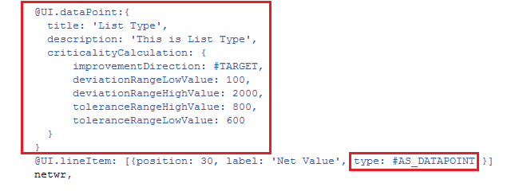

After executing this we will see a nice List chart on the screen be low screen shot will show how to add the list type card on the screen for that we will right click on the project and then will select **New** then select **Card** and then in the card we will select List.

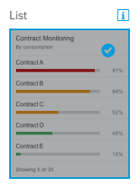

Then we will fill all the details like below.

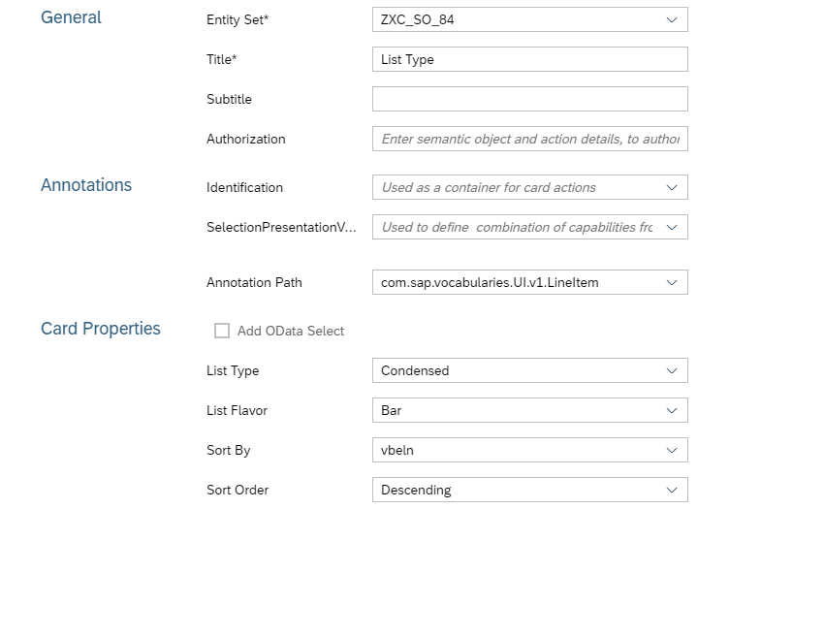

Now once we execute this, we will see the below chart on the screen.

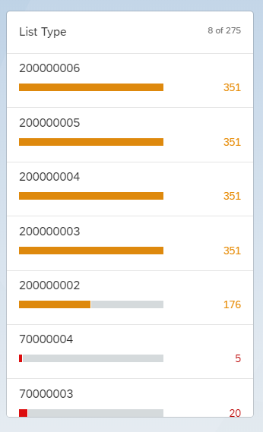

## Analytical Card

Now after Table card and List Card we will add the **Analytical Card** and for that we will add **UI.Chart** annotation in CDS view and then we will add a new card in **manifest.json** file.

Below is the Chart annotation, here we have added a Donut chart.

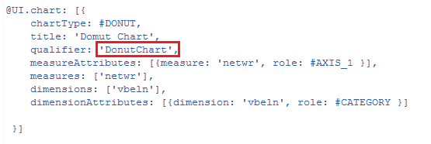

Now we are going to add a card in manifest.json file manually. Below is the syntax for the same.

"card03": {

"model": "ZXC_SO_84_CDS",

"template": "sap.ovp.cards.charts.analytical",

"settings": {

"title": "{{card03_title}}",

"entitySet": "ZXC_SO_84",

"chartAnnotationPath": "com.sap.vocabularies.UI.v1.Chart#DonutChart"

}

}

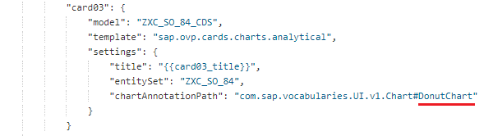

Now once we execute this, we will see a nice donut chart on the screen like below.

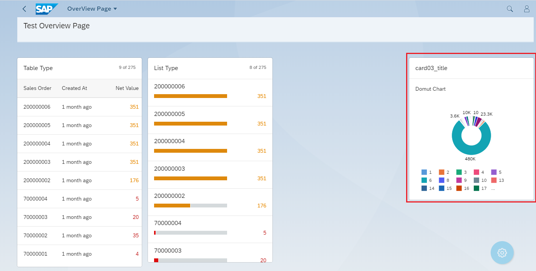

## Stack Card

Now after addition of Analytical Card, List Card, Table Card we are going to add the Stack Card for stack card we need **UI.HeaderInfo** annotation in CDS view.

So, the below annotation is been added to the CDS view.

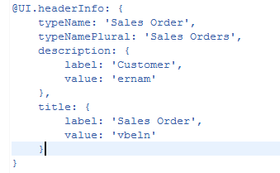

Now we are going to add a stack card on the screen. To add the Card, we will right click on the project and select **New** and then click on **Card** and add **Stack Card.**

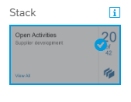

Then we will fill all the details and execute.

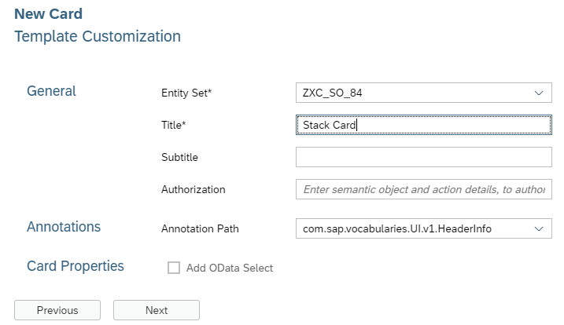

Now after execution we will the total over view page like below. It has all the charts (**List Card, Table Type, Analytical Card, Stack Card**)

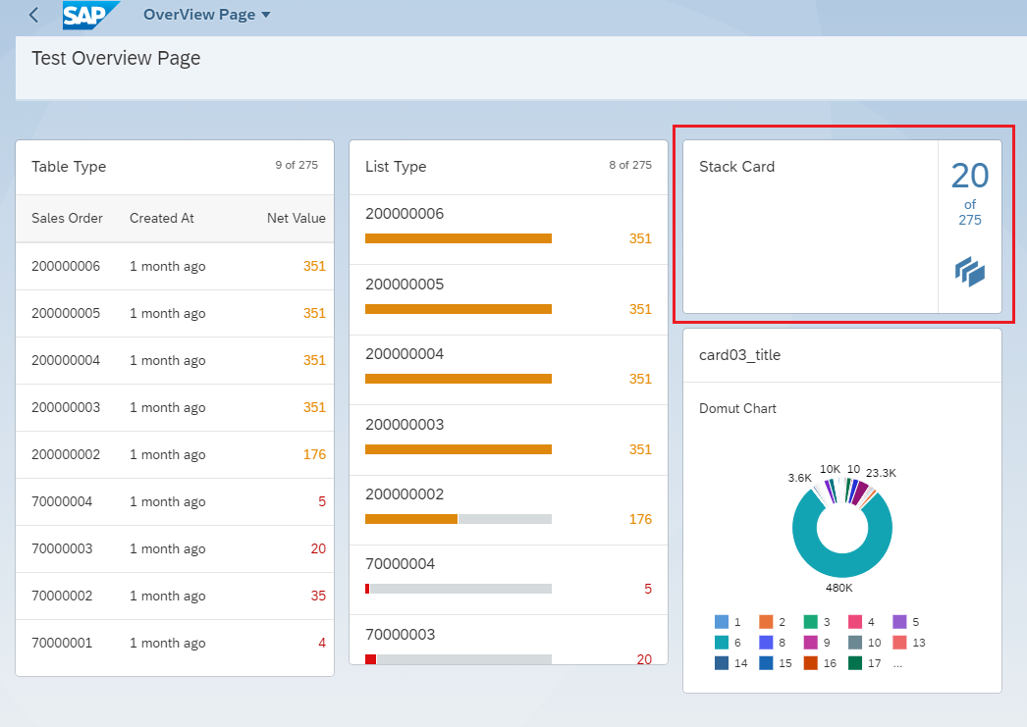

## Link List Card

This link list card is same as Stack card it also take the Header info.

**Details can be found here:**

<https://blogs.sap.com/2020/04/25/sap-fiori-elements-overview-page-part-1introduction/>

# Facet Pictures

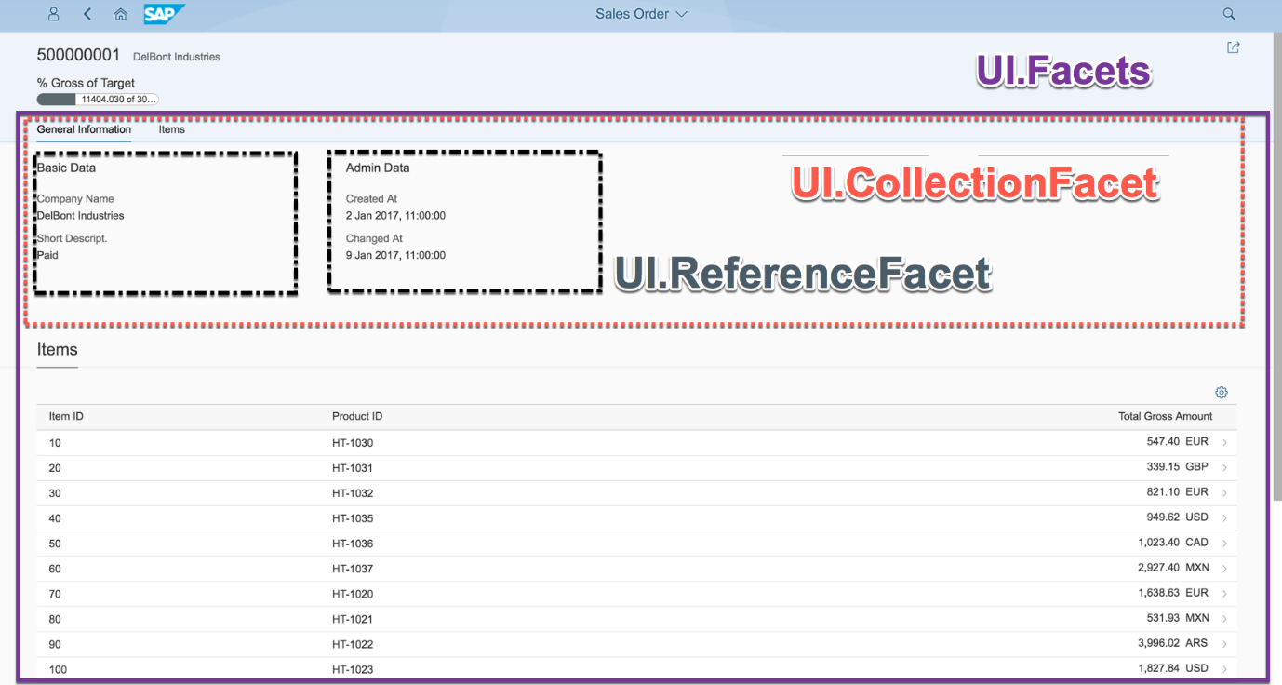

# Add multiple Annotations of same type

Now let’s say we need to add multiple chart annotations with different qualifier. And for that if we add **@UI.Chart** again then it will throw error saying that **UI.Chart** multiple times.

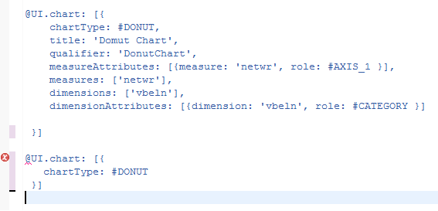

To add them we will use the below technique we will add a parenthesis (**{}**) inside the bracket (**[]).**

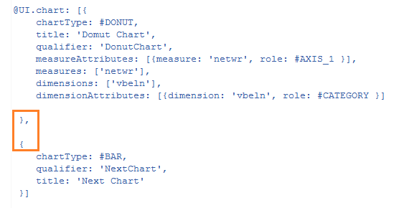

Like here we have added two chart with different qualifier, like way we can add any number of **LineItem, Chart, SelectionField.**

# Adding Custom Filter in sap Fiori elements

To add a new custom filter, we will create a new extension and select filter option in the list page like below screen shot.

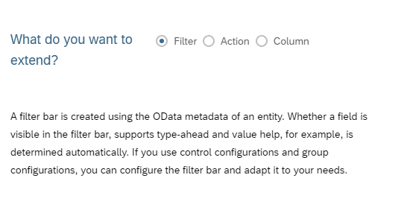

Then if we finish it, it will generate a new fragment and a controller, like below.

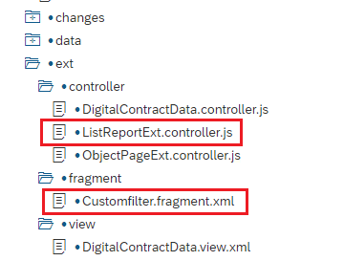

Then we will implement the filter in the fragment like below, here we have used a simple input as a filter.

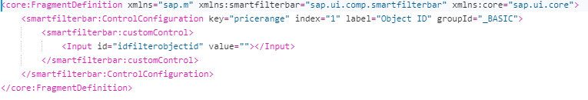

Then in the Controller we have 3 methods, listed below.

* **GetCustomAppStateDataExtension:** In this section we will save the app state.
* **restoreCustomAppStateDataExtension:** in this section we will restore the app state.
* **onBeforeRebindTableExtension:** This is the main section where we will create the filter and pass it to the backend and push it to the older filter.

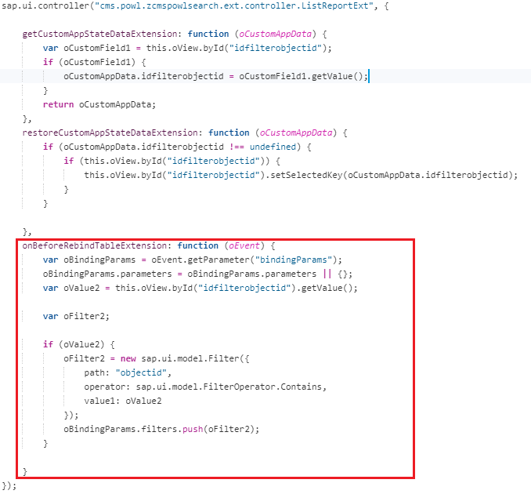

Sample code for details.

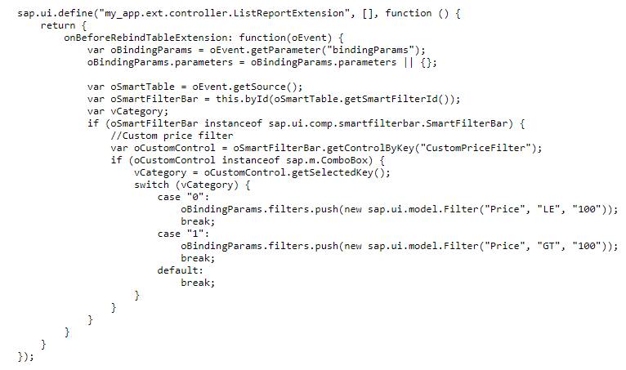

# Next Topic